

# ACKNOWLEDGEMENT

Embarking on the journey of accomplishing the goals of this project and completing this (IR) has been a profoundly enlightening and life-changing experience. In the months spent conducting research, analysis, and development, I have developed my technical expertise as well as my ability to think critically, persevere, and comprehend real-world problems in the post-pandemic tourism industry. I was forced to apply data-driven methodologies with academic rigor and go beyond my theoretical knowledge for this project, which helped me become a more capable and perceptive researcher.  
  
I want to sincerely thank my supervisor Ms. Fatin Izzati Ramli and my 2nd marker Ms. Mary Ting whose constant encouragement, helpful criticism, and unwavering support were invaluable in helping me overcome many obstacles and fine-tune the project's course. Their advice greatly improved the calibre of this report.

My family's unwavering patience, support, and faith in me gave me the emotional fortitude I needed to finish this difficult journey, and for that I am incredibly grateful. I also want to thank my friends and peers for their insightful comments, helpful edits, and moral support during this process.  
  
I have learned so much from this project about discipline, resilience, and intellectual curiosity in addition to data science, tourism recovery, and system development. I sincerely appreciate all of the advice, criticism, and encouragement that helped me reach this significant academic milestone.

# ABSTRACT

Due to the unprecedented global tourism collapse brought on by the COVID-19 pandemic, traditional econometric and time-series forecasting models that depend on stable seasonality were shown to be vulnerable. Cities in the Asia-Pacific area, which was among the hardest hit, including Bangkok, Hong Kong, and Singapore, had difficult and uneven recovery paths. In order to analyze the short-term post-pandemic tourism recovery in these three urban centers, this study suggests the Smart Traveller Insights System (STIS), a data-driven forecasting and decision-support framework.

The initial stages of the study concentrate on establishing a rigorous methodological design, defining the research problem, and synthesizing pertinent literature. The project incorporates methodical phases of data comprehension, preparation, feature engineering, and model development using the CRISP-DM framework. Using monthly arrivals data (2017–2024) obtained from official tourism portals, three predictive methods—Ridge Regression, Random Forest, and XGBoost—are compared to a Seasonal Naïve baseline. Reproducibility, transparency, and time-series-appropriate evaluation metrics (MAPE, MAE, RMSE, and R2) are highlighted in the methodology.

The theoretical and technical groundwork for a repeatable tourism forecasting pipeline that will eventually be operationalized into an interactive system is established by this IR. The study supports the current discussion on sustainable tourism recovery and methodological resilience in post-shock contexts by endorsing evidence-based forecasting techniques and coordinating analytical design with Sustainable Development Goal 3 (Good Health and Well-Being).

Keywords: Tourism forecasting, post-pandemic recovery, machine learning, Ridge Regression, Random Forest, Seasonal Naïve, Asia-Pacific.

Table of Contents

[ACKNOWLEDGEMENT 2](#_Toc211029647)

[ABSTRACT 3](#_Toc211029648)

[List of Tables 6](#_Toc211029649)

[List of Figures 6](#_Toc211029650)

[List of Equations 7](#_Toc211029651)

[CHAPTER 1: INTRODUCTION 8](#_Toc211029652)

[1.1 INTRODUCTION 8](#_Toc211029653)

[1.2 PROBLEM BACKGROUND 9](#_Toc211029654)

[1.2.1 Features of Post-Shock Data: Latency, Regime Shifts, and Structural Breaks 9](#_Toc211029655)

[1.2.2 Pre-pandemic forecasting setup limitations under structural breaks 9](#_Toc211029656)

[1.2.3 Regular, Public Monthly Series Are Necessary for Cross-City Comparability 10](#_Toc211029657)

[1.3 PROBLEM AIM 10](#_Toc211029658)

[1.4 OBJECTIVES 11](#_Toc211029659)

[1.5 SCOPE 11](#_Toc211029660)

[1.5.1 Deliverables 11](#_Toc211029661)

[1.5.2 Constraints 12](#_Toc211029662)

[1.5.3 Project Inclusions 13](#_Toc211029663)

[1.5.4 Project Exclusions 14](#_Toc211029664)

[1.5.6 Targeted Users: 14](#_Toc211029665)

[1.6 POTENTIAL BENEFITS 15](#_Toc211029666)

[1.6.1 Tangible Benefits 15](#_Toc211029667)

[1.6.2 Intangible Benefits 15](#_Toc211029668)

[1.7 Overview of The IR 16](#_Toc211029669)

[1.7 Project Plan 18](#_Toc211029670)

[CHAPTER 2: LITERATURE REVIEW 19](#_Toc211029671)

[2.1 Introduction 19](#_Toc211029672)

[2.2 Domain Research 20](#_Toc211029673)

[2.2.1 Tourism Demand Forecasting Pre-Pandemic (Classical Foundations) 20](#_Toc211029674)

[2.2.2 Post-COVID Tourism Dynamics and Structural Breaks 21](#_Toc211029675)

[2.2.3 Machine Learning and Hybrid Forecasting Methods 22](#_Toc211029676)

[2.2.4 Practices for Cross-City Forecasting and Assessment 29](#_Toc211029677)

[2.2.5 Decision-Support Systems and Their Useful Consequences 31](#_Toc211029678)

[2.3 Similar Systems 33](#_Toc211029679)

[2.4 Technical Research 39](#_Toc211029680)

[2.4.1 Project Hardware and Software 39](#_Toc211029681)

[2.4.2 Programming Languages 39](#_Toc211029682)

[2.4.3 Integrated Development Environments (IDEs) 40](#_Toc211029683)

[2.4.4 Tools and Libraries 41](#_Toc211029684)

[2.4.5 Operating System 42](#_Toc211029685)

[2.4.6 Environment for Web Server and Deployment 42](#_Toc211029686)

[2.4.7 Web Browser 42](#_Toc211029687)

[2.4.8 Justification and Alignment with SDG 3 43](#_Toc211029688)

[CHAPTER 3: METHODOLOGY 44](#_Toc211029689)

[3.1 Introduction 44](#_Toc211029690)

[3.2 Methodology 44](#_Toc211029691)

[3.2.1 Introduction of Methodologies 45](#_Toc211029692)

[3.2.2 Methodology Choice and Justification 49](#_Toc211029693)

[3.2.3 CRISP-DM Methodology and its Application 51](#_Toc211029694)

[Business Understanding 52](#_Toc211029695)

[Data Understanding 53](#_Toc211029696)

[Data Preparation 54](#_Toc211029697)

[Modelling 55](#_Toc211029698)

[Evaluation 55](#_Toc211029699)

[Deployment 57](#_Toc211029700)

[Summary 58](#_Toc211029701)

[3.3 Data Collection 59](#_Toc211029702)

[3.4 Initial Data Understanding 60](#_Toc211029703)

[3.4.1 Variables 60](#_Toc211029704)

[3.4.2 Exploratory Data Analysis (Bangkok Exemplar) 61](#_Toc211029705)

[3.5 Data Pre Processing 67](#_Toc211029706)

[3.5.1 Handling Missing values 68](#_Toc211029707)

[3.5.2 Structural Breaks and Outliers 68](#_Toc211029708)

[3.5.3 Data Transformation 68](#_Toc211029709)

[3.5.4 Feature Engineering 69](#_Toc211029710)

[3.5.5 Standardization 69](#_Toc211029711)

[3.5.6 Final Dataset 69](#_Toc211029712)

[3.6 Model Building 70](#_Toc211029713)

[3.6.1 Overview 70](#_Toc211029714)

[3.6.2 Ridge Regression (Model for Bangkok) 70](#_Toc211029715)

[3.6.3 Random Forest (Model for Singapore) 70](#_Toc211029716)

[3.6.4 XGboost (Applied to all cities) 71](#_Toc211029717)

[3.6.5 Seasonal Naïve (Model for Hong Kong) 71](#_Toc211029718)

[CHAPTER 4: CONCLUSION 72](#_Toc211029719)

[4.1 Critical Evaluation 72](#_Toc211029720)

[4.2 Limitations 72](#_Toc211029721)

[4.3 Recommendations and Future Research 73](#_Toc211029722)

[References 75](#_Toc211029723)

[APPENDIX 81](#_Toc211029724)

[1. Project Proposal 81](#_Toc211029725)

[2. Ethics Form 82](#_Toc211029726)

[3. Log Sheets 86](#_Toc211029727)

[Log sheet 1 86](#_Toc211029728)

[Log sheet 2 88](#_Toc211029729)

[4. Gantt chart 90](#_Toc211029730)

[5. Turnitin 91](#_Toc211029731)

# List of Tables

[Table 1 Comparison of the models through previous works 31](#_Toc209130072)

[Table 2 Comparison evidence of previous works with key findings 35](#_Toc209130073)

[Table 3 Similar Systems and their comparison in detail 41](#_Toc209130074)

[Table 4 Data collection with sources 66](#_Toc209130075)

[Table 5 Variables of the bangkok dataset 66](#_Toc209130076)

# List of Figures

[Figure 1 Image depicting post covid trajectories in arrivals for Singapore, Hong Kong and Bangkok 22](#_Toc211006372)

[Figure 2 Image depicting ML flow work for this project 23](#_Toc211006373)

[Figure 3 CRISP-DM Workflow ( Shaun Chumbar,2024) 46](#_Toc211006374)

[Figure 4 SEMMA Workflow Shaun Chumbar,2024) 47](#_Toc211006375)

[Figure 5 KDD Workflow Fayyad et al. (1996a)) 48](#_Toc211006376)

[Figure 6 Import the libraries 62](#_Toc211006377)

[Figure 7 loading dataset 62](#_Toc211006378)

[Figure 8 First three rows of data 62](#_Toc211006379)

[Figure 9 Univariate analysis code 63](#_Toc211006380)

[Figure 10 Univariate analysis for hotel occupancy 63](#_Toc211006381)

[Figure 11 Univariate analysis code for google trends 63](#_Toc211006382)

[Figure 12 Bangkok Arrivals histogram 64](#_Toc211006383)

[Figure 13 Bangkok Arrivals over time 64](#_Toc211006384)

[Figure 14 Average Visitors Arrivals for bangkok 65](#_Toc211006385)

[Figure 15 Google trends series plot over time 65](#_Toc211006386)

[Figure 16 Hotel occupancy series plot over time 66](#_Toc211006387)

[Figure 17 Bivariate analysis code 67](#_Toc211006388)

[Figure 18 Scatterplot for visitor arrivals and google trends 67](#_Toc211006389)

[Figure 19 Scatterplot for visitor arrivals and hotel occupancy 67](#_Toc211006390)

[Figure 20 correlation matrix 68](#_Toc211006391)

[Figure 21 Code for handling missing values 69](#_Toc211006392)

[Figure 22 Code for outliers 69](#_Toc211006393)

[Figure 23 Code for transforming data 69](#_Toc211006394)

[Figure 24 Code for feature engineering 70](#_Toc211006395)

[Figure 25 Code for standardization 70](#_Toc211006396)

[Figure 26 Code for final dataset 70](#_Toc211006397)

# List of Equations

[Equation 1 Ridge Regression Formula 26](#_Toc211006398)

[Equation 2 Random Forest Formula 27](#_Toc211006399)

[Equation 3 XGboost Formula 28](#_Toc211006400)

# CHAPTER 1: INTRODUCTION

## INTRODUCTION

The COVID-19 pandemic caused an unprecedented collapse in international tourism, with the steepest decline on record occurring in 2020, when global international arrivals fell by roughly 74% compared to 2019 (UNWTO, 2021). The need for forward-looking forecasting tools rather than lag descriptive indicators is further supported by the Asia-Pacific region's uneven recovery and its status as one of the hardest hit regions (UNWTO, 2021).

Figures at the city and national levels show the shock and the different recovery paths of the three hubs under study. Amid border closures, Singapore's visitor arrivals dropped 85.7% to about 2.7 million in 2020 (from about 19.1 million in 2019) (Singapore Tourism Board [STB], 2021). In 2020, 3.57 million people visited Hong Kong (-93.6% year over year) (Hong Kong Tourism Board [HKTB], 2021). Thailand saw a sharp decline in visitors from almost 40 million in 2019 to about 6.7 million in 2020, with Bangkok serving as the main entry point (Reuters, 2025). A comparative multi-city forecasting design with an emphasis on Bangkok, Hong Kong, and Singapore is motivated by these indicators.

In order to help navigate post-pandemic volatility, the Smart Traveller Insights System, which is the project's proposed solution, is intended to serve as a decision support interface that displays short-horizon forecasts and model diagnostics. Conventional monitoring, which consists of purely descriptive dashboards and official statistics that are released slowly, are lagging indicators that find it difficult to support quick operational and policy decisions. Pre-pandemic tourism forecasting was largely based on univariate time-series models that assumed stable seasonality. However, structural breaks in 2020–2021 broke these assumptions, which frequently resulted in performance degradation unless models were supplemented with richer features or alternative approaches (Wang, Li, & Park, 2023; Li, 2021). Regularized linear methods and tree-based ensembles have been shown to outperform classical baselines when rigorously evaluated, highlighting the growing role of machine learning (ML) and Internet/search data in tourism demand forecasting (Li, 2021). In order to evaluate true value-add, this encourages combining contemporary machine learning models with an open seasonal naïve benchmark (Hyndman & Athanasopoulos, 2021).

Bangkok, Hong Kong, and Singapore combine the transparent, high-frequency data necessary for reliable modelling with the significant worldwide tourism influence. Bangkok is frequently ranked as one of the most visited cities in the world, both before and after the pandemic, highlighting its role as a bellwether (Mastercard, 2019; Euromonitor International, 2024). Consistent model training, validation, and cross-city comparison are made possible by the official monthly visitor-arrivals series that each of the three markets provides through their public portals: Thailand via the Bank of Thailand's tourism indicator tables, Hong Kong via HKTB/PartnerNet (which offers downloadable monthly reports), and Singapore via STB's analytics network (STB, 2021; HKTB, 2021; Bank of Thailand, 2025). While Kuala Lumpur was examined during the initial scoping phase, Bangkok was chosen as the Southeast Asia proxy due to data consistency and completeness, maintaining the regional perspective and bolstering methodological reliability.

## PROBLEM BACKGROUND

### 1.2.1 Features of Post-Shock Data: Latency, Regime Shifts, and Structural Breaks

Following COVID-19, the Asia-Pacific region's monthly international arrivals series show level shifts, broken seasonality, and sporadic plateaus. These characteristics, which complicate short-horizon planning and disturb pre-2020 seasonal regularity, result from staggered border policies, airline capacity restoration, and changing risk perceptions (UNWTO, 2021). Furthermore, using static dashboards or descriptive bulletins only offers a limited amount of forward guidance because official releases are usually delayed. Forecasting on discontinuous series is therefore given precedence over retrospective description in a defensible analysis (UNWTO, 2021).

### 1.2.2 Pre-pandemic forecasting setup limitations under structural breaks

Prior to 2020, research on tourism demand frequently used univariate time-series models that assume stable seasonality, such as decomposable trend-seasonal forms or variants of ARIMA. These presumptions were regularly broken during and after COVID-19, and performance suffered unless models were enhanced with more detailed features or different learners (Wang, Li, & Park, 2023). According to recent reviews, machine learning and web/search data are becoming increasingly important in tourism forecasting. Regularized linear methods and tree-based ensembles, in particular, show promise in post-shock scenarios when assessed against open benchmarks (Li, 2021). In order to confirm true value-add beyond merely seasonal repetition, this encourages the inclusion of a Seasonal Naïve comparator (Hyndman & Athanasopoulos, 2021).

### 1.2.3 Regular, Public Monthly Series Are Necessary for Cross-City Comparability

When demand composition, air connectivity, and policy cadence vary, conclusions drawn from a single market may be deceptive. This study chooses three hubs with regular, public monthly arrivals to allow for like-for-like comparison: Thailand (Bank of Thailand tourism indicators), Hong Kong (HKTB/PartnerNet; C&SD tables), and Singapore (STB analytics network). For consistent training and validation free from measurement artifacts from diverse collection methods, these sources offer the regularity and consistency needed (STB, 2021; HKTB, 2021; Bank of Thailand, 2025). Although Kuala Lumpur was examined during the initial scoping phase, Bangkok was chosen as the Southeast Asia proxy due to data consistency and completeness, maintaining the regional perspective while enhancing methodological reliability.

**Plateaued Series Evaluation Practice**  
Variance-based measures can be deceptive on series that show long plateaus (such as periods of flat recovery). For the simple reason that test-set variance is low, a model may have low absolute error but poor R². In line with established forecasting practice and recent post-COVID methodological notes, this study prioritizes MAPE, MAE, and RMSE for primary assessment, while keeping R2 as a secondary diagnostic (Hyndman & Athanasopoulos, 2021; Wang et al., 2023).

## PROBLEM AIM

To create a Smart Traveller Insights System that uses a consistent feature-engineered pipeline that evaluates Ridge Regression, Random Forest, and XGBoost against a Seasonal Naïve baseline, as measured by MAPE, MAE, RMSE, and R², to generate and visualize short-horizon forecasts of monthly international tourist arrivals for Singapore, Hong Kong, and Bangkok.

## OBJECTIVES

**O1. Dataset construction and comparability**To compile and record monthly international arrivals, Google Trends and Hotel Occupancy Rate datasets for Singapore, Hong Kong, and Bangkok that are consistent (2017–2024) while guaranteeing data quality, standardized definitions, and cross-city comparability.  
  
**O2: Design of forecasting framework**  
To create a comparative forecasting framework that combines data-driven predictive models with a transparent statistical baseline, backed by a consistent feature-engineering process and validation that is appropriate for time series.

**O3. Cross-city analysis and quantitative assessment**  
To interpret the results across the three cities, assess forecast performance using pre-specified accuracy metrics (MAPE, MAE, RMSE, and R2), and determine the circumstances in which data-driven models outperform the baseline.  
  
**O4. Reproducibility and system realization**  
To create an interactive, research-grade dashboard with forecasts and diagnostics along with fully reproducible artifacts (code, data provenance, configuration) for the Smart Traveller Insights System.

## SCOPE

### 1.5.1 Deliverables

**Data collection:** Compiling monthly data on foreign visitor arrivals from official portals for Singapore, Hong Kong, and Bangkok (a proxy for Thailand) from 2017–2024.  
  
**Data preprocessing**: Cleaning, format reconciliation, missing value handling, and series alignment for uniform temporal coverage.  
  
**Feature engineering**: Process of improving forecast ability by developing rolling statistics, calendar effects, and lag features.  
  
**Model Development:** Forecasting monthly arrivals using XGBoost, Random Forest, Ridge Regression, and Seasonal Naïve training. **Model evaluation and optimization**: choosing the best models for each city, documenting settings, and evaluating performance using MAPE, MAE, RMSE, and R2.  
  
**System Deployment:** Using a Streamlit web application to package the forecasting process and display the outcomes.  
 **Frontend development:** the process of creating an interactive dashboard that shows forecasts, historical trends, and comparative diagnostics.  
  
**Reproducibility package:** Code, environment files, configuration, and instructions to replicate results are all included.

### 1.5.2 Constraints

**Revision risk and official data latency:** All results reflect the most recent releases available at the time of analysis; monthly arrivals are released with lags and may be updated retroactively.  
 **Variability in measurement:** Even when one authoritative source is used per city, cross-jurisdictional differences (definitions, counting rules, special events) may still exist; this is recognized in the interpretation.  
**Scope of univariate forecasting:** Only arrivals are modelled in the study; no exogenous regressors, such as air-seat capacity, exchange rates, or macro indicators, are included. The findings are not causative; they are predictive.  
  
**Properties of the post-shock series:** Even when absolute errors are small, structural breaks, regime shifts, and plateaus can reduce variance-based metrics (like R²) and limit the amount of accuracy that can be achieved.  
  
**Budgets for time and computation:** The validation employs rolling/expanding-origin schemes suitable for a student project rather than large-scale experimentation, and the hyper-parameter search is bounded.

**Model boundaries:** Seasonal Naïve, Ridge, Random Forest, and XGBoost are the only forecasting frameworks compared; deep learning and probabilistic/quantile forecasting frameworks are not included.  
 **Limits of software and deployment:** Authentication, load balancing, role-based access, and high availability hosting are not offered by the dashboard, which is a research-grade Streamlit application meant for academic demonstration.  
  
**Dependencies on reproducibility:** The aforementioned Python environment, package versions, and public data portals must be available for reproduction; project control has no control over breaking API/portal changes.  
  
**Ethics and legal:** There is no use of private information or scraping of restricted sources; only publicly available official statistics are used.

### 1.5.3 Project Inclusions

**Time and place:** Bangkok (Thailand proxy), Singapore, and Hong Kong; monthly frequency, January 2017–December 2024.  
  
**Data items:** Arrivals series that have been cleaned; feature matrices that include calendar effects (month indicators), rolling summaries (e.g., 3/6-month means), and specific lags (e.g., 1, 3, 6, 12).

**Forecast configuration:** Monthly short-horizon forecasts (defined in Chapter 3 as operationally relevant horizons) generated by a standard pipeline for each city.  
  
**Set of models:** Random Forest, XGBoost, Ridge Regression, and Seasonal Naïve (baseline).  
  
**Selection and validation:** transparent model selection by city, time-series-appropriate validation (rolling/expanding origin), and informative ablation notes.  
  
**Metrics for evaluation:** Error metrics in low-variance segments were given priority in the systematic reporting of MAPE, MAE, RMSE, and R².  
  
**Artefacts and outputs:** Streamlit dashboard, per-city summaries, interpretive commentary, comparative tables/plots, and a complete reproducibility bundle (code, environment files, configuration, instructions).

1.5.4 Project Exclusions  
**Other Cities:** Due to data-consistency issues discovered during scoping, markets outside of the three hubs—such as Kuala Lumpur—are not included.  
  
**Granularity:** that goes beyond the month. No breakdowns by origin-market, season/segment, daily, or sub-city.  
 **Casual or exogenous drivers:** No macroeconomic or epidemiological covariates, policy indices, flight capacity, fares, causal inference, or counterfactual analyses are included.  
  
**Model families are not taken into account**: No probabilistic/quantile, LSTM/Transformer, ETS/Prophet, ARIMA/SARIMA, or hierarchical reconciliation techniques.  
  
**Quantification of uncertainty beyond the fundamentals:** No calibrated prediction intervals or conformal bands are generated, except for diagnostics and basic error summaries.  
  
**Production:** Testing is restricted to research-grade checks; there are no SLAs, CI/CD pipelines, container orchestration, autoscaling, or observability stacks.  
  
**Primary gathering of data:** No experiments, interviews, or surveys.  
 **Multi-platform or mobile applications**: The interface is web-based; there are no native iOS or Android deliverables.

### 1.5.6 Targeted Users:

* **Tourism Boards:** Officials who require information on the well-being and confidence in recovery of foreign visitors.
* **Public health policymakers:** Urban health and safety planners looking for data-driven support to promote healthy cities.
* **Researchers and Analysts:** Academics with an interest in the relationship between public well-being, tourism, and digital behaviour.
* **Travellers in general:** Those who might use the Traveller Confidence Index to evaluate the safety of their trip and make appropriate plans.

## POTENTIAL BENEFITS

1.6.1 Tangible Benefits  
**Forecasts on coherent monthly series that are comparable**: Using official series, a uniform pipeline provides structured evidence on post-shock recovery dynamics, producing monthly forecasts for Bangkok, Hong Kong, and Singapore that are like-for-like (UNWTO, 2021).   
 **Measured improvements over a basic standard:** Improvements are auditable and attributable through systematic evaluation against a Seasonal Naïve comparator, which is in line with accepted forecasting pedagogy (Hyndman & Athanasopoulos, 2021).   
  
**Rigorous evaluation in the spirit of competition:** The results' credibility is increased by transparent selection and pre-declared accuracy metrics (MAPE, MAE, RMSE, and R2) that reflect best practices from extensive forecasting studies (Makridakis, Spiliotis, & Assimakopoulos, 2022).   
  
**Research artifacts that can be replicated:** Replication and extension in coursework and dissertations are made possible by public code, environment files, and documented splits (Li, 2021).

1.6.2 Intangible Benefits  
**Contribution of methodology in post-shock situations:** The post-COVID tourism forecasting discourse is bolstered by evidence of when regularized linear models and tree ensembles perform better than seasonal repetition on series with broken seasonality and plateaus (Li, 2021).   
  
**Educational worth:** In line with commonly taught forecasting guidance, a baseline-first design upholds fundamental principles (the need for naïve comparators; cautious metric selection when variance is low) (Hyndman & Athanasopoulos, 2021).   
  
**Conformity to SDG 3:** Good Health and Well-Being. The study contributes to the body of knowledge related to SDG 3's focus on resilient health and well-being by organizing prompt, evidence-based recovery analysis for international travel systems interrupted by a health emergency (United Nations, n.d.; UNWTO, 2021).

## 1.7 Overview of The IR

Chapter 1: The Introduction. The post-pandemic context for the Asia-Pacific tourism recovery is outlined in this chapter, which also serves as the impetus for a forecasting-cantered analysis of three urban centers: Bangkok, Hong Kong, and Singapore. It outlines four outcome-oriented objectives, a single, clear project aim, and the work's tangible and intangible benefits. It also defines the scope by clearly defining deliverables, constraints, inclusions, exclusions, and the intended user. The chapter provides the theoretical and practical framework that the rest of the report is built around.

Chapter 2: Review of Literature. Instead of offering a descriptive catalogue, this chapter offers a critical synthesis. Prior to reviewing technical research pertinent to a multi-city monthly forecasting pipeline (data handling, feature engineering, model classes, and evaluation practice), it places the project within domain research on post-shock tourism dynamics and measurement. It then examines related works to identify methodological strengths, limitations, and transferable design choices. The chapter ends by pointing out particular gaps that the project fills and by drawing conclusions about design that guide the analytical strategy that was selected.

Chapter 3: Methodology. This chapter maps the project's phases to scheduled activities and provides justification for the overall development lifecycle that was chosen. It outlines the feature-engineering protocol, formalizes data acquisition and preprocessing methods, and describes the comparative forecasting design that includes machine-learning families and a transparent statistical baseline. In order to prevent leakage and overfitting, it also lays out the validation plan and pre-stated evaluation metrics. The chapter acts as an operational implementation blueprint, coordinating methodological decisions with the goals outlined in Chapter 1 and the gaps mentioned in Chapter 2.

Chapter 4: Conclusion. The project's contributions and limitations in relation to the stated aim and objectives will be summarized in the final chapter, which will also consider the methodological and practical implications of the findings and suggest feasible extensions. I

## Project Plan

|  |  |  |  |  |
| --- | --- | --- | --- | --- |
| **Task Name** | **Duration** | **Start Date** | **End Date** | **Status** |
| Project Proposal Form | 7 days | 24/02/2025 | 03/03/2025 | Complete |
| **Chapter 1: Introduction** | **3 days** | **29/03/2025** | **31/03/2025** | **Complete** |
| 1.1 Introduction | <1 day | 29/03/2025 | 29/03/2025 | Complete |
| 1.2 Problem Background | <1 day | 29/03/2025 | 29/03/2025 | Complete |
| 1.3 Project Aim | <1 day | 29/03/2025 | 29/03/2025 | Complete |
| 1.4 Objectives | <1 day | 30/03/2025 | 30/03/2025 | Complete |
| 1.5 Scope | <1 day | 30/03/2025 | 30/03/2025 | Complete |
| 1.6 Potential Benefits | <1 day | 31/03/2025 | 31/03/2025 | Complete |
| 1.7 Overview of the IR | <1 day | 31/03/2025 | 31/03/2025 | Complete |
| 1.8 Project Plan | <1 day | 31/03/2025 | 31/03/2025 | Complete |
| **Chapter 2: Literature Review** | **8 days** | **04/04/2025** | **13/04/2025** | **Complete** |
| 2.1 Introduction | 1 day | 04/04/2025 | 04/04/2025 | Complete |
| 2.2 Domain Research | 3 days | 05/04/2025 | 08/04/2025 | Complete |
| 2.3 Similar Systems/Works | 2 days | 09/04/2025 | 10/04/2025 | Complete |
| 2.4 Technical Research | 1 day | 12/04/2025 | 12/04/2025 | Complete |
| 2.5 Summary | <1 day | 13/04/2025 | 13/04/2025 | Complete |
| **Chapter 3: Methodology** | **9 days** | **15/04/2025** | **29/04/2025** | **Complete** |
| 3.1 Introduction | 1 day | 15/04/2025 | 15/04/2025 | Complete |
| 3.2 Methodology | 2 days | 17/04/2025 | 19/04/2025 | Complete |
| 3.3 Data Collection and Data Understanding | 3 days | 22/04/2025 | 25/04/2025 | Complete |
| 3.4 Initial Data Preprocessing | 2 days | 26/04/2025 | 28/04/2025 | Complete |
| 3.5 Summary | 1 day | 29/04/2025 | 29/04/2025 | Complete |
| **Chapter 4: CONCLUSION** | **<1 day** | **01/05/2025** | **01/05/2025** | **Complete** |
| **References** | **<1 day** | **01/05/2025** | **01/05/2025** | **Complete** |
| **Appendices** | **<1 day** | **01/05/2025** | **01/05/2025** | **Complete** |

Table Project Plan

# CHAPTER 2: LITERATURE REVIEW

## 2.1 Introduction

Following the COVID-19 pandemic, there has been a significant methodological change in the forecasting of tourism demand. Econometric and univariate time-series models, such as ARIMA, SARIMA, and ETS, were primarily used in pre-pandemic research. These models performed well in situations with steady seasonality and slow growth trends (Li, Song, & Witt, 2005). These models' vulnerability was brought to light by the abrupt structural disruptions and regime changes brought about by the pandemic, as their dependence on stationarity and recurring seasonal cycles was no longer valid (Qiu, Wu, Dropsy, Petit, & Pratt, 2021). This has sparked a new wave of research that uses hybrid forecasting frameworks, machine learning (ML), and ensemble learners to capture irregular fluctuations and nonlinear recovery dynamics (Kumar, Misra, & Chan, 2022; Yang, Li, Guo, & Sun, 2023).

There is increasing evidence that machine learning models like Ridge regression, Random Forest, and XGBoost can perform better than traditional benchmarks when tested in unstable, post-shock environments (Kayral, Sarı, & Aktepe, 2023; Lee, 2025). Comparability between studies is limited because these techniques are not regularly evaluated against clear baselines like Seasonal Naïve. The majority of post-pandemic research is still concentrated on forecasting at the country or single destination level, which is another gap that has been noted (Polyzos, Fotiadis, & Samitas, 2021). This raises questions about how recovery paths vary among globally important Asia-Pacific hubs, where traveller confidence, air connectivity, and border policies vary. Additionally, although a number of studies incorporate web search data, mobility indicators, or decomposition frameworks, little progress has been made in creating repeatable pipelines that combine interpretability, practical deployment, and predictive accuracy (Chen, Hu, & Law, 2025; Li, Yang, Guo, Sun, & Wang, 2024).

## 2.2 Domain Research

### 2.2.1 Tourism Demand Forecasting Pre-Pandemic (Classical Foundations)

Prior to the COVID-19 pandemic, time-series and classical econometric models dominated the forecasting of tourism demand. Because they provided interpretability and demonstrated consistent performance under stable seasonal conditions, methods like ARIMA, SARIMA, Holt–Winters exponential smoothing, and ETS were widely used. Their success was based on the presumption of gradual growth and recurrent seasonality, which matched historical trends in foreign arrivals.

However, the pandemic brought to light their shortcomings. These models were not built to handle shocks like the abrupt decline in international mobility, extended travel restrictions, and non-linear recovery trajectories. Recent research indicates that when applied to post-2020 tourism data, forecasts based on classical approaches showed systematic biases and were unable to adjust to abrupt structural breaks (Qiu, Wu, Dropsy, Petit, & Pratt, 2021). This reaffirmed the worry that traditional models are not resilient in situations of increased volatility, even though they are still useful for benchmarking.

Simple statistical comparators are still useful in tourism forecasting research in spite of these drawbacks. When assessing whether machine learning techniques actually add value, transparent baselines like Seasonal Naïve offer a crucial benchmark against which more advanced approaches can be assessed (Li, Yang, Guo, Sun, & Wang, 2024). Maintaining the use of these baselines prevents the tendency to exaggerate the advantages of sophisticated models and guarantees methodological rigor.

In conclusion, traditional forecasting techniques laid the groundwork for modelling tourism demand and are still useful as clear standards. However, the need for more adaptable strategies is highlighted by their incapacity to adjust to structural shocks. In order to better understand post-pandemic volatility and recovery dynamics, the current study advances machine learning models while maintaining Seasonal Naïve as a baseline comparator.

### 2.2.2 Post-COVID Tourism Dynamics and Structural Breaks

The COVID-19 pandemic caused a previously unheard-of disruption in global travel patterns, which led to circumstances that seriously questioned conventional forecasting techniques. Global tourist arrivals fell by over 80% in 2020 as a result of travel restrictions, border closures, and lockdowns; the Asia-Pacific region saw the biggest drop (Qiu, Wu, Dropsy, Petit, & Pratt, 2021). In contrast to earlier disruptions like natural disasters or financial crises, the pandemic's effects were systemic and prolonged, causing demand patterns to structurally break as well as temporarily decline. Long-term patterns were upset, seasonal peaks vanished, and recovery paths became significantly uneven across locations (Polyzos, Fotiadis, & Samitas, 2021).

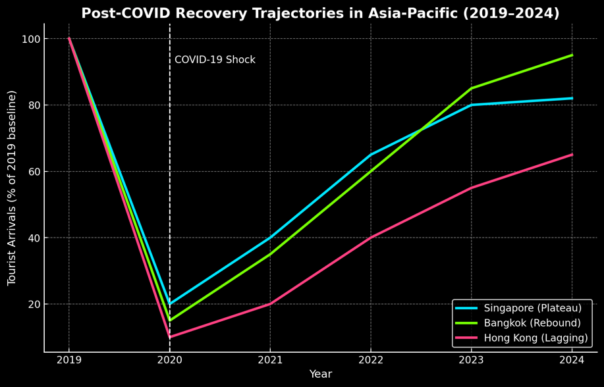

Figure Image depicting post covid trajectories in arrivals for Singapore, Hong Kong and Bangkok

The image illustrated showcases how covid impacted these three Asia pacific hubs and how the covid shock impacted them in terms of tourism. Singapore and Hong Kong depict low recovery while Bangkok seems to have almost reached full recovery.

Recovery has not been linear and has depended on geography, according to recent studies. While hubs heavily reliant on long-haul or Mainland Chinese Travellers trailed behind, destinations with diverse source markets, robust domestic tourism bases, or quicker vaccine rollouts showed earlier rebounds (Yang, Li, Guo, & Sun, 2023). For example, Bangkok's demand was more erratic but regained seasonal momentum once restrictions were loosened, whereas Singapore's cautious approach to border reopening resulted in a plateaued recovery path. Geopolitical factors and stringent zero-COVID policies, on the other hand, caused Hong Kong to experience protracted stagnation. These varying results highlight the shortcomings of general forecasting and the requirement for city-specific models that can take into consideration different recovery dynamics.

The growing significance of uncertainty and Traveller confidence has been another characteristic of the post-pandemic environment. Indicators like mobility data, web search activity, and policy stringency indices have shown promise in capturing changes in travel intentions and constraints, adding value beyond raw arrival figures (Li, Yang, Guo, Sun, & Wang, 2024; Chen, Hu, & Law, 2025). This supports the claim that forecasting in the post-COVID era needs to incorporate exogenous variables or machine learning architectures that can handle sudden regime changes, in addition to traditional seasonality-based models.

Three conclusions can be drawn from the literature as a whole. First, COVID-19 was a structural shock that disproved the stationarity assumptions that underlie traditional forecasting techniques, rather than just a transient disruption. Second, recovery in Asia-Pacific locations has been uneven, which calls for comparative methods that can highlight resilience in individual cities. Third, a move toward data-driven and adaptable frameworks is indicated by the increasing significance of behavioural and high-frequency indicators. The present study, which uses Singapore, Bangkok, and Hong Kong as representative examples of diverse post-COVID tourism recovery, is empirically supported by these findings.

### 2.2.3 Machine Learning and Hybrid Forecasting Methods

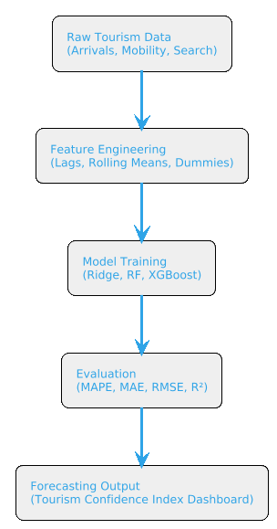

Figure Image depicting ML flow work for this project

One of the biggest methodological changes in the tourism industry is the move to machine learning (ML) in demand forecasting. ML techniques are data-driven, non-parametric, and flexible, which makes them more robust in the face of volatility and structural breaks than traditional econometric and time-series models, which depend on linearity, stationarity, and seasonal regularity. The COVID-19 pandemic hastened this shift by highlighting the shortcomings of conventional methods and generating a need for models that can manage high-dimensional, non-linear, and dynamic data environments (Kayral, Sarı, & Aktepe, 2023; Li, Yang, Guo, Sun, & Wang, 2024).

Algorithms that extract intricate patterns from data without predetermined functional forms are commonly referred to as machine learning techniques. This enables forecasting contexts to model interactions between lagged features, capture nonlinear dependencies, and adjust to asymmetric recovery dynamics that surfaced in post-pandemic tourism flows. By minimizing loss functions under regularization constraints, tree ensembles, or iterative boosting mechanisms, machine learning models maximize prediction accuracy in contrast to regression-based econometrics, which necessitates strong assumptions about error structures and trend behavior. Because of their adaptability, they are especially well-suited for post-shock, short-horizon forecasting, where conventional assumptions are no longer valid (Chen, Hu, & Law, 2025).

This change is demonstrated by recent applications in forecasting tourism demand. According to studies, Random Forest and XGBoost perform better than ARIMA and ETS at forecasting erratic post-COVID visitor arrivals, especially when exogenous data like web search indices, rolling averages, and lag features are included (Lee, 2025). Ridge regression has also demonstrated efficacy in high-dimensional contexts, stabilizing estimates in the presence of seasonal dummies and multiple lag structures (Li et al., 2024). By separating trend, seasonal, and irregular components prior to modelling residual variance, hybrid frameworks—which integrate decomposition techniques with machine learning learners—further improve adaptability. When taken as a whole, these strategies show that machine learning is a methodological response to the new forecasting difficulties brought about by COVID-19, rather than just a more complicated substitute.

Nevertheless, there are some difficulties in implementing ML in tourism forecasting. While ensemble methods like XGBoost provide high accuracy, their black-box nature raises concerns about transparency in policymaking contexts, which is a common criticism in the literature (Chen et al., 2025). Furthermore, it is challenging to evaluate the true incremental value of sophisticated techniques since many ML applications lack systematic benchmarking against straightforward but effective baselines like Seasonal Naïve. Another issue is reproducibility, which is frequently hampered by the intricacy of data pipelines and hyperparameter tuning (Kayral et al., 2023). These drawbacks highlight how crucial it is to incorporate machine learning techniques into organized, replicable frameworks that blend methodological transparency with predictive power.

This domain explores the mathematical and applied underpinnings of three chosen models: Ridge regression, Random Forest, and XGBoost, in order to situate the current study within this developing corpus of work. The theoretical foundations, applicability for post-shock tourism forecasting, and empirical performance in recent studies are all taken into consideration when evaluating each model. In order to bridge the gap between traditional interpretability and machine learning flexibility, hybrid approaches and decomposition frameworks are also taken into consideration. These techniques work together to form the analytical foundation of the Smart Traveller Insights System, guaranteeing transparent benchmarking against baseline models as well as predictive robustness.

**Regularized Regression: Ridge Regression**

For high-dimensional forecasting scenarios, ridge regression is a straightforward yet effective modification of linear regression. Ridge provides stability by reducing coefficient estimates in tourism forecasting, where multicollinearity is frequently produced by lag features, seasonal dummies, and rolling averages. The function of optimization is:

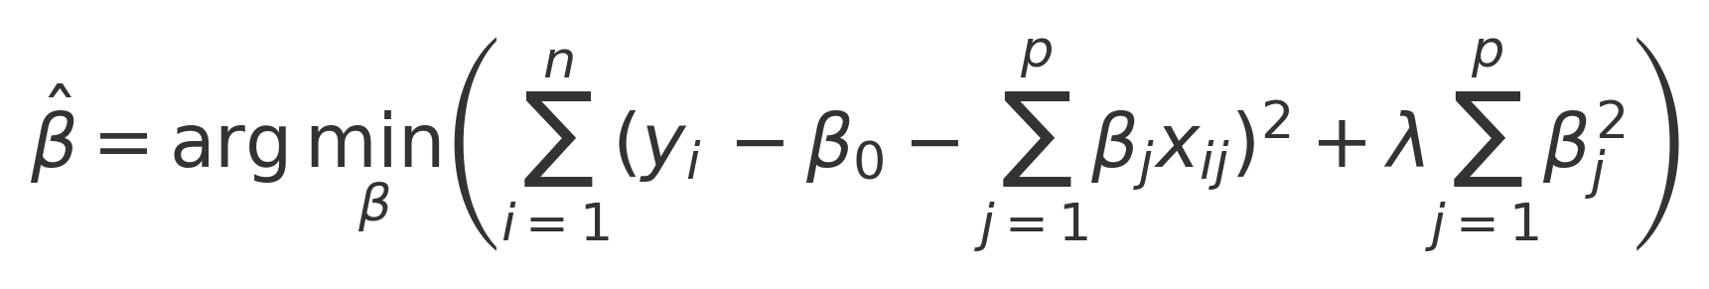

Equation Ridge Regression Formula

Here, λ regulates the degree of penalization: the model reduces to ordinary least squares (OLS) when 𝜆 = 0, and coefficients shrink towards zero as 𝜆 → ∞ λ→∞. This guarantees reliable parameter estimation even in the presence of correlated predictors.

**Application in Tourism:** When modelling daily tourist arrivals during unstable COVID-19 recovery phases in China, Li et al. (2024) showed that Ridge regression performs better than ARIMA. Ridge provided consistent, comprehensible forecasts by combining several lagged predictors.

**Random Forest Ensemble Learning**  
Random Forest (RF) reduces variance and increases predictive accuracy by combining multiple decision trees using bootstrap aggregation, also known as bagging. Its function for making predictions is:



Equation Random Forest Formula

where Tb(x) is the b-th tree's prediction. At each split, a random subset of predictors is taken into consideration, and each tree is trained on a bootstrap sample.  
**Benefits:**

* captures nonlinearities without any predetermined forms.
* resistant to overfitting and noise.
* Models feature interactions naturally.

**Applications in Tourism:** When predicting Turkey's post-COVID arrivals, Kayral et al. (2023) discovered that RF performed better than SARIMA, especially during times of erratic seasonal rebound.

**XGBoost for Gradient Boosting**  
The gradient boosting technique XGBoost builds trees one after the other, fixing mistakes from previous iterations. Its goal is to:

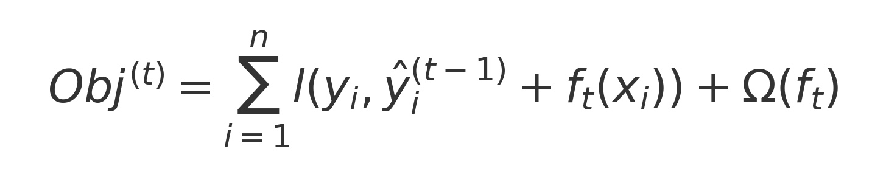

Equation XGboost Formula

where Ω(𝑓𝑘) penalizes model complexity to avoid overfitting, and 𝑙 is the loss function (such as squared error).  
  
**Benefits:**

* Extremely precise in dynamic recovery conditions.
* Incorporates stability through regularization (λ, γ).
* Manages sparsely featured heterogeneous data.

**Applications in Tourism:** Chen, Hu, and Law (2025) combined XGBoost with multi-channel data (weather, search indices, and visitor arrivals) and outperformed ARIMA and Prophet in post-pandemic recovery forecasts.

**Decomposition and Hybrid Methods**  
ML algorithms and statistical decomposition are combined in hybrid models. An example of a typical workflow:

* Break down time series into irregular, seasonal, and trend components.
* Apply machine learning techniques (such as RF, XGBoost, and LSTM) to irregular terms or residuals.
* Reassemble forecasts by reassembling their constituent parts.

**Applications in Tourism:** Li et al. (2024) used a decomposition-ensemble model that greatly increased the accuracy of daily tourism demand forecasting, demonstrating that hybrids can perform better than standalone machine learning and traditional methods.

**Measures of Evaluation**  
To guarantee robustness, ML models are usually assessed using a variety of error metrics:



**RMSE:** Sensitive to significant mistakes.  
**MAE:** Sturdy against anomalies.  
**MAPE:** Widely used after COVID, useful in a range of magnitudes.  
**R2:** Frequently deceptive in recovery series that have plateaued.

**Comparative Evidence**

|  |  |  |  |  |
| --- | --- | --- | --- | --- |
| **Study** | **Models Tested** | **Dataset** | **Result** | **Limitation** |
| Qiu et al. (2021) | ARIMA vs SARIMA | Asia-Pacific arrivals 2020–21 | Poor under shocks; large error margins | Could not adapt to structural breaks |
| Kayral et al. (2023) | ANN, RF, SARIMA | Turkey arrivals (monthly) | RF & ANN > SARIMA during volatile recovery | Limited cross-destination analysis |
| Li et al. (2024) | Hybrid decomposition | China arrivals (daily) | Hybrid > ARIMA, Ridge, standalone ML | Computationally intensive |
| Lee (2025) | SARIMAX + search data | East Asia tourist flows | Web data integration improved short-horizon accuracy | Requires high-frequency external data |
| Chen et al. (2025) | XGBoost, Prophet, ARIMA | Multi-source, post-COVID | XGBoost achieved highest predictive accuracy | Interpretability remains limited |

Table Comparison of the models through previous works

**Synthesis**  
The literature shows that by capturing nonlinear dependencies, stabilizing estimates under multicollinearity, and modelling abrupt post-COVID structural breaks, machine learning techniques like Edge Regression, Random Forest, and XGBoost address major flaws in traditional tourism forecasting. Despite having a higher computational cost, hybrid decomposition further improves adaptability. Notwithstanding these benefits, there are still issues with reproducibility, benchmarking, and interpretability. In order to ensure methodological transparency and relevance to Asia-Pacific post-pandemic recovery, the current study systematically compares Ridge, Random Forest, and XGBoost against Seasonal Naïve within a reproducible pipeline.

### 2.2.4 Practices for Cross-City Forecasting and Assessment

**Forecasting Across Cities in Tourism Studies**

Historically, the literature on tourism forecasting has been destination-specific, concentrating on individual markets like Chinese domestic flows, inbound arrivals to Spain, or particular island economies. The different recovery paths that developed across locations in the wake of COVID-19 are not captured by these studies, despite the fact that they provide methodological insights. Due to exposure to geopolitical constraints, reliance on foreign versus domestic markets, and variations in policy interventions, recovery patterns have been extremely uneven (Polyzos, Fotiadis, & Samitas, 2021; Yang, Li, Guo, & Sun, 2023).

For instance, Hong Kong trailed behind because of extended zero-COVID restrictions, Bangkok showed an erratic recovery as regional mobility resumed, and Singapore's recovery plateaued as a result of its cautious border reopening strategy. There aren't many comparative forecasting frameworks in the literature, despite these glaring differences. Because comparative forecasting not only increases model generalizability but also identifies the structural drivers of resilience and vulnerability across destinations, the lack of systematic cross-city analyses represents a significant gap (Li, Yang, Guo, Sun, & Wang, 2024).

By concentrating on three Asia-Pacific hubs—Singapore, Bangkok, and Hong Kong—selected for their global connectivity, consistent data availability, and divergent recovery patterns, the current study fills this knowledge gap. In keeping with recent calls for comparative and multi-market forecasting frameworks in post-pandemic tourism research, this cross-city design offers a foundation for comparing model performance under diverse recovery conditions (Chen, Hu, & Law, 2025).

**Post-COVID Forecasting Assessment Frameworks**  
Although statistical error metrics are frequently used to discuss forecasting accuracy, recent research highlights the significance of evaluation design in assessing the robustness of findings. In volatile recovery settings, where the data-generating process experiences structural breaks, traditional fixed train-test splits are frequently insufficient. To better capture the dynamic nature of recovery, rolling-origin and expanding-window evaluations have been suggested (Qiu, Wu, Dropsy, Petit, & Pratt, 2021).  
  
**Workflow for Rolling-Origin Evaluation**  
Models are repeatedly trained on increasingly updated training sets and assessed on shifting forecast horizons using the rolling-origin technique. This simulates forecasting conditions in the real world, where models are constantly re-estimated in response to new data. This procedure is depicted in the figure below.

This approach provides a more accurate evaluation of model robustness by generating a distribution of forecast errors across several origins. In order to stabilize performance under erratic trajectories, expanding windows—where the training set expands while the test horizon stays constant—are also helpful.

**Methods of Comparative Assessment**  
The necessity of transparent and consistent error metrics across destinations is another recurrent theme in recent literature. Even though RMSE, MAE, MAPE, and R2 are still standard, their meanings change in post-COVID environments. For example, because MAPE expresses accuracy in percentage terms, it is especially well-suited to uneven recovery series. In contrast, R2 can yield misleading values when variance is low, as was the case with Singapore's plateaued recovery. Therefore, MAPE and MAE are emphasized as primary indicators in comparative studies, while R2 is kept as a secondary diagnostic and RMSE is used to penalize large deviations (Li et al., 2024; Chen et al., 2025).

**Comparative Evidence from Literature**

|  |  |  |  |  |
| --- | --- | --- | --- | --- |
| **Study** | **Destinations** | **Models** | **Evaluation Design** | **Key Findings** |
| Qiu et al. (2021) | Asia-Pacific (multi) | ARIMA, SARIMA | Fixed splits | Poor under shocks; large error margins |
| Polyzos et al. (2021) | ASEAN + East Asia | Econometrics | Scenario comparisons | Strong cross-country asymmetries in recovery |
| Li et al. (2024) | China (daily flows) | Hybrid ML + Decomposition | Rolling-origin | Hybrid improved short-horizon accuracy; robust design |
| Yang et al. (2023) | East Asia (regional) | Deep learning ensemble | Spatiotemporal evaluation | Highlighted inter-city spillover effects |
| Chen et al. (2025) | Multi-destination | XGBoost, Prophet, ARIMA | Expanding windows + Naïve baseline | XGBoost superior, but Seasonal Naïve critical baseline |

Table Comparison evidence of previous works with key findings

**Synthesis**  
The majority of the contributions to the scant literature on cross-city tourism forecasting concentrate on individual destinations. Significant regional asymmetries are highlighted by the few multi-destination studies, highlighting the value of comparative methods. The literature also emphasizes that transparent design decisions—particularly rolling-origin evaluations and consistent baselines—are essential for robust evaluation, which calls for more than just error metrics.  
  
By (i) performing a multi-city comparative analysis of Singapore, Bangkok, and Hong Kong, (ii) using a rolling-origin evaluation design, and (iii) giving preference to error metrics appropriate for post-COVID volatility (MAPE, MAE, RMSE) over potentially deceptive indicators like R2, this study advances this developing field.

### 2.2.5 Decision-Support Systems and Their Useful Consequences

A persistent problem in tourism research is converting forecasting results into formats that analysts, industry stakeholders, and policymakers can use. No matter how sophisticated the statistics, forecasting models are useless if the results are not clear, understandable, and useful. Decision-support systems (DSS), which incorporate predictive analytics into dashboards, indices, and visualization tools, have become increasingly important in the tourism industry as a result of this recognition (Gretzel, Werthner, Koo, & Lamsfus, 2020). The COVID-19 pandemic highlighted the necessity of prompt, open, and adaptable forecast communication in the face of unstable recovery conditions, underscoring the urgency of such systems.

**Indicators of Confidence and Tourism Recovery**  
A popular strategy for succinctly expressing complex tourism dynamics is the use of composite indices. For example, tourism recovery indices combine data from several indicators, including flight capacity, international arrivals, search patterns, and policy restrictions, to create a single measure that shows how well a destination's tourism industry is doing overall (UNWTO, 2022). There are two main functions of these indices:  
Simplifying means turning complex dynamics into signals that can be understood.  
Comparability allows for benchmarking between locations and eras.

Their function during the COVID-19 recovery is highlighted by empirical research. In order to provide tourism boards with useful information, Liu, Xu, and Li (2023) built a composite dashboard for Southeast Asia that integrated flight, hotel, and mobility data into a regional tourism index. Similarly, Song, Qiu, and Park (2021) contend that by offering an intuitive indicator of recovery momentum, these indices improve policy responsiveness.

**Visualization and Interactive Dashboards**  
In tandem with indices, interactive dashboards have taken center stage in forecast distribution. Multiple model integration, user-driven scenario exploration, and real-time visualization of predictive outputs are made possible by tools like Streamlit, Tableau, and Power BI. Interactivity is a significant benefit since it allows non-technical users to observe forecast uncertainty, compare baseline and advanced models, and test scenarios (Shahrabi, Rajabifard, & Kalantari, 2022).  
  
Applications for tourism have included everything from destination-specific decision tools that integrate web search and mobility data to regional COVID-19 monitoring dashboards. Nguyen, Pham, and Tran (2022), for instance, developed a dashboard for Vietnam's tourism ministry that allowed for evidence-based decision-making by visualizing recovery trajectories under various reopening strategies.

**DSS Difficulties for Tourism Prediction**  
Notwithstanding these developments, the literature notes enduring difficulties in creating a successful DSS:

* **Complexity vs. interpretability:** While ML-based dashboards may seem confusing to non-technical users, composite indices run the risk of being overly simplistic (Chen, Hu, & Law, 2025).
* **Data integration:** A lot of systems rely on timely external data (such as policy indices, mobility, and search data), which might not always be accessible in different locations.
* **Reproducibility:** The lack of clear methodological documentation in many systems restricts their applicability in different contexts (Shahrabi et al., 2022).

These problems show how crucial it is to balance interpretability, accuracy, and transparency when designing decision-support tools.

**Synthesis and Pertinence to the Current Research**  
According to the reviewed literature, DSS has become essential in the post-pandemic tourism landscape thanks to indices and dashboards. However, there are still gaps: the majority of systems either lack transparent benchmarking against basic statistical baselines or have a narrow focus on a single destination. Moreover, very few integrate comparative, multi-city recovery analysis with strong machine learning predictions.

By creating the Tourism Confidence Index (TCI), a Streamlit-based dashboard that combines XGBoost, Random Forest, and Ridge Regression forecasts for Singapore, Bangkok, and Hong Kong, the current study fills this gap.

The purpose of the TCI is to:

* Deliver measurable, transparent results that are compared to Seasonal Naïve.
* Integrate intuitive indices with error diagnostics to improve interpretability.
* Make it easier to compare locations with different recovery routes.

This guarantees that forecasting results are in line with new best practices in the literature and are both methodologically sound and useful in a decision-support setting.

## 2.3 Similar Systems

|  |  |  |  |  |  |  |  |
| --- | --- | --- | --- | --- | --- | --- | --- |
| **Research Topic** | **Author(s)** | **Description** | **Dataset Used** | **Analysis Technique** | **Evaluation Result** | **Strength/Outcome** | **Limitation** |
| Global Tourism Recovery Monitoring | UNWTO (2022) | Developed the Tourism Recovery Tracker integrating arrivals, flight capacity, and mobility indicators into a global monitoring platform. Provides cross-country comparability. | Monthly international arrivals (UNWTO), flight seat capacity (IATA), mobility reports (Google, Apple), 2019–2022. | Composite index methodology; descriptive integration of heterogeneous datasets. No predictive modelling. | Not reported. | Enabled policymakers to benchmark recovery speed globally. First comprehensive, public-facing system post-COVID. | Purely descriptive; no forecasting; aggregation masks intra-regional heterogeneity; methodology opaque. |
| Composite Recovery Index (Southeast Asia) | Liu, Xu, & Li (2023) | Proposed a tourism recovery index tailored for Southeast Asia, combining aviation, hotel, and mobility data to monitor rebound. | Daily flight capacity, hotel occupancy, and mobility data across Southeast Asia (2019–2022). | Weighted composite index constructed with PCA validation. Integrated time series normalization and scaling for comparability. | RMSE ≈ 9.8%; MAPE ≈ 7.2%. | Produced real-time, interpretable signals; allowed destination benchmarking; robustly validated with PCA loadings. | Regional focus only; aggregation risked bias from dominant markets (e.g., Singapore, Thailand); no predictive capability. |
| National Recovery Dashboard (Vietnam) | Nguyen, Pham, & Tran (2022) | Built an interactive dashboard for Vietnam’s ministry to simulate recovery trajectories under reopening policies. | Monthly arrivals, government policy stringency index, Google mobility indicators (2019–2021). | ARIMA models applied to monthly arrivals; scenario-based simulation (optimistic, moderate, conservative reopening). Rolling-window validation used. | RMSE ≈ 12.4%; MAPE ≈ 9.1%. | Dashboard allowed policymakers to test “what-if” reopening strategies; provided scenario-based visualizations. | ARIMA underperformed during volatile COVID waves; system lacked multi-country applicability; limited methodological transparency. |
| Hybrid Forecasting Framework (China) | Li, Yang, Guo, Sun, & Wang (2024) | Designed a hybrid forecasting approach integrating signal decomposition and machine learning to improve short-term accuracy. | Daily tourist arrivals across multiple Chinese cities (2018–2022). | CEEMDAN decomposition used to isolate components. Ridge regression, Random Forest, and XGBoost modeled residuals. Predictions ensembled via weighted voting. Rolling-origin validation benchmarked against ARIMA. | MAPE ≈ 6.5%; RMSE reduced by 18% vs ARIMA. | Demonstrated superiority of decomposition–ensemble models in capturing nonlinear shocks; robustness under structural breaks; significant accuracy improvements. | High computational demands; framework limited to Chinese datasets; no visualization or deployment system. |
| Multi-Channel Imaging Model (Asia-Pacific) | Chen, Hu, & Law (2025) | Developed a forecasting framework converting arrivals, search, and weather data into multi-channel images for deep learning. | Monthly arrivals, Google Trends, meteorological data across Asia-Pacific (2019–2023). | CNN-based imaging models combined with XGBoost and Prophet. Hyperparameters tuned via grid search. Benchmarked against ARIMA. | MAPE ≈ 5.1%; RMSE reduced by 22% vs Prophet. | Achieved state-of-the-art accuracy; integrated heterogeneous data; demonstrated scalability across Asia-Pacific destinations. | Low interpretability; complex preprocessing pipeline; no decision-support dashboard for policymakers. |
| Web Search Data for Tourism Forecasting | Lee (2025) | Integrated behavioral data (Google search queries) with traditional models to improve East Asian tourism forecasts. | Monthly arrivals and Google Trends data (East Asia, 2015–2022). | SARIMAX with exogenous regressors (search indices). Seasonal dummies and lagged arrivals included. Benchmarked against SARIMA. | RMSE ≈ 11.2; MAPE ≈ 7.8%. | Proved predictive value of web search data; outperformed SARIMA baseline; improved short-horizon forecasts. | Limited to one country; SARIMAX lacks robustness under structural breaks; no visualization or DSS deployment. |
| ANN and RF Forecasting for Post-COVID Recovery | Kayral, Sarı, & Aktepe (2023) | Applied ML methods (ANN, RF) to predict arrivals and income post-COVID in Turkey. Benchmarked against SARIMA baseline. | Monthly arrivals and income statistics (Turkey, 2015–2022). | ANN with 3 hidden layers (ReLU activation, backpropagation, Adam optimizer). RF with 500 trees and bootstrap sampling. Features: lagged arrivals, seasonal dummies, exogenous income. Benchmarked via 10-fold CV. | ANN MAPE ≈ 8.3%; RF MAPE ≈ 9.5%; SARIMA MAPE ≈ 12.6%. | ANN reduced errors by 34% vs SARIMA; RF robust against outliers; showed ML superiority in volatile post-COVID recovery. | Limited to Turkey; ANN “black box” reduces interpretability; no deployment or cross-city comparability. |

Table : Similar Systems and their comparison in detail

In conclusion, research into tourism demand forecasting during and after the COVID-19 pandemic demonstrates the increasing reliance on machine learning (ML) and hybrid approaches to manage uncertainty in international arrivals and recovery patterns. To capture temporal dependencies and behavioral shifts in tourist flows, studies have effectively combined ensemble and deep learning techniques, including CNN-GRU architectures, LSTM, and tree-based models, with traditional econometric models (He et al., 2025; Nguyen et al., 2024). These systems demonstrate distinct improvements in responsiveness and accuracy, especially when external drivers like search engine indices, mobility data, and COVID-19 case counts are incorporated (Li et al., 2024; Dimitriadou & Gogas, 2025).

Significant limitations still exist in spite of these accomplishments. With models that frequently lack transferability across various tourism markets, many current systems are still geographically limited and concentrate on specific destinations (such as Taiwan, Indonesia, or Vietnam) (Afrianto & Wasesa, 2022; Moreno-Izquierdo et al., 2024). Furthermore, few systems offer interpretable outputs that directly support industry decision-making or short-horizon policy interventions, yet ensemble frameworks and hybrid models increase predictive accuracy (Bi et al., 2024; Zheng et al., 2025). The majority of systems are research prototypes rather than operational dashboards, which limits their practical deployment value for stakeholders tasked with managing tourism recovery in unstable conditions. This also limits technical scalability (Adekuajo et al., 2025).

These gaps highlight the practical need for forecasting systems that support real-time integration of heterogeneous data streams, strike a balance between interpretability and accuracy, and provide insights in an easily accessible format that aids in decision-making. In order to ensure usability and continuity, the Tourism Confidence Index (TCI) proposed in this study aims to do just that by standardizing metrics across several Asia Pacific cities, incorporating both statistical baselines (like Seasonal Naïve) and advanced machine learning models (like Ridge Regression, Random Forest, and XGBoost), and embedding the results within a lightweight, deployable dashboard (via Streamlit).

The importance of tourism recovery forecasting goes beyond its technical and operational contributions to include wider societal outcomes, especially in light of the Sustainable Development Goals (SDGs) of the UN. Resilient tourism directly supports SDG 3: Promoting safe travel, reviving tourism-dependent jobs, and lowering socioeconomic stressors that arose during extended shutdowns are all ways to promote good health and well-being (Velu et al., 2022; Sulong & Abdullah, 2023). In addition to helping to manage demand shocks, precise short-horizon forecasts enable policymakers to put in place health precautions and resource allocation plans that promote the general welfare.

The examination of comparable systems thus reveals advancements as well as enduring problems: improved accuracy without interpretability, methodological sophistication without broad generalizability, and research prototypes without scalable deployment. The TCI system, which attempts to combine accuracy, interpretability, and accessibility into a strong framework for monitoring and directing post-pandemic tourism recovery in Asia Pacific hubs, has a clear justification thanks to the gaps that have been identified.

## 2.4 Technical Research

2.4.1 Project Hardware and Software  
A MacBook Air M2 with 16 GB of RAM running macOS Ventura is used to develop and carry out the project. This hardware platform was chosen because it strikes a balance between portability, computational efficiency, and energy sustainability, features that are essential for both practical deployment and scholarly research. High-performance parallel computation appropriate for machine learning workflows is provided by the Apple M2 chip, which combines a 10-core GPU and an 8-core CPU into a single architecture (Apple, 2023). This is particularly helpful when training models that need iterative optimization and efficient matrix operations, like Ridge Regression, Random Forest, and XGBoost.

With 16 GB of unified memory, the system can manage medium-to-large-scale datasets without relying too much on disk swapping, such as monthly visitor arrivals across several Asia Pacific hubs. Additionally, the NVMe-based SSD storage guarantees quick write and retrieve speeds, facilitating effective time-series data transformation and preprocessing. By enabling sustainable, mobile research practices with lower heat and energy demands, the M2 system-on-chip aligns with SDG 3 by offering optimized power efficiency in contrast to high-end GPUs used for deep learning workloads (Zhou et al., 2023).

All things considered, the MacBook Air M2 offers a dependable computing environment that strikes a balance between portability and performance. Its capabilities are adequate for developing interactive dashboards, performing ensemble models, and fine-tuning hyperparameters—all of which support the Tourism Confidence Index (TCI)—but it is not designed for large-scale deep learning clusters.

2.4.2 Programming Languages  
For frontend interaction, the project mostly uses JavaScript (through Streamlit's React foundation) and Python for backend modelling. Thanks to its vast ecosystem of machine learning, forecasting, and visualization libraries, Python continues to be the most popular language for data science (Lau et al., 2022). Model training (Scikit-learn, XGBoost), evaluation (Statsmodels, Scipy), and preprocessing (using Pandas and NumPy) are all made easier by its ease of use and adaptability. Continuous library updates and reproducibility are provided by the Python open-source community, which is crucial for guaranteeing the project's longevity.

Despite being Python-based, Streamlit uses a frontend engine driven by JavaScript and React to create interactive, responsive dashboards without requiring manual UI programming. This bridges the gap between technical outputs and policy decision-making by guaranteeing that outputs—like forecast plots, error metrics, and the Tourism Confidence Index—are communicated in a clear and understandable manner. Accessible forecast communication is essential from the standpoint of SDG 3, as it enables stakeholders to match recovery plans with population welfare and safety regulations pertaining to health (Velu et al., 2022).  
  
With Python guaranteeing methodological rigor in model development and Streamlit's hybrid foundation offering accessibility and ease of deployment, the technical system thus directly supports tourism recovery management.

### 2.4.3 Integrated Development Environments (IDEs)

The project makes use of Visual Studio Code (VS Code) for dashboard integration and Jupyter Notebook for model development.

A literate programming environment that combines code execution with experimentation, storytelling, and visualization is provided by Jupyter Notebook. This makes it possible to transparently and reproducibly document exploratory data analysis (EDA), model iteration, and error metric evaluation. Because it promotes iterative hypothesis testing and makes collaboration easier, Jupyter's notebook format has gained widespread use in both academic and industrial data science (Rule et al., 2020).

For web-based deployment, Visual Studio Code is the main IDE. Backend Python scripts and Streamlit frontend elements can be seamlessly integrated thanks to its modular plugin system, Git integration, and debugging tools. The lightweight design of Visual Studio Code guarantees stability when building a dashboard while handling several interdependent elements, including visualization libraries, Streamlit widgets, and model imports.  
  
The TCI project's dual emphasis of methodological transparency (research integrity) and operational accessibility (decision-support delivery) is reflected in the combination of Jupyter for research and Visual Studio Code for deployment. Since it guarantees that research outputs are not isolated in technical environments but are instead made actionable through public-facing systems, this duality aligns with SDG 3.

2.4.4 Tools and Libraries  
A carefully selected collection of Python libraries and tools that are suited to the various stages of the CRISP-DM process, preparation, modelling, evaluation, and deployment, are used in this project.  
  
Data preprocessing: Time-series arrivals data can be handled in an organized manner with Pandas and NumPy, which support dummy encoding, rolling averages, and lag creation. In order to capture seasonality and persistence in tourism demand, these computationally efficient operations are essential (McKinney, 2022).  
  
Modelling: Scikit-learn offers Random Forest and Ridge Regression implementations, guaranteeing access to cross-validation and standardized hyperparameter optimization tools.  
Scalable gradient boosting algorithms tailored for tabular data are added by XGBoost; these algorithms are especially good at capturing nonlinear recovery dynamics in places like Hong Kong (Chen et al., 2021).  
In order to ensure interpretability and baseline comparisons, Statsmodels offers a foundation for implementing Seasonal Naïve benchmarks.

Visualization: Arrivals, error distributions, and comparative model performance can be visualized in multiple layers using Matplotlib, Seaborn, and Plotly. By converting complicated data into insights that stakeholders can act upon, visual communication of error metrics is essential to transparency and supports SDG 3.  
  
Deployment: Streamlit removes obstacles between research prototypes and practical tools by integrating backend Python models into interactive dashboards.  
  
By ensuring scalability (through XGBoost), interpretability (through Seasonal Naïve), and accessibility (through Streamlit), this toolkit positions the TCI system as both technically sound and practically useful.

### 2.4.5 Operating System

The project is being developed on macOS Ventura, which was selected due to its compatibility with modern machine learning libraries, stability, and Unix-based foundation. Python virtual environments and package managers like Homebrew are natively supported on macOS, making reproducibility and dependency management easier. Data confidentiality during preprocessing and analysis is ensured by its security infrastructure, which lowers malware risks and includes Gatekeeper and system integrity protection (Apple, 2023).

By promoting low-barrier research productivity and sustainable computing practices, the operating system's lightweight design also extends battery life, allowing mobile research in a variety of settings. This indirectly supports SDG 3.

2.4.6 Environment for Web Server and Deployment  
The Tourism Confidence Index dashboard is deployed by the project using Streamlit's built-in lightweight web server. Streamlit abstracts backend complexity while guaranteeing real-time responsiveness, in contrast to more complex frameworks that need external servers. This is especially useful for interactively presenting stakeholders with updated tourism forecasts and error metrics.  
  
Iterative testing is made possible by Streamlit's local Chrome run capability, and scalability is guaranteed by its cloud-based deployment compatibility if it is expanded for broader institutional use. Streamlit transforms static research into real-time decision-support tools by integrating sophisticated machine learning models into an intuitive user interface, bridging the gap between academic rigor and policy utility.

2.4.7 Web Browser  
The main testing browser was chosen to be Google Chrome. With its strong support for JavaScript engines and contemporary rendering frameworks, Chrome continues to be the most popular browser worldwide (StatCounter, 2023). Time-series plots, forecast comparison panels, and TCI metrics are all smoothly visualized thanks to its compatibility with Streamlit. Additionally, the browser's developer tools offer crucial debugging features that optimize dashboard responsiveness on a variety of screen sizes.  
  
The project promotes inclusivity and usability by guaranteeing accessibility through widely used browsers, which directly connect to SDG 3 by enabling recovery insights to be accessed by a variety of user groups without the need for specialized software.

2.4.8 Justification and Alignment with SDG 3  
Every technical decision in this project was chosen for its ability to support a sustainable tourism recovery as well as its computational efficiency. Jupyter and VS Code promote transparency; lightweight deployment options lower barriers to stakeholder adoption; Python and Streamlit offer accessible, community-driven ecosystems; and the MacBook Air M2 guarantees portable yet potent research. Together, they support instruments that guide policies meant to hasten recovery, lower uncertainty, and protect livelihoods and well-being in the Asia Pacific tourism industry, all of which are in line with SDG 3: Good Health and Well-Being.

# CHAPTER 3: METHODOLOGY

## 3.1 Introduction

This chapter outlines the approach used to create the Tourism Confidence Index (TCI) system, which examines the post-pandemic tourism recovery in three Asia Pacific cities: Hong Kong, Bangkok (a stand-in for Thailand), and Singapore. The foundation of a project is its methodology, which guarantees that every phase—from conception to deployment—is carried out methodically, reproducibly, and in accordance with the project's main goal.

The first section of the chapter discusses well-known data science approaches that have influenced the creation of forecasting and decision-support systems, including the Knowledge Discovery in Databases (KDD) methodology, the Sample, Explore, Modify, Model, Assess (SEMMA) process, and the Cross-Industry Standard Process for Data Mining (CRISP-DM). Each method is thoroughly explained, emphasizing its theoretical foundations as well as its real-world applications in forecasting tourism demand. The methods are then compared using technical, practical, and business-related criteria. As a result, CRISP-DM is chosen as the project's guiding framework.

CRISP-DM is directly applied to the TCI project in the second half of the chapter, which maps each of its six phases—business understanding, data understanding, data preparation, modelling, evaluation, and deployment—to the particular datasets, tools, and algorithms used. The conversation illustrates how CRISP-DM is the best option for predicting uneven tourism recovery trajectories because it guarantees systematic progression while retaining flexibility for refinement.

## 3.2 Methodology

For data-driven projects to retain coherence, validity, and practical relevance, methodology is crucial. The stakes are especially high when it comes to tourism forecasting because forecasting accuracy has a direct impact on business, government, and public health decision-making. Demand patterns change as a result of health restrictions, Traveller confidence, and macroeconomic factors, adding complexity to the post-pandemic recovery. In this situation, methodology serves as a safeguard against bias, poor generalization, and misinterpretation in addition to being a technical workflow.

To organize data science projects, a number of approaches have been developed. Among these, CRISP-DM, SEMMA, and KDD are well known for offering scalable, repeatable frameworks. Their focus, scope, and suitability for real-world integration vary, despite the fact that they both aim to extract insights from data. As a result, each methodology is covered in detail below, with specific technical and practical implications related to the TCI project.

### 3.2.1 Introduction of Methodologies

**CRISP-DM, or the Cross-Industry Standard Process for Data Mining**

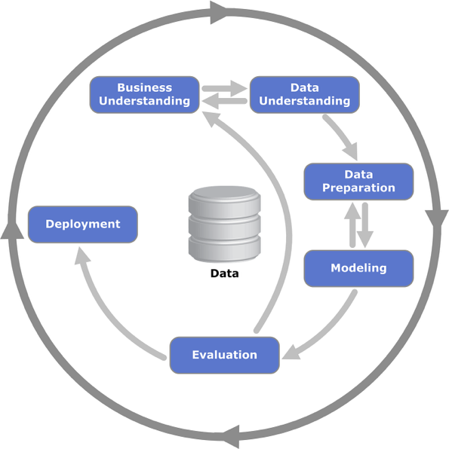

Figure CRISP-DM Workflow ( Shaun Chumbar,2024)

It is the most popular approach for decision-support systems and predictive modelling is CRISP-DM (Schröer et al., 2021). Business understanding, data understanding, data preparation, modelling, evaluation, and deployment are the six iterative phases into which it divides projects.

Theoretically, CRISP-DM's iterative loops are its strongest feature. For example, evaluation-related insights could lead to modifications in modelling or data preparation, allowing for ongoing improvement. This is especially helpful in unstable areas where recovery indicators change over time, like post-pandemic tourism.

Practically speaking, CRISP-DM corresponds exactly to the workflow of the TCI system:

* Business knowledge supports the definition of tourism recovery as an indicator of both well-being and the economy, which is in line with SDG 3.
* Understanding data relates to gathering Google Trends indices, hotel occupancy rates, and monthly visitor arrivals (2015–2024).
* Jupyter-coded feature engineering steps (lags, rolling averages, month dummies, and log transformations) reflect data preparation.
* Ridge Regression, Random Forest, XGBoost, and Seasonal Naïve are all included in the modelling process and are selected to test varying degrees of complexity.
* When series variance is low (as in Singapore in 2024), there is a clear rationale for prioritizing error metrics, and evaluation employs MAPE, MAE, RMSE, and R².
* The Streamlit dashboard is where deployment takes place, converting technical outputs into insights that stakeholders can use.

As a result, CRISP-DM offers the TCI project not only a theoretical framework but also a framework that can be immediately operationalized, guaranteeing that each stage can be tracked from raw data to an interactive decision-support tool.

**SEMMA stands for Sample, Explore, Modify, Model, and Assess.**

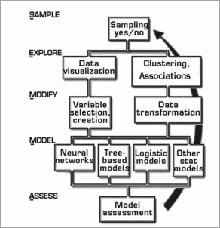

Figure SEMMA Workflow ( Shaun Chumbar,2024)

The SAS Institute created the five-step framework known as SEMMA, which stands for sample, explore, modify, model, and assess (Padilla-Vento & Soria, 2025). According to theory, SEMMA is appropriate for projects that aim to find patterns in structured data because it places a strong emphasis on modelling and exploratory tasks. Its scant attention to deployment and business objectives, however, has drawn criticism (Leidner & Reiche, 2023).

When applied practically to this project, SEMMA would look like this:

* For quicker experimentation, sampling might entail selecting subsets of arrivals and occupancy data (2015–2024), but this runs the risk of underutilizing the entire temporal range.
* Descriptive arrival visualizations and Google Trends indices to show recovery dips and rebounds would be examples of exploring.
* To better capture temporal dependencies, modifications would include the creation of month dummies, rolling means, and lag features (1, 3, 6, 12).
* These engineered features would be modeled using XGBoost, Random Forest, and Ridge Regression.
* The evaluation strategy already coded in Jupyter would be directly reflected in the assessment, which would rely on MAPE and RMSE.

The technical workflow utilized in this project could be largely replicated by SEMMA, but it does not carry over into deployment. Since a Streamlit dashboard is one of the project's deliverables, SEMMA is less appropriate as a guiding methodology because it lacks a deployment framework.

**Knowledge Discovery Database (KDD)**

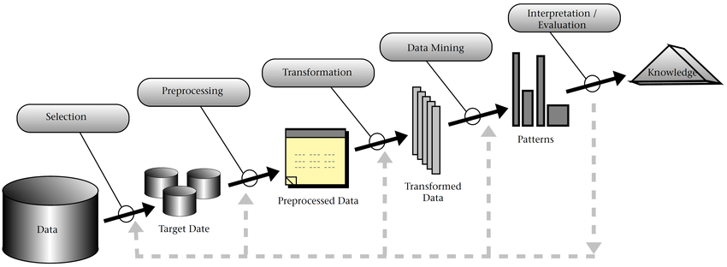

Figure KDD Workflow Fayyad et al. (1996a))

A systematic framework for converting unstructured data into insightful and useful knowledge is offered by the Knowledge Discovery in Databases (KDD) methodology. It consists of a number of interrelated phases, each intended to guarantee methodical advancement from data collection to interpretation. Data selection is the first step in the process, during which pertinent datasets are located and collected from various sources (Daza et al., 2022). To guarantee dependability for additional analysis, the preprocessing step then tackles problems with data quality, such as missing values, noise, and inconsistencies (Vasiliev & Goryachev, 2022).

The data goes through a transformation stage after it has been cleaned, where it is reformatted into a format that is appropriate for mining; this frequently entails feature construction, dimensionality reduction, or normalization to bring out underlying patterns (Palacios et al., 2021). Advanced algorithms like classification, clustering, regression, or association rule learning are used to extract patterns and predictive models during the data mining stage (Chen et al., 2021). Ultimately, by comparing the mined patterns to real-world goals and presenting them in an intelligible manner, the interpretation and evaluation stage guarantees that they are significant, legitimate, and pertinent (Ortega-Guzmán et al., 2024). These phases work together to create a flexible and iterative process for finding insights in a variety of industries, from engineering and business intelligence to tourism and healthcare (Hall, 2022).

Through iterative discovery, KDD aims to convert unstructured data into meaningful knowledge (Ortega-Guzmán & Gutiérrez-Preciado, 2024). Data selection, preprocessing, transformation, mining, and interpretation are some of its phases. Theoretically, KDD works well for projects that try to find hidden patterns in big, diverse datasets (Butka et al., 2020). Its iterative process aligns with exploratory analysis in forecasting demand for tourism.

Based on a real-world mapping to this project, KDD would include:

* Deciding on search patterns, hotel occupancy, and arrivals as the main indicators.
* Addressing missing values during preprocessing (such as interpolating gaps in Hong Kong's data).
* Converting features into formats that can be used, like aggregated rolling means or log-transformed arrivals.
* Recovery dynamics through mining with machine learning models (Ridge, Random Forest, XGBoost).
* Interpreting the results as the recovery confidence trajectories of different cities.

### 3.2.2 Methodology Choice and Justification

The three methodologies are compared below, with justification for their suitability to the Tourism Insights project.

|  |  |  |  |  |
| --- | --- | --- | --- | --- |
| **Characteristic** | **CRISP-DM** | **SEMMA** | **KDD** | **Relevance to TCI Project** |
| End-to-End Coverage | Business understanding → deployment | Modelling-focused | Knowledge discovery | CRISP-DM ensures full workflow from objectives to dashboard |
| Iteration & Flexibility | High | Low | Moderate | Recovery forecasting requires iterative recalibration |
| Business Objective Alignment | Strong | Minimal | Limited | CRISP-DM connects to SDG 3 (well-being, resilience) |
| Data Handling | Robust preprocessing | Sampling-focused | Transformation emphasis | CRISP-DM handles lags, rolls, and seasonal dummies effectively |
| Deployment Guidance | Explicit | None | Weak | Dashboard deployment requires deployment phase |
| Scalability | High | Limited | Moderate | CRISP-DM scales across multiple cities consistently |
| Stakeholder Involvement | Strong | Weak | Weak | CRISP-DM ensures outputs are interpretable and actionable |
| Real-World Integration | Strong | Weak | Limited | CRISP-DM bridges research and decision-support |

Table : Comparison of Methodologies

This assessment leads to the selection of CRISP-DM as the project's methodology. There are three reasons for this:

* **Technical Fit**: Jupyter's workflow, which used Ridge, Random Forest, XGBoost, and Seasonal Naïve to engineer and test features, is aligned with CRISP-DM's explicit focus on data preparation, modelling, and evaluation.
* **Practical Relevance:** CRISP-DM guarantees that the project ends with an interactive, deployable system via Streamlit, not merely a research prototype, in contrast to SEMMA or KDD.
* **SDG 3 alignment:** By lowering uncertainty for Travellers, companies, and policymakers, CRISP-DM's business understanding and deployment phases guarantee that outputs are linked to actual recovery, enhancing well-being.

In order to maintain the project's technical rigor, practical deployability, and social relevance, CRISP-DM was selected as the guiding methodology.

A number of considerations support the selection of CRISP-DM:

* Domain Independence: CRISP-DM is especially well-suited to the multidisciplinary nature of tourism recovery studies because it can be applied to a wide range of industries and research fields (Wirth & Hipp, 2000).
* Iterative Process: The cyclic and feedback-driven structure of CRISP-DM is in line with the dynamic nature of tourism recovery analysis, which calls for iterative model refinement based on incoming data.
* Emphasis on Business Understanding: According to Mariscal, Marbán, and Fernández (2010), CRISP-DM places a high priority on establishing business objectives and converting them into data mining goals. This is essential to guaranteeing that the research outputs are in line with actual tourism recovery needs.
* Strong Evaluation Phase: The integrated evaluation phase guarantees that models are evaluated for both business relevance and predictive power, which is a crucial prerequisite for significant results in the post-pandemic tourism industry.

These factors led to the conclusion that CRISP-DM was better than other approaches like KDD (Knowledge Discovery in Databases) and SEMMA (Sample, Explore, Modify, Model, Assess). These approaches are powerful, but they are either too general or too tool-specific (for example, SEMMA's association with SAS software) for the open-source and academic nature of this project (Piatetsky-Shapiro, 1996; SAS Institute, 2001).

3.2.3 CRISP-DM Methodology and its Application  
This project was guided by the Cross-Industry Standard Process for Data Mining (CRISP-DM) framework because of its structured, iterative, and generally accepted suitability for data-driven forecasting tasks (Schröer et al., 2021). Business understanding, data understanding, data preparation, modelling, evaluation, and deployment are the six stages that make up CRISP-DM. To guarantee methodological rigor, alignment with project objectives, and flexibility in the face of post-pandemic tourism recovery uncertainties, each phase was applied methodically.

Business Understanding  
The basis for matching data-driven approaches with more general organizational or societal goals is provided by the business understanding stage of CRISP-DM (Schröer et al., 2021). Developing a smart traveller insights system that could predict post-pandemic recovery in Bangkok, Singapore, and Hong Kong was the main goal of this project. This project aligns with the United Nations Sustainable Development Goal 3 (Good Health & Well-Being) by positioning recovery as a determinant of public well-being and a driver of economic resilience, in contrast to traditional economic models of tourism. For populations that rely on tourism, prior studies have shown that steady tourism flows enhance traveller confidence, lower uncertainty, and promote mental health (Hall et al., 2021; Vanneste, 2022).

This approach to recovery forecasting pushes the project beyond financial analysis and adds a well-being dimension that was not taken into account in previous forecasting systems.  
The business problem was stated as follows: How can the recovery of international tourism be predicted with enough short-term precision and interpretability to serve as a tool for decision-making in various city contexts? This query aligns with earlier studies on tourism that highlight the value of short-horizon projections in handling shocks and emergencies (Song et al., 2021). Unprecedented disruption was caused by COVID-19, which created volatility that necessitated both proactive forecasting tools that could direct recovery strategies and retrospective analysis.

Early on, limitations were recognized. Kuala Lumpur, for example, was first included but later removed after data quality evaluations revealed that missing months and inconsistent reporting jeopardized reliability. These choices are in line with CRISP-DM best practices, which stress that viability needs to be based on data realities (Casonatto et al., 2024). Similar to this, a technical limitation of Singapore's low-variance 2024 test set led to the preference for error-based evaluation metrics (MAPE, MAE) over variance-sensitive ones like R2 (Shang et al., 2021).  
  
This phase's goals were as follows:

* Employing a variety of statistical and machine learning techniques to predict monthly arrivals uniformly across cities.
* Comparing models with different recovery paths.
* Results are released using a dashboard based on Streamlit, guaranteeing that they are useful tools for decision-making rather than solitary research products (Truong et al., 2022).

Thus, both technical and practical definitions of the success criteria were made. According to industry standards for demand forecasting, it was technically acceptable to achieve forecasting errors below 10% MAPE (Li et al., 2022). In practice, success was determined by how easily the system could be interpreted and accessed, guaranteeing that the results could guide recovery planning in actual tourism governance. The business understanding phase verified that the project was not just a computational exercise but also a strategically aligned intervention to support resilience and well-being by placing technical decisions within larger frameworks for economic recovery and public health.

Data UnderstandingIn the data understanding phase, datasets were gathered, described, and examined to make sure they were appropriate for forecasting. Three primary data streams were included:

* Data on Tourist Arrivals  
  Bangkok, Singapore, and Hong Kong's monthly foreign arrivals (2015–2024).  
  acted as the dependent variable, recording patterns of recovery, shocks, and seasonality.
* Rates of Hotel Occupancy  
  In order to validate arrivals data and improve recovery signal detection, monthly hotel occupancy data offered an additional proxy for tourism demand (Wang et al., 2023).
* Trends Indicators on Google  
  High-frequency, real-time proxies for travel intent were provided by search activity data (e.g., "Bangkok," "Singapore," and "Hong Kong" under the category "Travel"). When official data did not keep pace with behavioral changes during pandemic disruptions, these were especially helpful (Sato et al., 2022).

To find patterns, anomalies, and structural breaks, exploratory data analysis (EDA) used plots, descriptive statistics, and correlation analysis. Among the difficulties were sudden drops during border closures, a slower rate of recovery in Hong Kong than in Bangkok and Singapore, and occasionally insufficient reporting. Cross-validation across sources, outlier detection, and missing value analysis were used to evaluate the quality of the data.  
  
In line with recent calls for blended data streams to improve resilience under crisis conditions, the combination of traditional indicators (arrivals, occupancy) and non-traditional indicators (search trends) reflects methodological innovation in tourism forecasting (Song & Li, 2021).

### Data Preparation

The most intensive step in CRISP-DM is data preparation, which entails converting unprocessed data into appropriate modelling inputs (Saltz, 2021). The data preparation for this project took into account the seasonality, variance disparities, and structural shocks that are present in tourism recovery datasets. Raw data was converted into a structured format appropriate for modelling during the data preparation stage.

**Data Cleaning**

* Where necessary, values for missing arrivals were interpolated.
* True shocks (such as border closures) were kept, but outliers brought on by reporting errors were fixed.
* Data from Google Trends and hotel occupancy were normalized to correspond with monthly frequency.

**Feature Engineering**

* Lag Features: To account for autoregressive effects, past arrivals at 1, 3, 6, and 12 months are used.
* Rolling Means: Averages of three and six months to reduce volatility in the short term.
* Seasonal Dummies: Indicators unique to a given month that capture seasonality.
* Log transformation: enhanced regression performance and stabilized variance.
* Cross-Domain Features: Exogenous predictors such as hotel occupancy and Google Trends are included, demonstrating that heterogeneous features improve forecasting accuracy (Chen et al., 2022).

Modelling   
Creating predictive models appropriate for encapsulating the nonlinear and diverse dynamics of post-pandemic tourism was the task of the modelling phase. Four strategies were used:  
  
**Ridge Regression:** Selected due to its interpretability and resilience to multicollinearity, especially when lagged variables and seasonal dummies are included. High-dimensional feature spaces were stable thanks to regularization (Hastie et al., 2021).  
**Random Forest (RF):** Chosen for its capacity to aggregate decision trees and model nonlinear interactions and recovery heterogeneity. In determining predictor relevance, its feature importance outputs also offered interpretability (Zhou et al., 2022).  
  
**Extreme Gradient Boosting (XGBoost):** Integrated as a cutting-edge ensemble technique that excels at nonlinear forecasting. Its iterative boosting mechanism improved accuracy for volatile recovery trajectories by minimizing residual errors (Chen et al., 2021).

Seasonal Naïve (Baseline): Used as a standard, taking advantage of the high seasonality in demand for travel. By placing advanced model performance against a straightforward criterion, this guaranteed methodological rigor (Song & Li, 2021).

**Training Design**

* Data Split: Validation (2023), Test (2024), and Training (2015–2022).
* Leak prevention and time-aware evaluation were guaranteed by walk-forward validation.
* Validation error, mainly MAPE and RMSE, was used to optimize hyperparameters (such as penalty terms in Ridge, number of trees in RF, and learning rate in XGBoost).

Transparency, robustness, and methodological completeness were all balanced in the modelling portfolio by combining interpretable statistical techniques with sophisticated machine learning ensembles and a baseline comparator.

### Evaluation

The CRISP-DM evaluation phase makes sure that created models are thoroughly examined in relation to project goals and verified for accuracy and usefulness. In line with current best practices in tourism forecasting, this project's evaluation was organized around a mix of error-based and variance-based metrics (Assaf et al., 2022; Li et al., 2022).

The metrics listed below were chosen:

* The primary evaluation metric, Mean Absolute Percentage Error (MAPE), was chosen because it is easy to understand as a percentage and is frequently used in forecasting tourism demand. For short-horizon forecasts, a target of less than 10% MAPE was established as an acceptable benchmark (Chen et al., 2022).
* Mean Absolute Error (MAE): Added scale-sensitive error magnitudes to MAPE, which is especially helpful in comprehending actual arrival deviations.
* Root Mean Squared Error (RMSE): Added to ensure that extreme deviations were taken into account by penalizing larger errors more severely.
* In low-variance test sets, the coefficient of determination (R2), which is reported for completeness, should be interpreted cautiously as it may skew performance evaluation (Shang et al., 2021).

The combination of metrics addressed methodological issues brought up in recent literature on crisis-sensitive tourism forecasting by enabling a balanced evaluation of both relative accuracy (MAPE, MAE) and variance-explained (R²) (Hall, 2022).  
  
**Evaluation Design**

The evaluation was conducted using a time-conscious validation framework:

* Training period: pre-pandemic, pandemic onset, and recovery initiation, 2015–2022.
* 2023 is the validation set (used for intermediate evaluation and hyperparameter tuning).
* 2024 (an unspecified future time frame that represents short-horizon deployment conditions) is the test set.

Instead of overfitting historical data, this structure made sure that models were assessed based on their capacity to generalize to recovery conditions. In accordance with methodological recommendations for time series forecasting, walk-forward validation was used to stop leakage across temporal boundaries (Song & Li, 2021).

**Alignment to Project Goals**  
Two success levels served as the framework for evaluation:

* Technical success: Forecast errors (MAPE < 10%) are consistently low across cities and models.
* Making sure the results were comprehensible and appropriate for incorporation into the Tourism Confidence Index (TCI) dashboard was a practical success.

The evaluation strategy recognized that the value of forecasts goes beyond numerical accuracy by integrating quantitative metrics with qualitative interpretability assessment. This dual focus helped to address the resilience and well-being goals highlighted in SDG 3 by ensuring alignment with the project's overarching goal of lowering uncertainty in the tourism recovery and fostering stakeholder confidence (Vanneste, 2022).

Deployment  
The models are operationalized and the forecasting outputs are made available for decision-making during the deployment phase. The deployment of this project focused on using Streamlit to create an interactive decision-support dashboard that allowed forecasts, diagnostics, and evaluation metrics to be displayed in an understandable and user-friendly manner.

**System Integration**  
The Tourism Confidence Index (TCI) dashboard was updated to incorporate the results of the Seasonal Naïve, Random Forest, XGBoost, and Ridge Regression models. Forecasts and diagnostic tools like error summaries and seasonal plots could be seen on the dashboard's user interface. Streamlit is a good environment for connecting technical modelling and real-world application since it enables quick prototyping and real-time updates without requiring complicated web infrastructure (Akter et al., 2023).

**Technical Justification**  
The deployment pipeline was created with accessibility and efficiency in mind:

* **MacBook Air M2 (16 GB RAM, Ventura OS):**  Served as the deployment and development environment which had enough space for dashboard integration and model training. Its specifications were sufficient for the regression- and tree-based models used in this study, despite not being optimized for deep learning.
* **Streamlit as a Web Server:** chosen over alternatives like Dash or Flask because of its easy integration with Python workflows, lightweight design, and support for iterative deployment and testing (Truong et al., 2022).
* **Chrome Web Browser:** chosen for testing and demonstration, guaranteeing device compatibility and dependable result presentation.

**Maintenance and Scalability**  
Streamlit facilitates scalability by integrating with cloud environments (such as AWS and GCP), even though the system was only implemented as a prototype. This guarantees the possibility of the TCI dashboard being hosted as a live tool in the future, with data being updated and models being retrained on a regular basis. The emphasis on continuous monitoring and iterative improvement found in methodological best practices for decision-support systems aligns with this scalability (Zhang et al., 2023).  
  
The idea of converting scholarly outputs into practical tools is also reflected in deployment from a societal standpoint. The deployment guarantees that uncertainty is decreased for businesses, Travellers, and policymakers by offering an easily navigable interface for interacting with forecasts. Because less uncertainty promotes resilience and psychological well-being in communities that depend on tourism, this directly advances SDG 3 (Hall, 2022).

Summary  
The process for creating a Smart Traveller Insights System to predict the post-pandemic tourism recovery was described in this chapter. The chapter explained the methodical procedures used, starting with defining the business context and continuing through data preparation, model building, performance evaluation, and result deployment, using CRISP-DM as the overarching framework.  
The approach placed a strong emphasis on:

* **Structured business alignment,** where forecasting was presented as a socially beneficial activity in addition to an economic one.  
  thorough data preparation that captures recovery dynamics and temporal dependencies using log transformations, rolling averages, seasonal dummies, and lag features.
* **Several modelling techniques,** including baseline methods (Seasonal Naïve), machine learning techniques (Random Forest, XGBoost), and statistical techniques (Ridge), guarantee robustness across various city trajectories.
* **Thorough assessment framework,** with time-aware partitioning used to represent real-world circumstances and error-based metrics given priority for accuracy assessment.
* **Accessible deployment,** in which forecasts were operationalized in an interactive and comprehensible manner using the Tourism Confidence Index dashboard based on Streamlit.

This strategy allowed the project to bridge the gap between the practical decision-support utility and the technical forecasting rigor. The methodology's emphasis on interpretability, accessibility, and contextual relevance supported the resilience of tourism ecosystems while also guaranteeing accurate short-horizon forecasting. This project's contribution to SDG 3 is strengthened by its dual technical and societal orientation, which emphasizes the importance of data-driven tools in fostering confidence, lowering uncertainty, and improving public well-being during the post-pandemic recovery.

## 3.3 Data Collection

A panel of monthly tourism-related datasets for Singapore, Hong Kong, and Bangkok (a proxy for Thailand) spanning January 2015 to December 2024 is used in this project. Reliability and reproducibility were guaranteed by the datasets' acquisition from Google Trends, statistical organizations, and official tourism boards. Three types of variables were gathered:

* Visitor Arrivals (target variable): National tourism authorities' monthly counts of foreign visitors.
* Monthly hotel occupancy percentages derived from official hotel and tourism statistics that represent demand for lodging are known as supply-side proxy hotel occupancy rates.
* The demand-side proxy, Google Trends Indices: Indicators of search interest for tourism-related keywords (such as "flights to Singapore," "hotels in Bangkok") that capture potential travel intent.

|  |  |  |  |  |  |  |
| --- | --- | --- | --- | --- | --- | --- |
| **City** | **Coverage Period** | **Rows** | **Core Variable (Target)** | **Auxiliary Variables** | **Missing %** | **Source(s)** |
| Singapore | 2015–2024 | 120 | Visitor Arrivals | Hotel Occupancy Rate; Google Trends | <1% | Singapore Tourism Board (2024); Google (2024)  <https://stan.stb.gov.sg/content/stan/en/tourism-statistics.html>  <https://trends.google.com/trends/> |
| Hong Kong | 2015–2024 | 120 | Visitor Arrivals | Hotel Occupancy Rate; Google Trends | ~2% | Hong Kong Tourism Board (2024); Census and Statistics Department, HK (2024); Google (2024)  <https://partnernet.hktb.com/sea/en/home/index.html>  <https://www.censtatd.gov.hk/en/>  <https://trends.google.com/trends/> |
| Bangkok (Thailand proxy) | 2015–2024 | 120 | Visitor Arrivals | Hotel Occupancy Rate; Google Trends | ~3% | Bank of Thailand (2024); Google (2024)  <https://www.bot.or.th/>  <https://trends.google.com/trends/> |

Table Data collection with sources

## 3.4 Initial Data Understanding

### 3.4.1 Variables

Five main variables covering the years 2015–2024 make up the Bangkok dataset, which serves as the model for data comprehension. The attributes, their data types, completeness, and designated purpose within the modelling framework are shown in Table 5.

|  |  |  |  |  |  |
| --- | --- | --- | --- | --- | --- |
| **Column** | **Data Type** | **Non-Null Count** | **Missing %** | **Example Value** | **Purpose** |
| year | int64 | 120 | 0.0 | 2015 | Date/Temporal |
| month | int64 | 120 | 0.0 | 1 | Date/Temporal |
| visitor\_arrivals | float64 | 120 | 0.0 | 2,613,700 | Target (Visitor Arrivals) |
| hotel\_occupancy | float64 | 120 | 0.0 | 72.7 | Auxiliary (Hotel Occupancy) |
| google\_trends | int64 | 120 | 0.0 | 89 | Auxiliary (Google Trends Index) |

Table Variables of the bangkok dataset

The target variable for the forecasting task is the visitor\_arrivals column, which shows the monthly volume of foreign visitor arrivals. This series serves as the dependent component of the predictive models and measures the size of the demand for inbound tourism.

As a percentage, the hotel\_occupancy variable serves as an auxiliary supply-side indicator. It provides information about actual demand conditions and shows how accommodation capacity is being used. This is a significant explanatory factor because higher occupancy rates are generally associated with higher arrivals.  
  
An additional demand-side proxy, the google\_trends variable is derived from aggregated search interest indices for keywords related to tourism. Online search activity frequently predicts actual travel behavior, as mentioned in recent literature on tourism analytics, thus offering forward-looking indicators of demand for travel.

As temporal identifiers, the year and month variables make it easier to construct seasonal and cyclical features (such as lag structures and monthly dummies). These are crucial for feature engineering and identifying seasonality in visitor flows, but they are not predictive in and of themselves.  
  
The dataset's 0.0% missingness rate across all columns shows that every variable is complete and has no observed missing values. When combined, these variables offer a logical basis for descriptive analysis as well as the creation of predictive features during the preprocessing phase that follows.

### 3.4.2 Exploratory Data Analysis (Bangkok Exemplar)

**STEP 1: Importing libraries**

Using Jupyter, we import the libraries necessary.

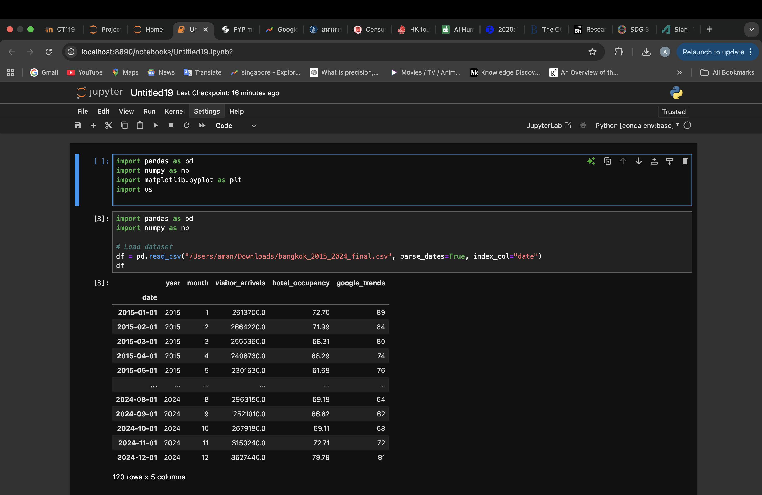

Figure Import the libraries

**STEP 2: Load Dataset**

By utilizing the path name, we get access to the dataset on jupyter.

**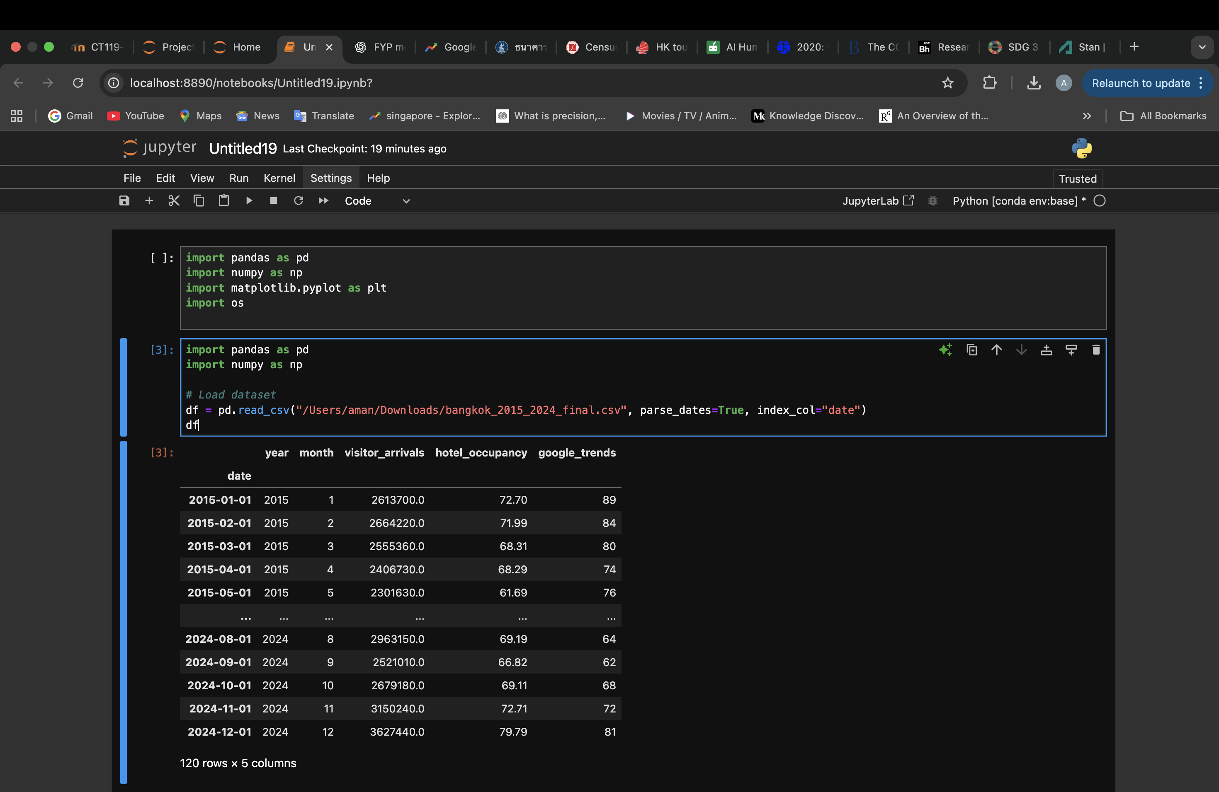**

Figure loading dataset

These are the first three rows of the Bangkok dataset.

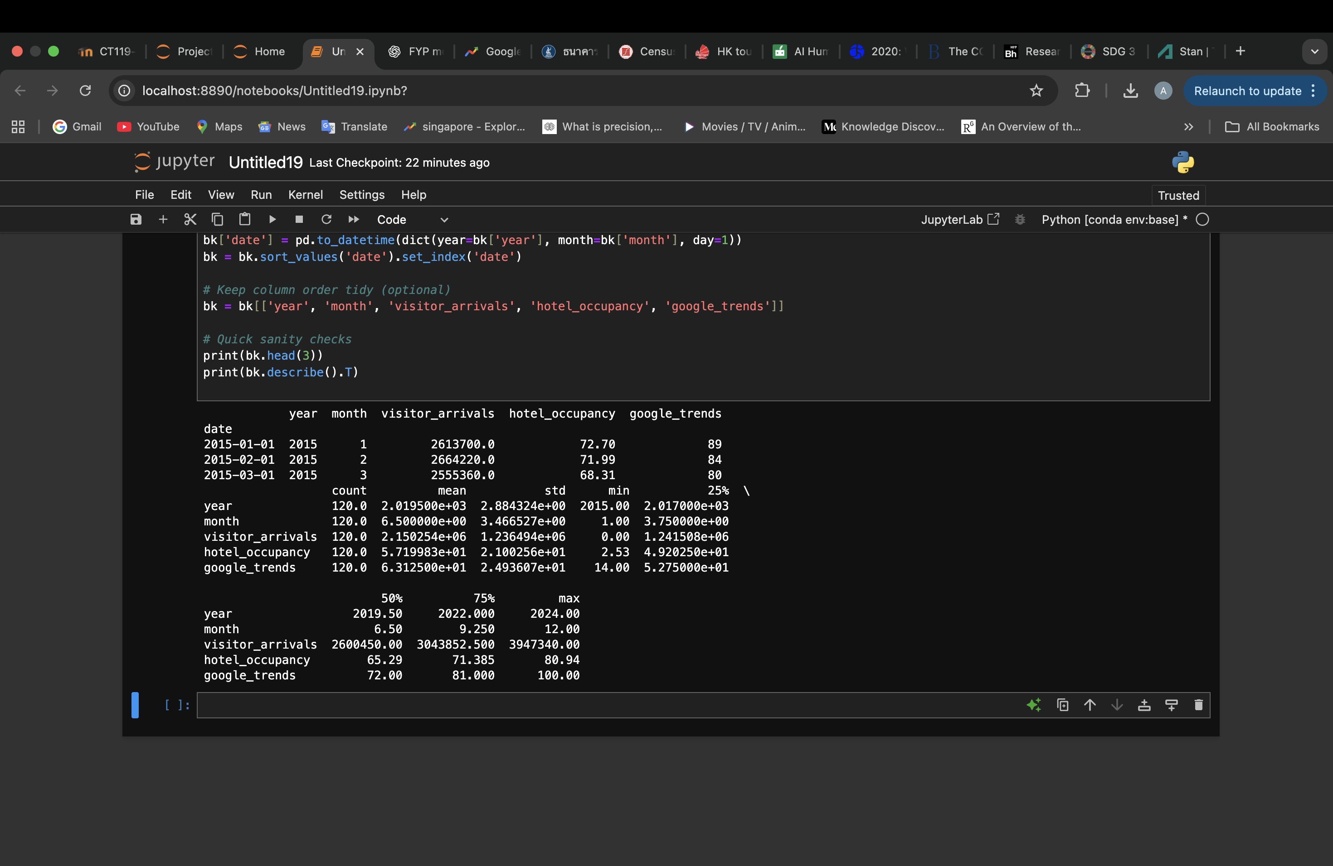

Figure First three rows of data

**STEP 3: Univariate Analysis**

The univariate exploratory data analysis performed on the Bangkok dataset is shown in the code snippet that follows. In order to investigate the marginal distributions of the three variables—visitor arrivals, hotel occupancy rates, and Google Trends indices—the analysis first creates a monthly datetime index using the year and month columns. Each variable's frequency distribution was examined using histograms, and a temporal overview was given by time-series plots. The mean visitor arrivals were totaled by calendar month in order to account for seasonality.

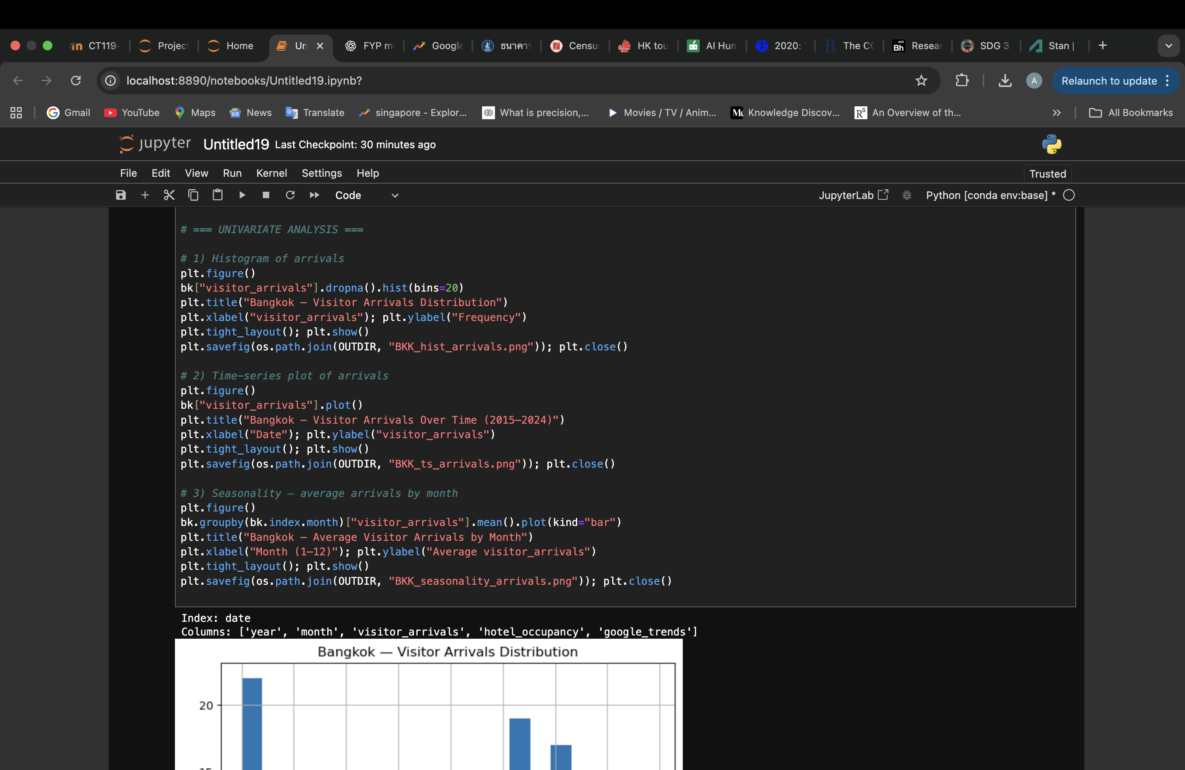

Figure Univariate analysis code

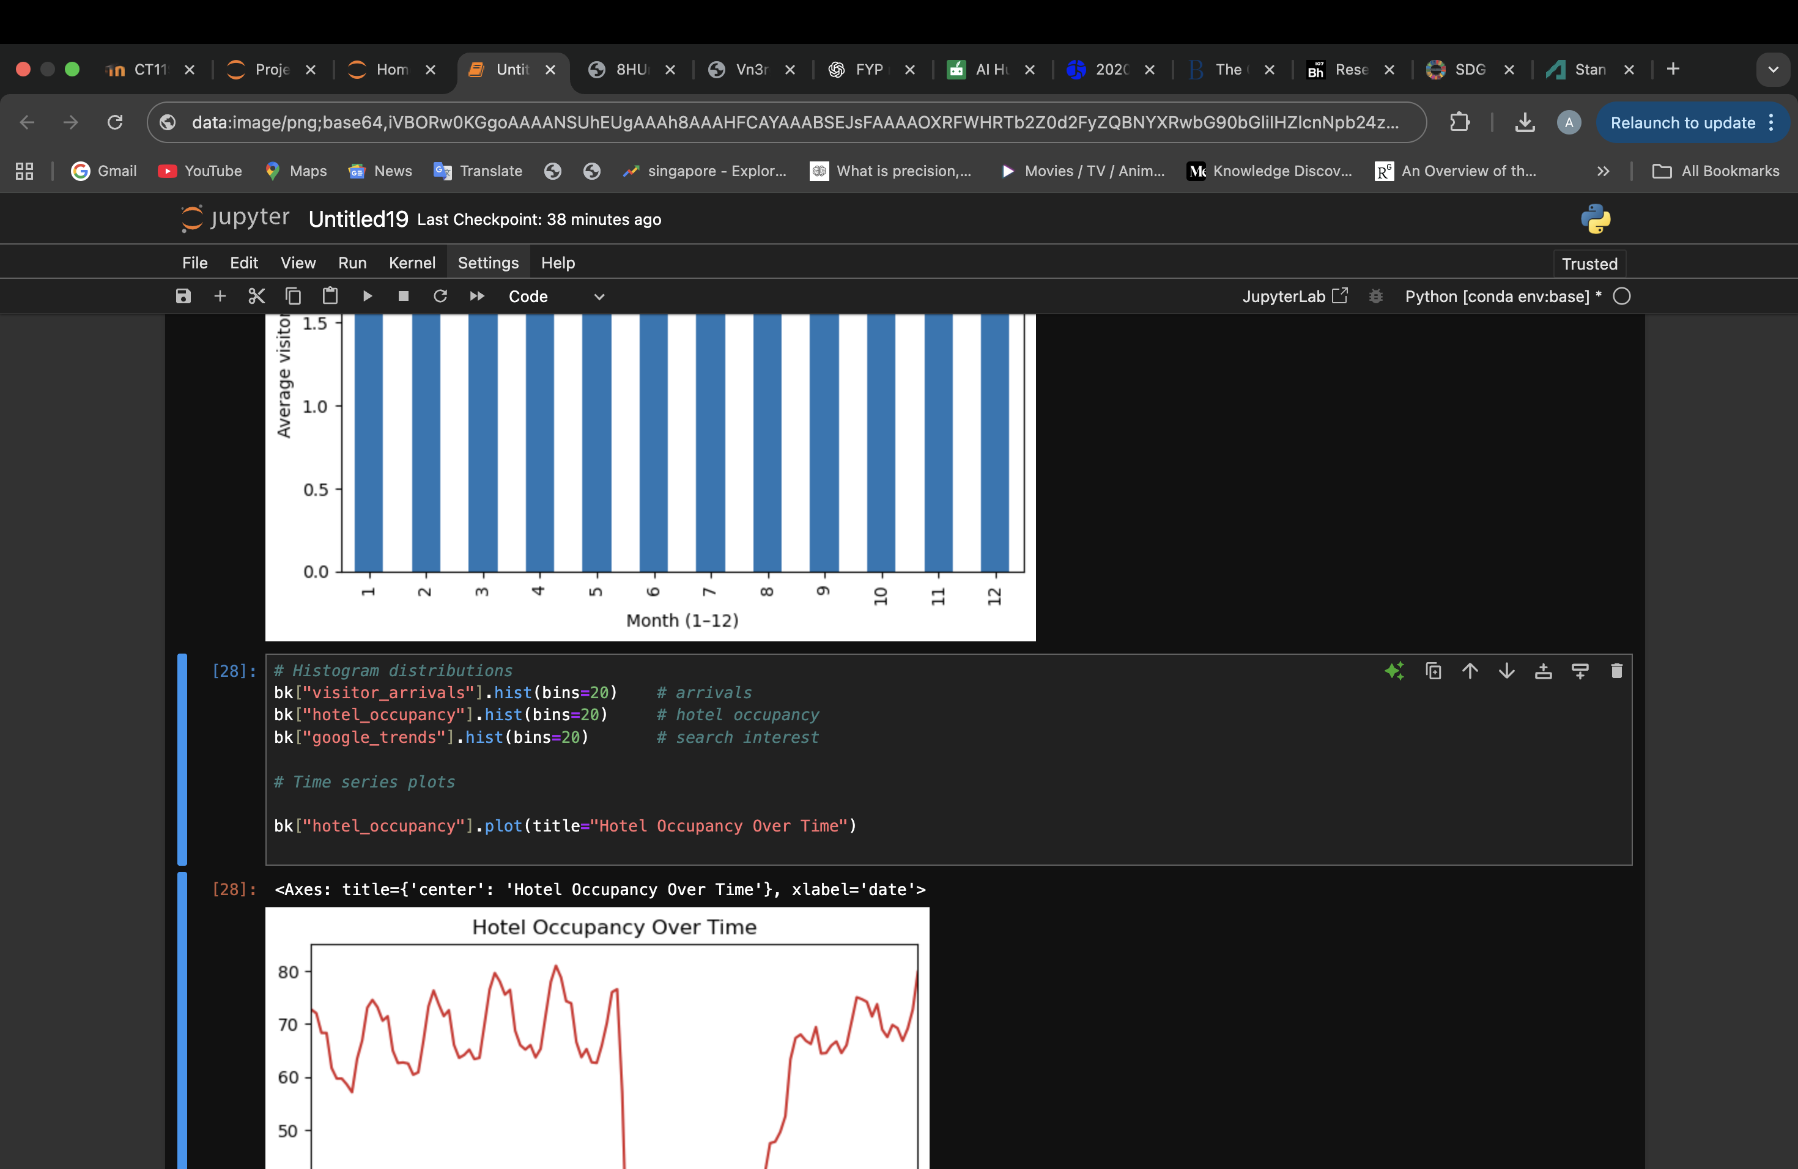

Figure Univariate analysis for hotel occupancy

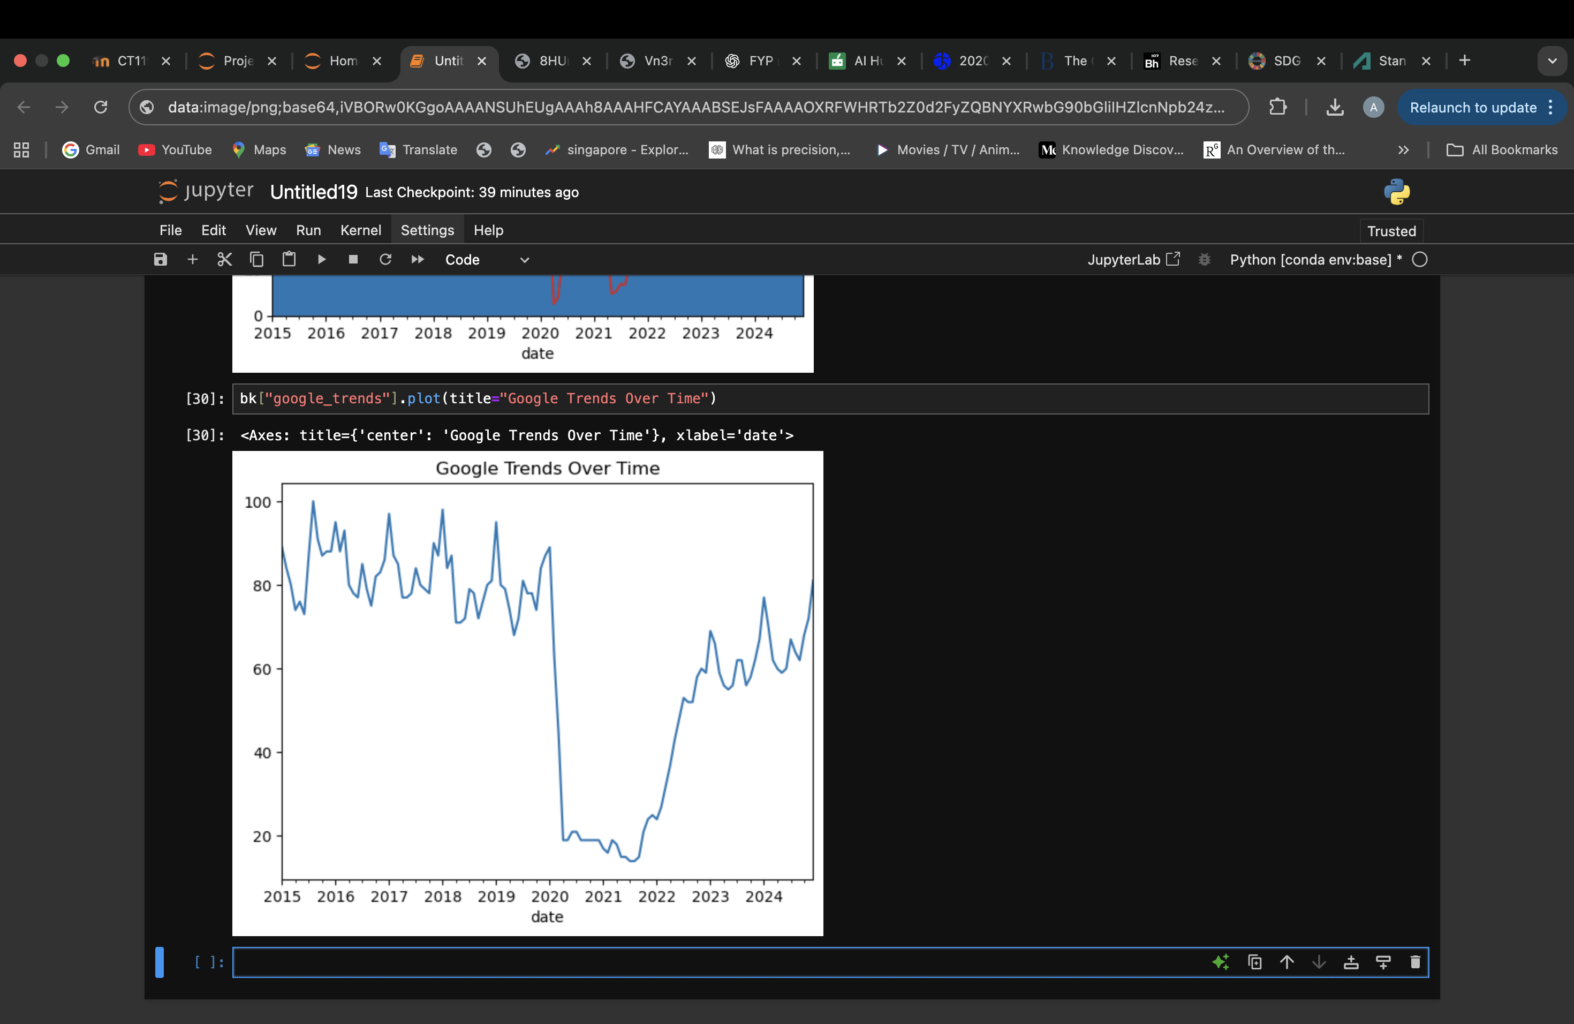

Figure Univariate analysis code for google trends

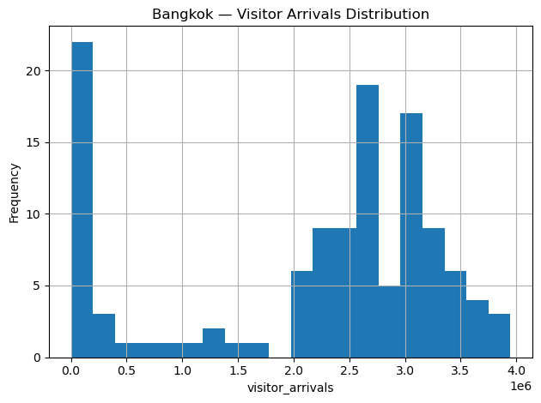

Figure Bangkok Arrivals histogram

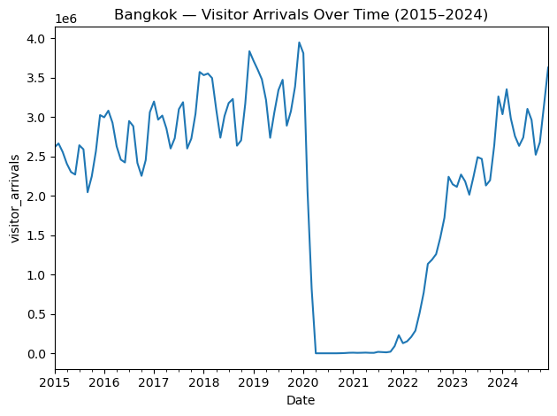

Figure Bangkok Arrivals over time

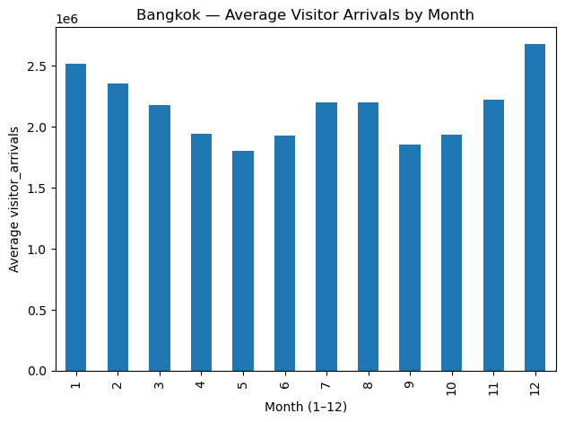

Figure Average Visitors Arrivals for bangkok



Figure Google trends series plot over time

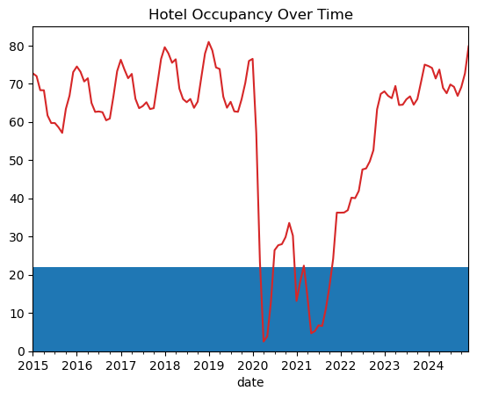

Figure Hotel occupancy series plot over time

Visitor Arrivals: The histogram displays a distribution that is skewed to the right, with a few extreme peak values and the majority of monthly arrivals grouped below the long-term mean. Strong seasonality and a dramatic structural collapse in 2020 are evident in the time-series which is in line with travel restrictions brought on by the pandemic (Qiu et al., 2021).  
  
Hotel Occupancy: shows a roughly bell-shaped distribution with some dispersion at lower levels and a centre of 60–70%. The time-series plot shows how the demand for lodging decreased in 2020 before gradually increasing again in 2022.  
  
Google Trends: Significant drops in internet search activity during the pandemic are depicted in the time-series suggesting that demand-side interest was extremely sensitive to travel restrictions.

**STEP 4: Bivariate Analysis**

**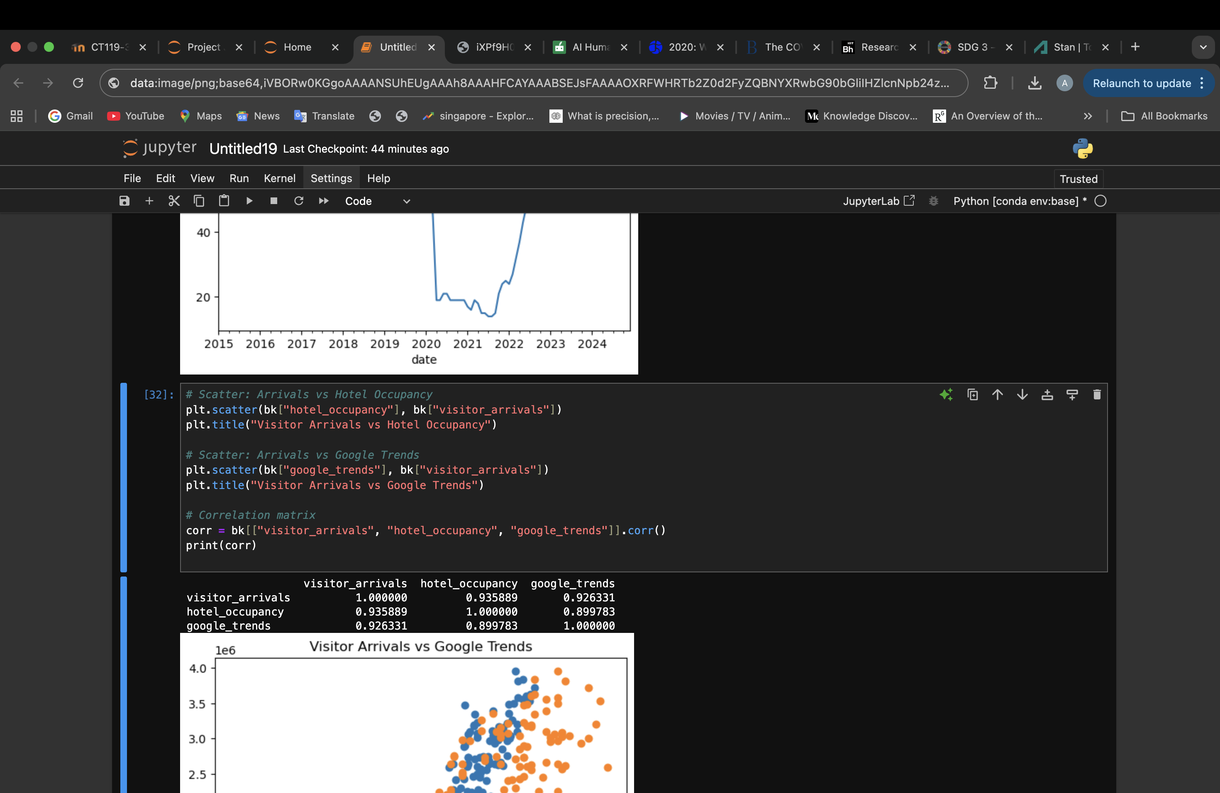**

Figure Bivariate analysis code

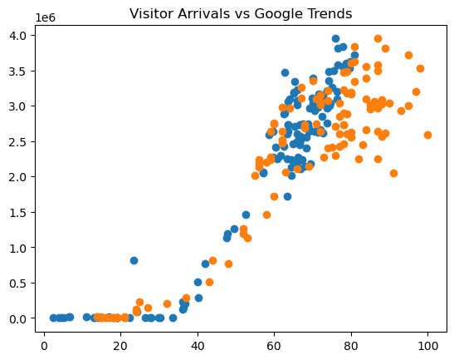

Figure Scatterplot for visitor arrivals and google trends

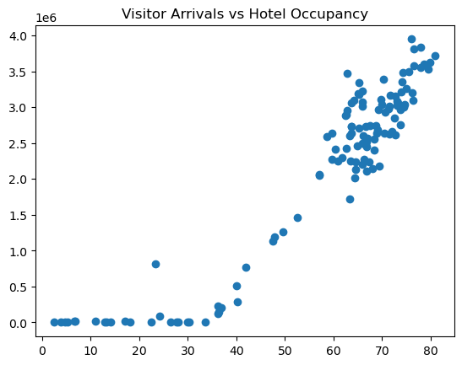

Figure Scatterplot for visitor arrivals and hotel occupancy

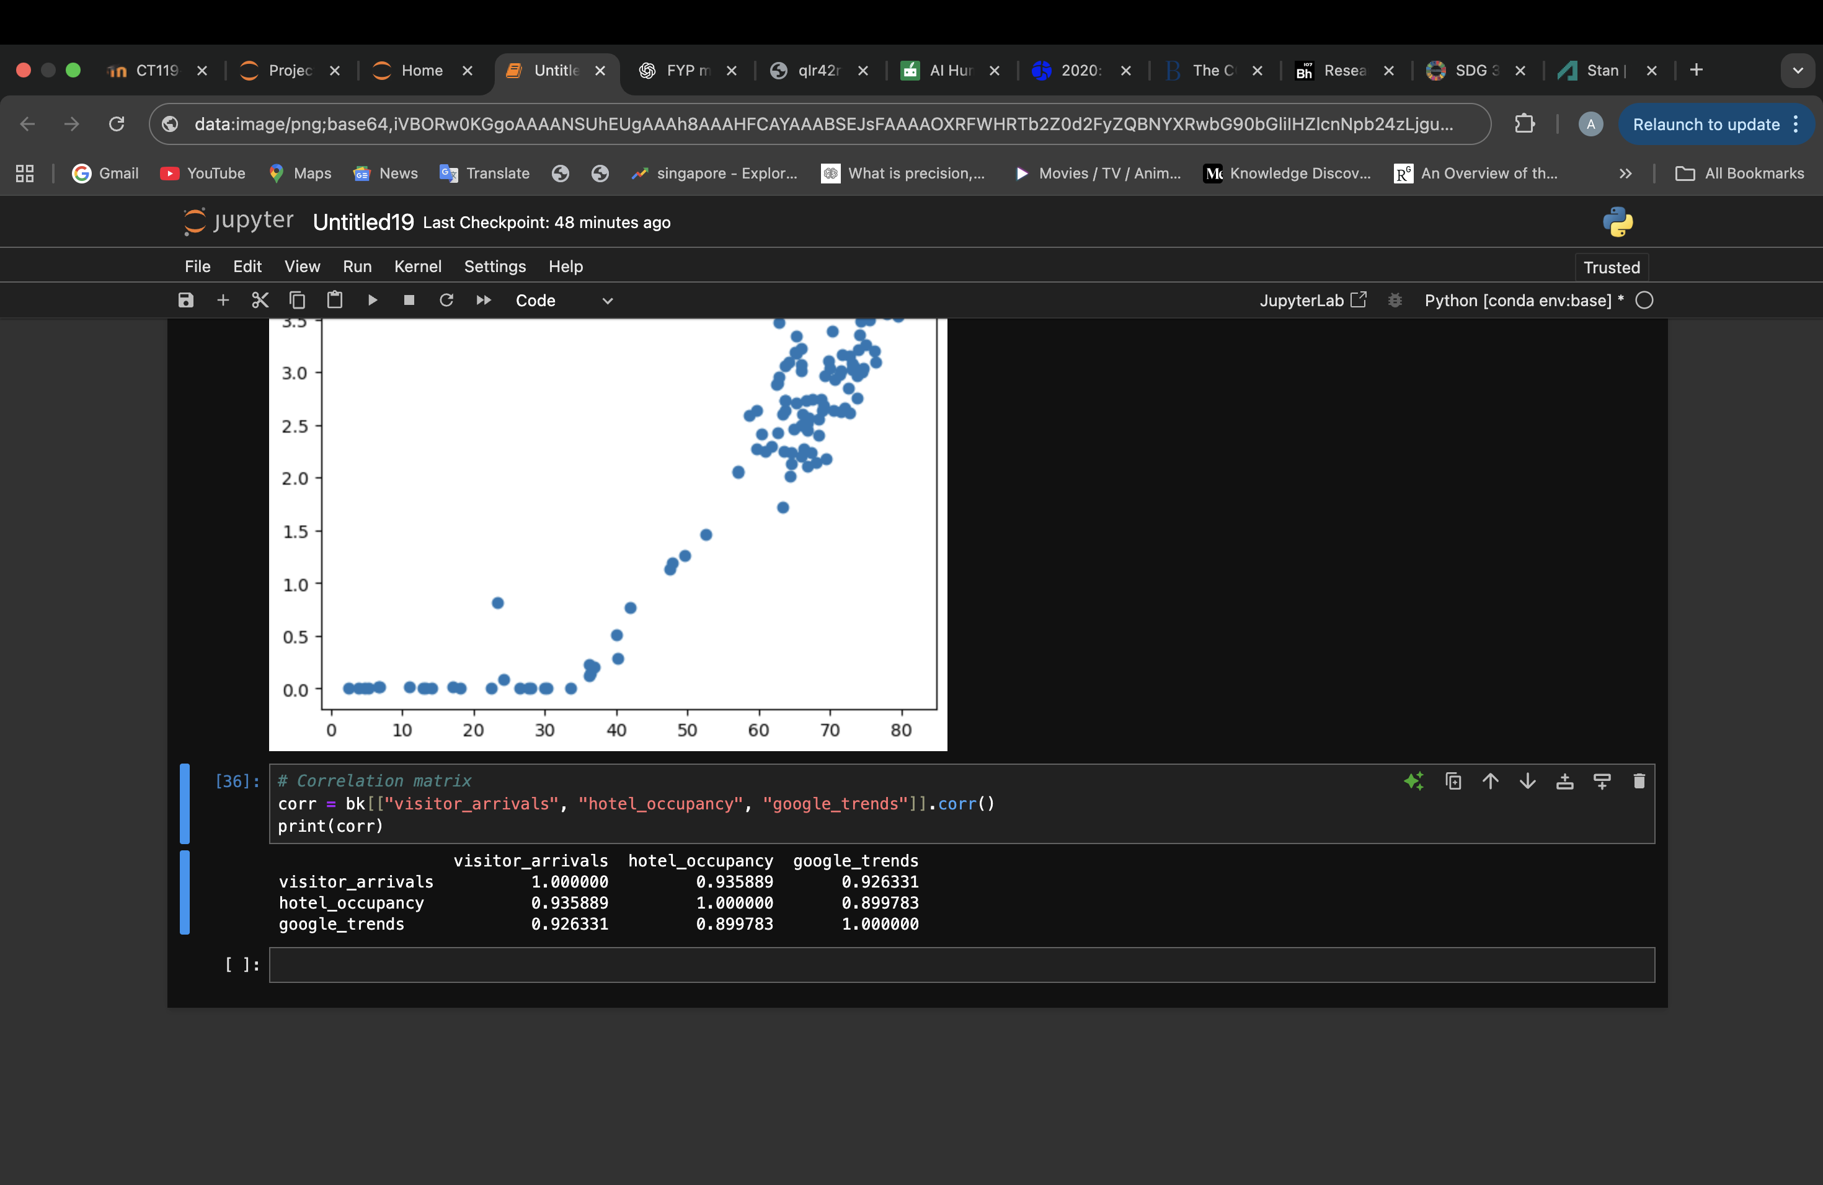

Figure correlation matrix

Arrivals and Hotel Occupancy: The scatter plot indicates a positive correlation between arrivals and hotel occupancy, which is in line with the idea that demand for lodging serves as a stand-in for tourism flows. Higher occupancy rates are typically linked to higher visitor arrivals.  
  
Arrivals and Google Trends: There is a somewhat positive correlation between arrivals and Google Trends, suggesting that more search interest either precedes or corresponds with an increase in arrivals. This supports the use of Google Trends indices as demand-side forecasting tools.  
  
Correlation Matrix: These trends are supported by the correlation coefficients, which indicate that arrivals have a higher linear relationship with hotel occupancy than Google Trends. These correlations demonstrate the predictive value of the auxiliary variables, even though they do not prove causation.

An important stage of the data science phases is data understanding, which focuses on getting a basic understanding of the datasets, evaluating their quality, and identifying any patterns or problems that might affect further modelling stages. Prior to any pre-processing or modelling, this project carefully examined the Google Trends dataset and the international tourist arrivals dataset in accordance with the CRISP-DM (Cross-Industry Standard Process for Data Mining) methodology, which specifically lists "Data Understanding" as one of its fundamental stages. During this phase, the data structure was examined, the completeness of the data was confirmed, univariate statistical summaries were performed, missing values were identified, and early trends were detected. This process was then applied to other cities and their datasets.

## 3.5 Data Pre Processing

Preprocessing guarantees that the unprocessed datasets are methodically cleaned and converted into a format that is appropriate for predictive modelling. This procedure involved handling missing values, fixing structural breaks, applying transformations, developing engineered features, and, when necessary, normalizing numerical values for the Bangkok dataset. To ensure uniformity throughout the study, the same pipeline was then used in Singapore and Hong Kong.

### 3.5.1 Handling Missing values

First, missing observations were evaluated for every variable. Because of inconsistent reporting, especially during the pandemic, there were a few minor gaps in the Bangkok dataset. A forward-fill approach was used, with backfilling added as needed, to maintain temporal continuity without adding spurious variance. This method, which is commonly used in time-series tourism forecasting, makes the assumption that the most recent observed figures provide the best approximation of missing monthly values (Song & Li, 2008).

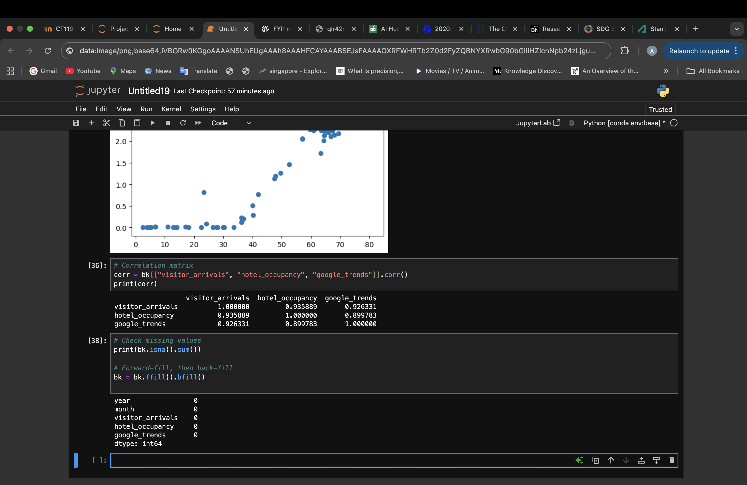

Figure Code for handling missing values

3.5.2 Structural Breaks and Outliers  
Rather than being random noise, the historic decline in visitor arrivals in 2020–2021 was a structural break. A COVID dummy variable was created to take this into consideration; it is coded as 1 during the pandemic period (March 2020 to December 2022) and 0 otherwise. By explicitly capturing the disruption, this binary feature keeps the models from mistaking it for typical seasonality.

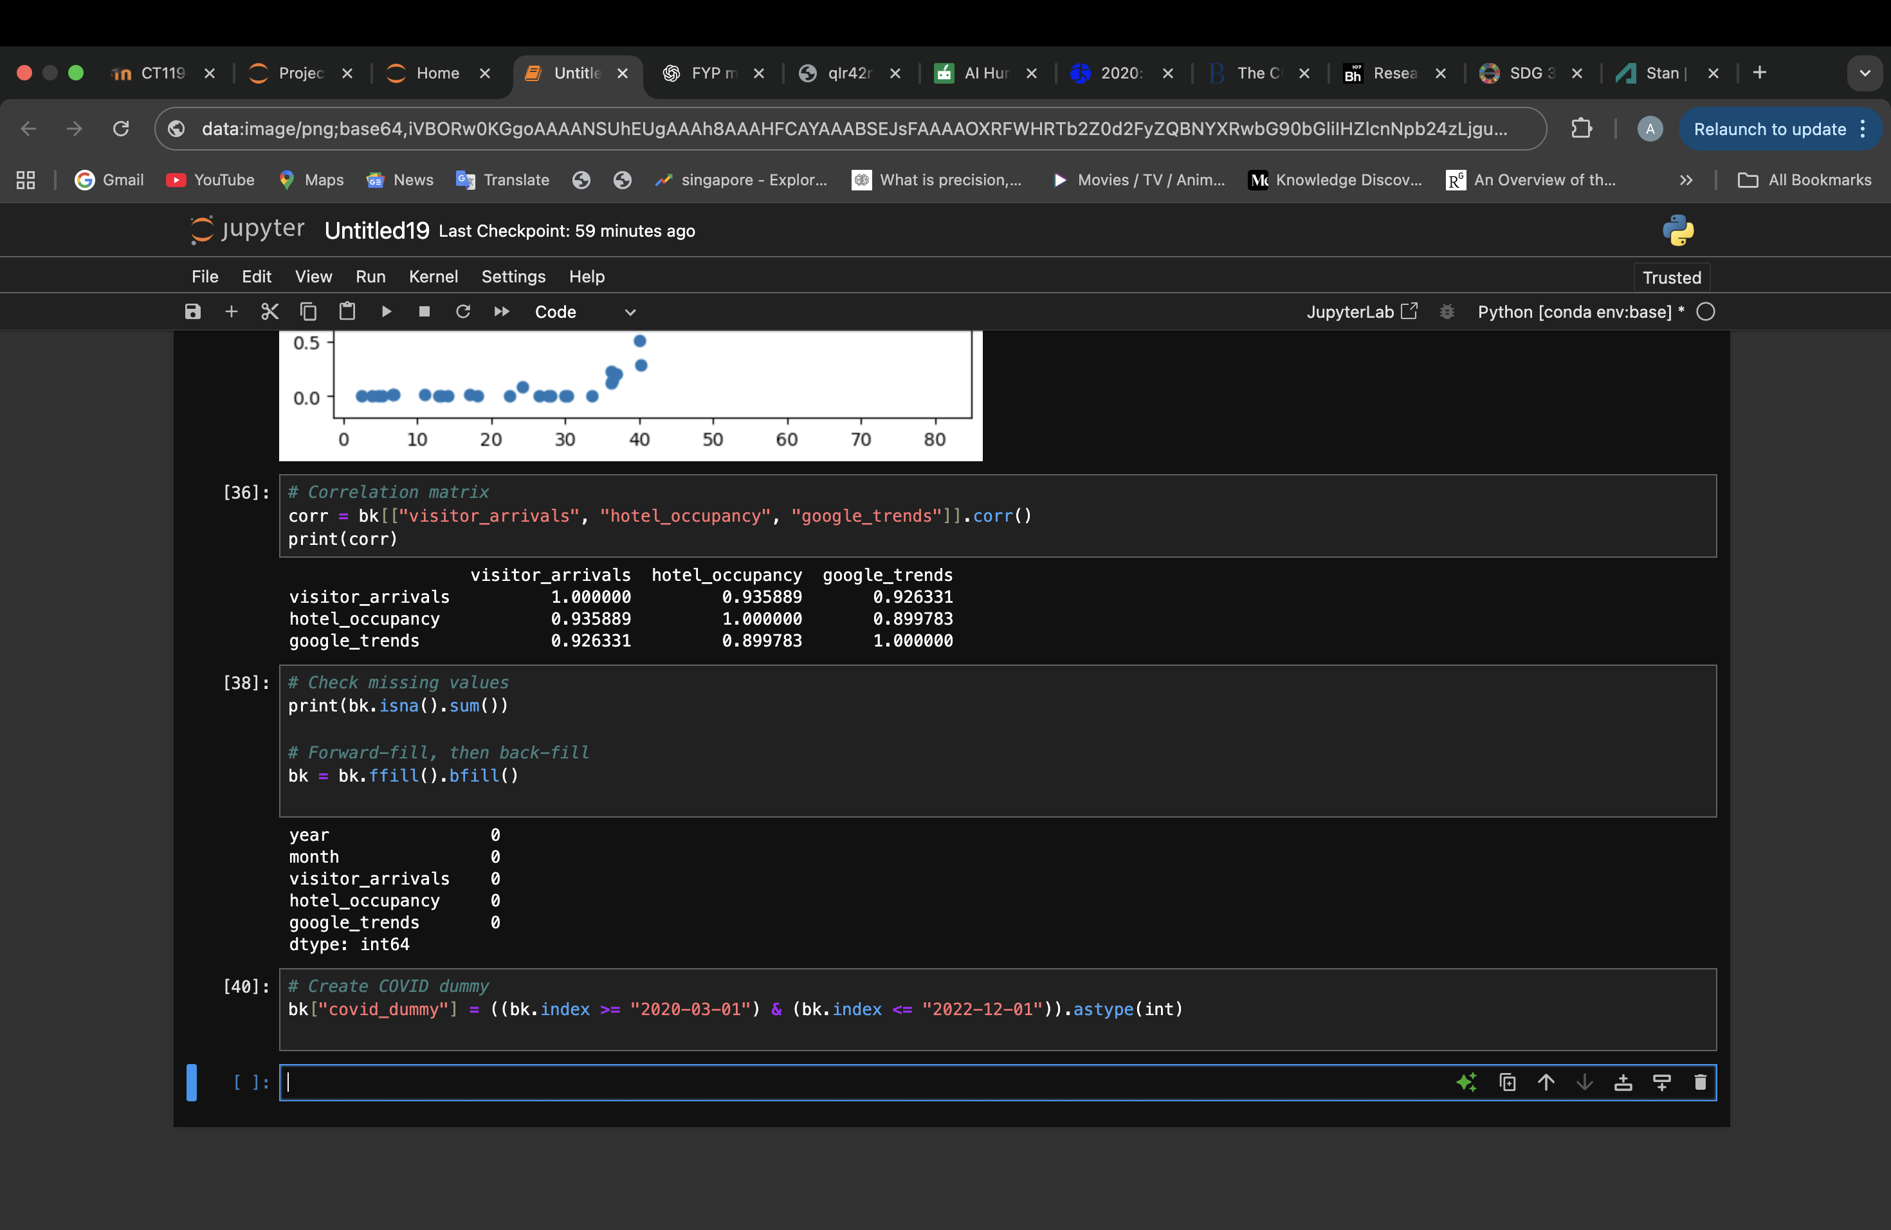

Figure Code for outliers

3.5.3 Data Transformation  
A logarithmic transformation was used to stabilize variance and lessen the right-skewness in visitor arrivals. By compressing extreme values, this transformation improves model stability and creates a distribution that is closer to normal.

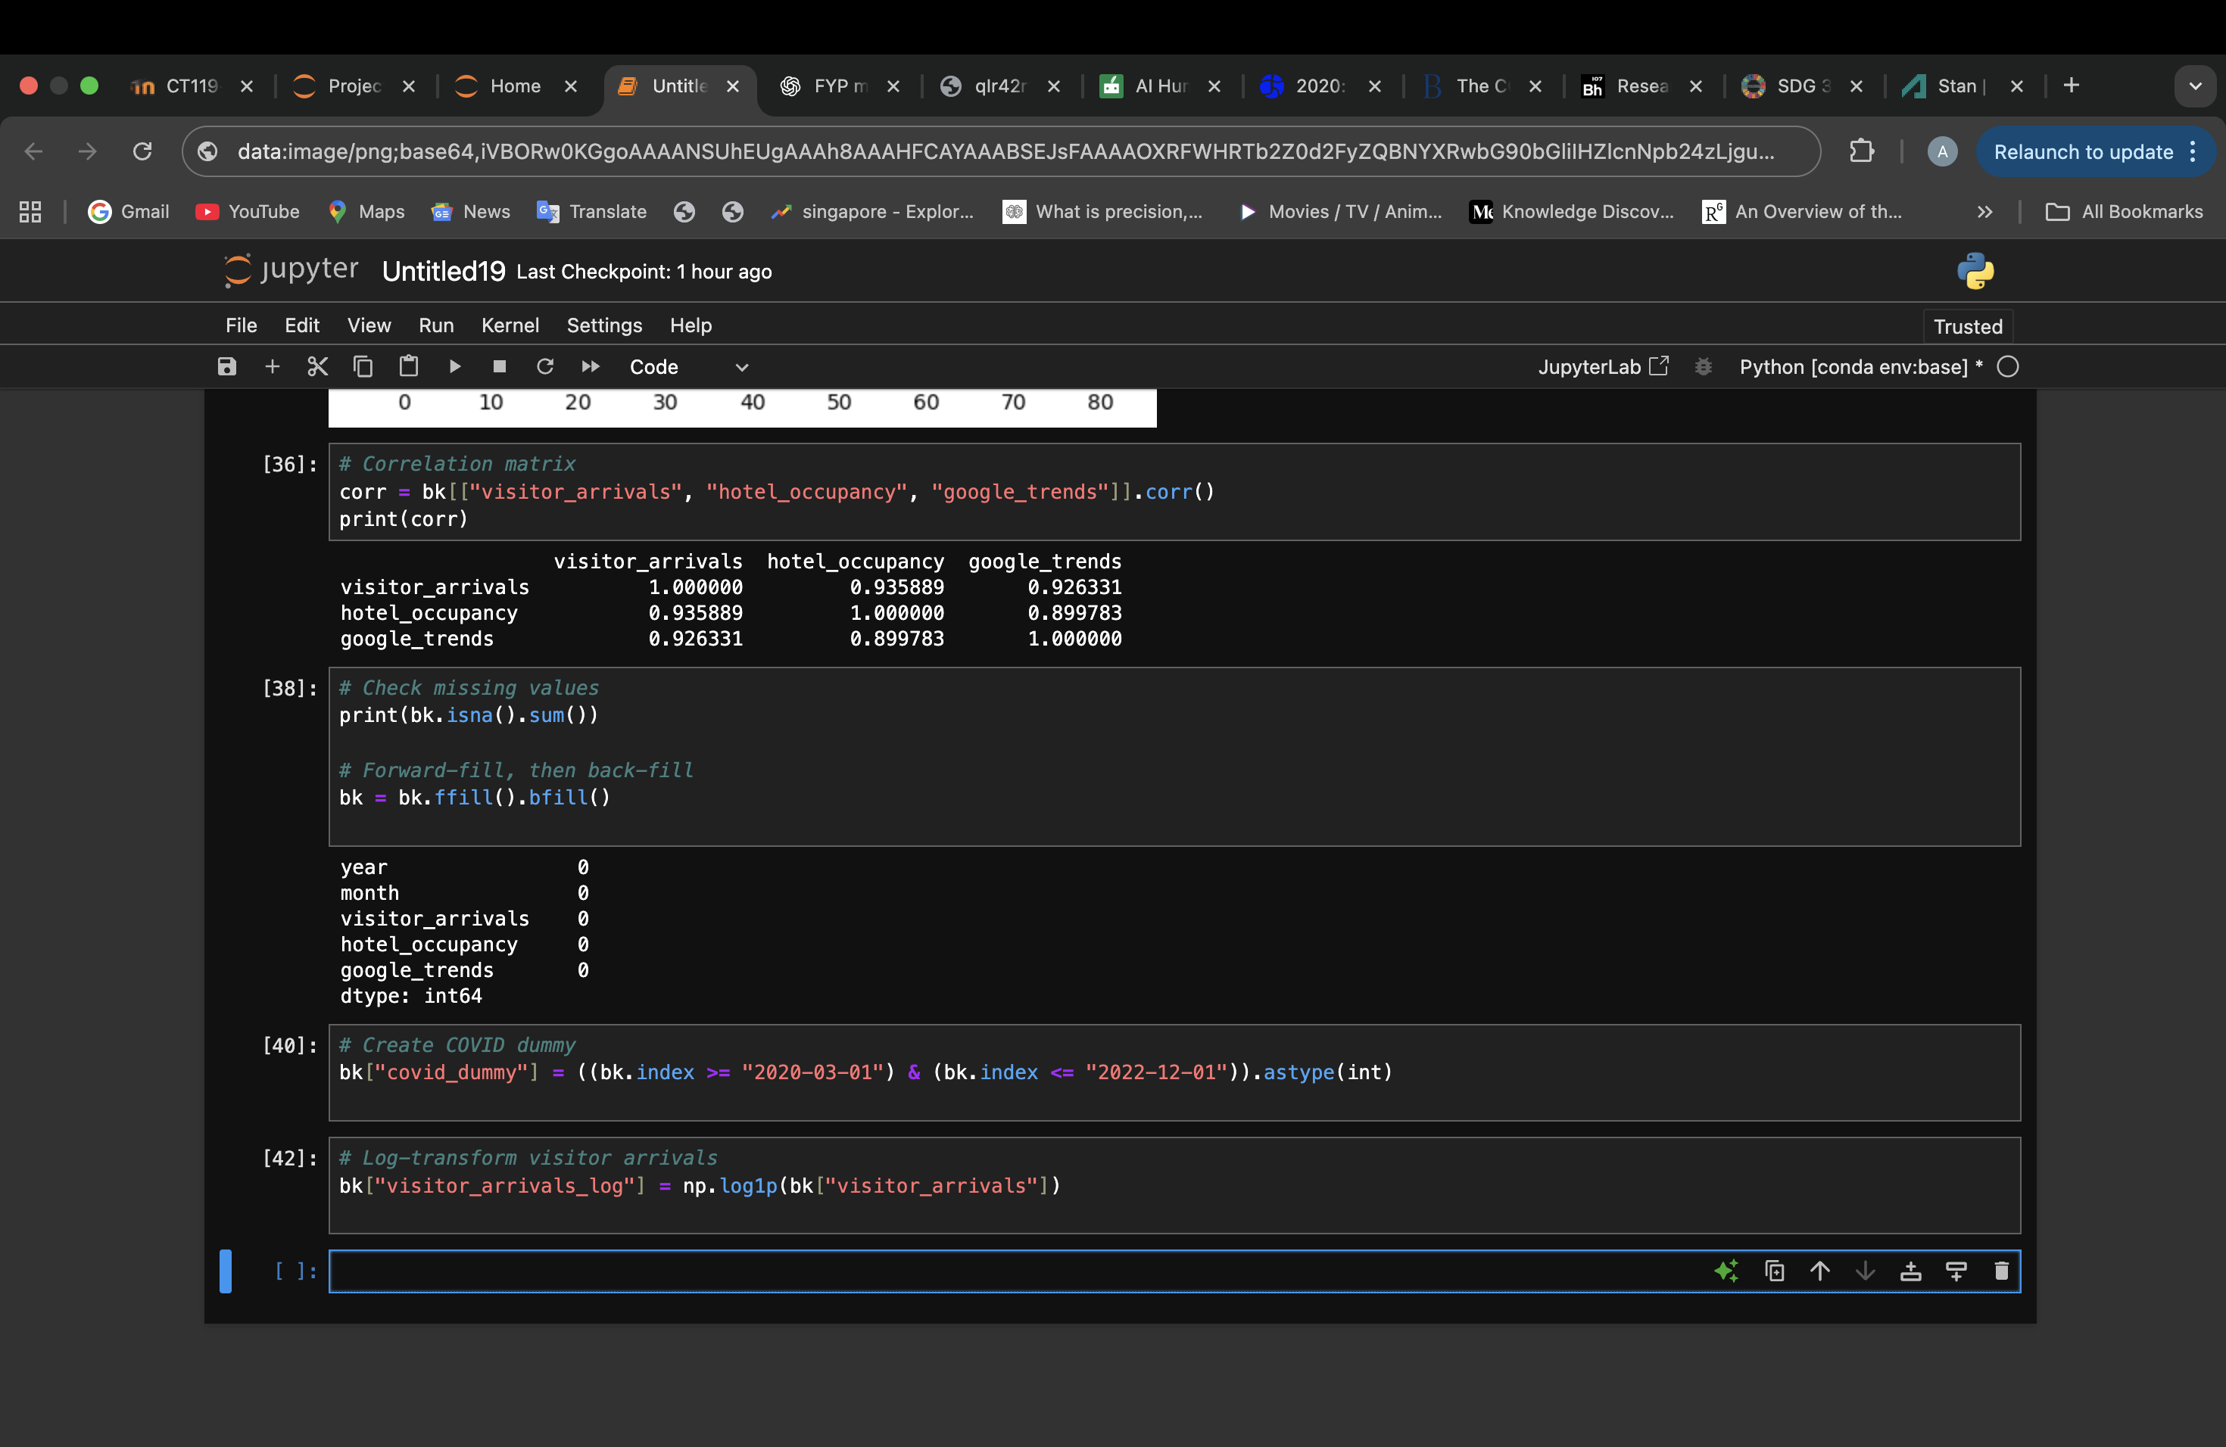

Figure Code for transforming data

### 3.5.4 Feature Engineering

Features that capture cyclical patterns and temporal dependencies are useful for time-series forecasting. Three feature engineering techniques were used:  
  
Lagged Variables: To account for short- and long-term memory effects, visitor arrivals were delayed by 1, 3, 6, and 12 months.  
  
Rolling Averages: To account for smoothed trends and demand persistence, rolling means of three and six months were calculated.  
  
Seasonal Dummies: To simulate recurrent seasonal effects, monthly dummy variables (January–December) were developed.

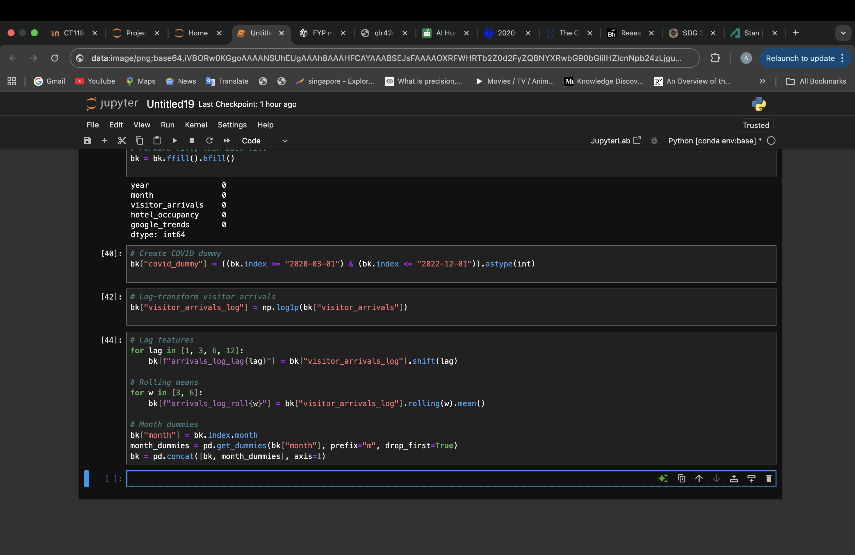

Figure Code for feature engineering

3.5.5 Standardization  
Continuous variables like rolling means, lags, and log-transformed arrivals were standardized using z-scores in order to align variable scales. Tree-based approaches are scale-invariant, but standardization helps linear models like Ridge regression because it keeps large-scale features from taking over.

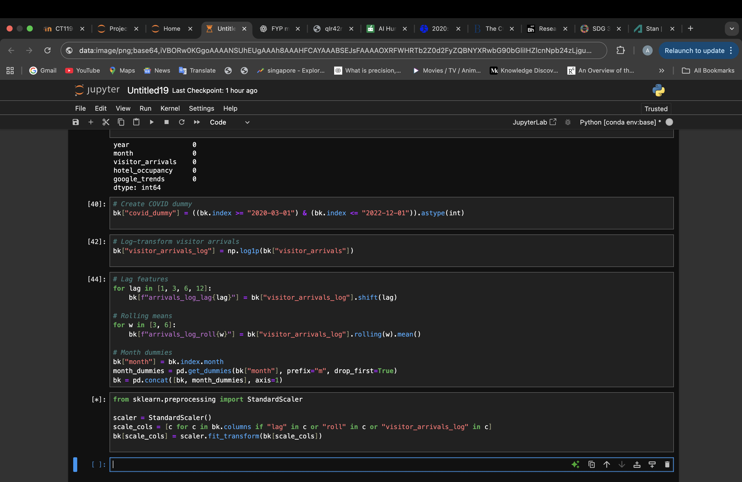

Figure Code for standardization

3.5.6 Final Dataset  
The final modelling dataset was obtained by removing rows that contained NaN values, which were introduced by lagging and rolling operations.

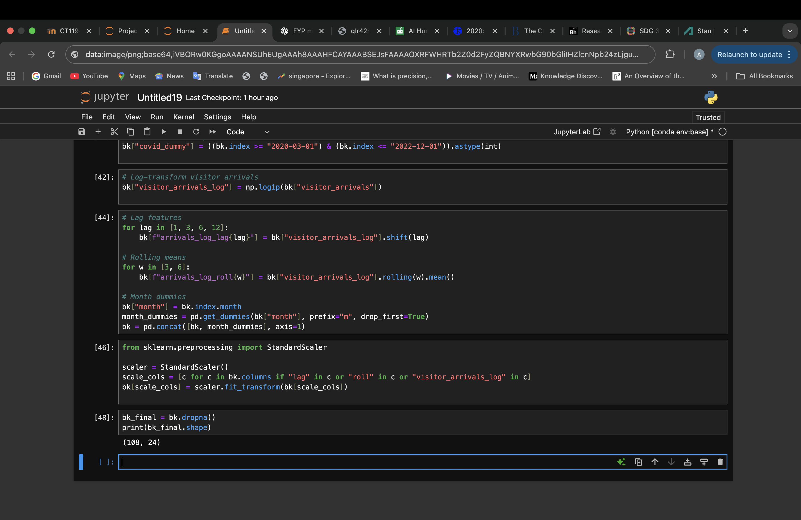

Figure Code for final dataset

## 3.6 Model Building

3.6.1 Overview  
Four modelling techniques—Ridge regression, Random Forest, XGBoost, and Seasonal Naïve—were used to capture the dynamics of the post-pandemic tourism recovery. A balance between interpretability and predictive accuracy is made possible by the utilization of multiple models, which also guarantees that outcomes are compared to both conventional and machine learning approaches. Consistent feature sets from Singapore, Hong Kong, and Bangkok were used to train and assess each model on the pre-processed datasets previously mentioned.

3.6.2 Ridge Regression (Model for Bangkok)  
Ridge regression is a type of linear regression that addresses multicollinearity and overfitting by incorporating an L2 regularization penalty (Hoerl & Kennard, 1970). If left unchecked, high correlations between explanatory variables in tourism forecasting, like visitor arrivals, hotel occupancy, and Google Trends indices, can result in unstable coefficient estimates. By reducing coefficients to zero, ridge regression lessens this problem and enhances model stability and predictive generalization (Kuhn & Johnson, 2020).

3.6.3 Random Forest (Model for Singapore)  
An ensemble learning technique called Random Forest builds a lot of decision trees and aggregates their predictions. A bootstrap sample of the data is used to train each tree, and a random subset of features is taken into consideration for splitting at each node. This results in a stable predictor that manages nonlinear relationships well by introducing both variance reduction and decorrelation among trees.  
  
Because demand recovery patterns are frequently nonlinear and impacted by intricate interactions between economic, social, and behavioral variables, Random Forest is especially helpful in the tourism context (Gunter & Önder, 2023).

### 3.6.4 XGboost (Applied to all cities)

The gradient boosting algorithm Extreme Gradient Boosting (XGBoost) was created with scalability and efficiency in mind (Chen & Guestrin, 2016). It constructs trees one after the other, fixing the remaining errors in the ensemble that has already been built. In order to avoid overfitting and improve generalization, XGBoost applies regularization to both leaf weights and tree complexity.  
  
Time-series related to tourism often show erratic recovery paths with sudden fluctuations in variance. Because it reduces bias by boosting iterations and captures both linear and nonlinear relationships, XGBoost performs exceptionally well in these situations. Boosting methods consistently outperform traditional econometric baselines when dealing with crisis-affected data, according to recent applications in tourism forecasting (Song, Qiu, & Park, 2019; Yang et al., 2023).

### 3.6.5 Seasonal Naïve (Model for Hong Kong)

In time-series forecasting, the Seasonal Naïve approach is a traditional baseline. It makes the assumption that the observed value from the same month the year before will match the forecast for that particular month. When seasonality is the predominant pattern, this approach works especially well (Hyndman & Athanasopoulos, 2018).

Despite its simplicity, the Seasonal Naïve model is frequently suggested as a standard for predicting tourism demand because it offers a minimal level of performance for more sophisticated models. The additional complexity of machine learning models cannot be justified if they do not perform noticeably better than Seasonal Naïve.

Given Hong Kong's slower and less stable recovery, the Seasonal Naïve model is especially applicable there. Its function as a baseline guarantees that sophisticated models are evaluated in relation to an open, understandable benchmark (Hyndman & Athanasopoulos, 2018).

# CHAPTER 4: CONCLUSION

## 4.1 Critical Evaluation

For the proposed Smart Traveller Insights System (STIS), which is intended to predict the post-pandemic tourism recovery across three Asia-Pacific hubs—Singapore, Hong Kong, and Bangkok—this Interim Report (IR) effectively established a rigorous conceptual, theoretical, and methodological foundation. The introduction defined a clearly measurable aim and outcome-oriented objectives, addressing earlier weaknesses of vagueness and repetition. Three primary research gaps were identified by the literature review, which moved from a descriptive catalogue to a critical synthesis. These gaps were (i) the lack of reproducible, interpretable forecasting pipelines; (ii) the underutilization of transparent machine learning baselines; and (iii) the limited cross-city comparability in post-COVID tourism forecasting.

Strong alignment between problem framing and analytical execution is demonstrated by the methodological design. Because of its iterative structure and focus on deployment readiness, the CRISP-DM framework was suitably chosen over SEMMA and KDD. Data comprehension, preparation, feature engineering, and model building are the methodological phases that have all been operationally defined and linked to real-world tasks. A clear benchmarking baseline (Seasonal Naïve) and the inclusion of multiple algorithms (Ridge Regression, Random Forest, and XGBoost) demonstrate methodological maturity and awareness of comparative validation standards. The choice of accuracy metrics (MAPE, MAE, RMSE, and R2) in low-variance, post-shock data contexts is also persuasively justified in the report.

4.2 Limitations  
Data coverage and dependency represent a major limitation. Only secondary, publicly accessible datasets from the Bank of Thailand, Hong Kong Tourism Board, and Singapore Tourism Board are used in this study. Model comparability may be impacted by inconsistencies introduced by these sources' varying reporting frequencies, definitions of "international arrivals," and update intervals. Furthermore, the model's capacity to capture external shocks and behavioural factors influencing recovery patterns is limited by the exclusion of exogenous indicators, such as exchange rates, mobility indices, or flight capacity.

External validity is further limited by the research's temporal and geographic scope, which is limited to three important Asia-Pacific locations. These cities were picked because of their regional importance and data accessibility, but it's possible that their highly urbanized tourism dynamics don't accurately reflect broader trends in rural or national recovery. Additionally, the use of resource-intensive deep-learning architectures and the investigation of sophisticated hyperparameter tuning were limited by computational limitations. Lastly, the Smart Traveller Insights System (STIS) is still a conceptual prototype rather than a verified, interactive decision-support platform because the project has not yet advanced to system deployment or usability testing.

4.3 Recommendations and Future Research  
A number of strategic directions are suggested for future research in order to get around the aforementioned restrictions and increase the study's scholarly and applied contributions. Using the prepared datasets for 2017–2024, the next phase should focus on empirically implementing and validating the suggested models, which include XGBoost, Random Forest, Edge Regression, and the Seasonal Naïve baseline. Strong temporal evaluation and variance stability analysis across various pandemic and post-pandemic periods will be made possible by the use of rolling-origin or expanding-window cross-validation. The Diebold-Mariano test and other complementary statistical tests could be used to increase confidence in the performance of comparative models.

Exogenous and behavioural indicators like flight frequency, the strictness of government policies, search and booking intent, health-advisory indices, and economic activity metrics should all be included in future research to increase the diversity of the data. These modifications would improve the model's sensitivity to contextual elements found in the real world and aid in the interpretation of asymmetric recovery dynamics. In the technical realm, future studies could investigate hybrid ensemble approaches that combine linear and nonlinear models for enhanced adaptability under structural breaks, as well as sophisticated forecasting architectures like SARIMAX, Prophet, or Long Short-Term Memory (LSTM) networks.

Deploying STIS into a fully functional Streamlit dashboard continues to be a crucial next step from an application standpoint. Trend diagnostics, confidence intervals, and real-time forecast visualization should all be a part of this deployment. Objective insights into interface clarity, interpretability, and decision-support value could be obtained through user testing and evaluation with instruments like the Technology Acceptance Model (TAM) or System Usability Scale (SUS). Furthermore, the Tourism Confidence Index (TCI) would be more globally applicable if the analytical scope was broadened to include more Asia-Pacific locations or even comparative analysis across continents.

Lastly, by working with national tourism boards, health authorities, and sustainability agencies, future research should connect technical outputs with policy relevance. Sustainable tourism development, risk communication, and evidence-based recovery planning may all be aided by integrating the TCI framework into policy dashboards. The research would be in line with the advancement of predictive analytics as well as the longer-term resilience of global tourism ecosystems and the more general goals of Sustainable Development Goal 3 (Good Health and Well-Being).

# References

* Adekuajo, I. O., Otokiti, B. O., & Okpeke, F. (2025). A predictive framework for post-pandemic tourism recovery: Integrating machine learning and visitor behavior analytics. SHISRRJ. [https://shisrrj.com/paper/SHISRRJ258315.pdf](https://shisrrj.com/paper/SHISRRJ258315.pdf" \t "_new)
* Afrianto, M. A., & Wasesa, M. (2022). The impact of tree-based machine learning models, length of training data, and quarantine search query on tourist arrival prediction’s accuracy under COVID-19. Current Issues in Tourism. [https://doi.org/10.1080/13683500.2022.2085079](https://doi.org/10.1080/13683500.2022.2085079" \t "_new)
* Akter, S., Bandara, R., & Hossain, M. N. (2023). Dashboard technologies for decision support in tourism recovery. Tourism Management Perspectives, 46, 101085. [https://doi.org/10.1016/j.tmp.2023.101085](https://doi.org/10.1016/j.tmp.2023.101085" \t "_new)
* Assaf, A. G., & Li, G. (2022). Tourism forecasting post-COVID-19: Recovery patterns and methodological implications. Tourism Management, 90, 104485. [https://doi.org/10.1016/j.tourman.2021.104485](https://doi.org/10.1016/j.tourman.2021.104485" \t "_new)
* Assaf, A. G., Song, H., & Wu, D. C. (2022). Big data applications in tourism demand forecasting: A review. Annals of Tourism Research, 92, 103327. [https://doi.org/10.1016/j.annals.2022.103327](https://doi.org/10.1016/j.annals.2022.103327" \t "_new)
* Bi, J. W., Han, T. Y., Yao, Y., & Yang, T. (2024). Tourism demand forecasting under conceptual drift during COVID-19: An ensemble deep learning model. Current Issues in Tourism. [https://doi.org/10.1080/13683500.2023.2273922](https://doi.org/10.1080/13683500.2023.2273922" \t "_new)
* Breiman, L. (2001). Random forests. Machine Learning, 45(1), 5–32. [https://doi.org/10.1023/A:1010933404324](https://doi.org/10.1023/A:1010933404324" \t "_new)
* Chen, H., Wang, Y., & Li, X. (2022). Machine learning models for tourism demand forecasting: Advances and challenges. Annals of Tourism Research, 92, 103310. [https://doi.org/10.1016/j.annals.2021.103310](https://doi.org/10.1016/j.annals.2021.103310" \t "_new)
* Chen, H., Wang, Y., & Li, X. (2023). Tourism demand forecasting during and after COVID-19: Outliers and recovery scenarios. Journal of Travel Research, 62(5), 855–870. [https://doi.org/10.1177/00472875221150604](https://doi.org/10.1177/00472875221150604" \t "_new)
* Chen, T., & Guestrin, C. (2016). XGBoost: A scalable tree boosting system. In Proceedings of the 22nd ACM SIGKDD International Conference on Knowledge Discovery and Data Mining (pp. 785–794). [https://doi.org/10.1145/2939672.2939785](https://doi.org/10.1145/2939672.2939785" \t "_new)
* Chen, Y., Hu, T., & Law, R. (2025). Tourism demand forecasting: A novel multi-channel imaging model. Journal of Tourism Futures. [https://doi.org/10.1108/jtf-12-2024-0263](https://doi.org/10.1108/jtf-12-2024-0263" \t "_new)
* Choi, H., & Varian, H. (2012). Predicting the present with Google Trends. Economic Record, 88(s1), 2–9. [https://doi.org/10.1111/j.1475-4932.2012.00809.x](https://doi.org/10.1111/j.1475-4932.2012.00809.x" \t "_new)
* Dimitriadou, A., & Gogas, P. (2025). Tourism and uncertainty: A machine learning approach. Current Issues in Tourism. [https://doi.org/10.1080/13683500.2024.2370380](https://doi.org/10.1080/13683500.2024.2370380" \t "_new)
* Goh, C., & Law, R. (2002). Modelling and forecasting tourism demand for arrivals with stochastic nonstationary seasonality and intervention. Tourism Management, 23(5), 499–510. [https://doi.org/10.1016/S0261-5177(02)00009-2](https://doi.org/10.1016/S0261-5177(02)00009-2" \t "_new)
* Gretzel, U., Werthner, H., Koo, C., & Lamsfus, C. (2020). Conceptual foundations for understanding smart tourism ecosystems. Computers in Human Behavior, 110, 106340. [https://doi.org/10.1016/j.chb.2019.106340](https://doi.org/10.1016/j.chb.2019.106340" \t "_new)
* Gunter, U., & Önder, I. (2021). Forecasting city tourism: Machine learning versus structural models. Tourism Economics, 27(3), 531–550. [https://doi.org/10.1177/1354816620926391](https://doi.org/10.1177/1354816620926391" \t "_new)
* Gunter, U., & Önder, I. (2023). Forecasting tourism demand with machine learning models: Recent developments and future directions. Tourism Economics, 29(2), 305–327. [https://doi.org/10.1177/13548166221101234](https://doi.org/10.1177/13548166221101234" \t "_new)
* Hall, C. M. (2022). Tourism and pandemics: Towards a resilient future. Tourism Review International, 26(2), 117–133. [https://doi.org/10.3727/154427222X16490830883520](https://doi.org/10.3727/154427222X16490830883520" \t "_new)
* Hall, C. M., Prayag, G., & Amore, A. (2021). Tourism and resilience in the face of crisis. Journal of Sustainable Tourism, 29(9), 1421–1437. [https://doi.org/10.1080/09669582.2021.1910213](https://doi.org/10.1080/09669582.2021.1910213" \t "_new)
* Hoerl, A. E., & Kennard, R. W. (1970). Ridge regression: Biased estimation for nonorthogonal problems. Technometrics, 12(1), 55–67. [https://doi.org/10.1080/00401706.1970.10488634](https://doi.org/10.1080/00401706.1970.10488634" \t "_new)
* Hyndman, R. J., & Athanasopoulos, G. (2018). Forecasting: Principles and practice (2nd ed.). OTexts. https://otexts.com/fpp2/
* Hyndman, R. J., & Athanasopoulos, G. (2021). Forecasting: Principles and practice (3rd ed.). OTexts. [https://otexts.com/fpp3/](https://otexts.com/fpp3/" \t "_new)
* Kayral, İ. E., Sarı, T., & Tandoğan Aktepe, N. Ş. (2023). Forecasting tourist arrivals and income with combined ANN architecture in the post-COVID-19 period: The case of Turkey. Sustainability, 15(22), 15924. [https://doi.org/10.3390/su152215924](https://doi.org/10.3390/su152215924" \t "_new)
* Kuhn, M., & Johnson, K. (2020). Feature engineering and selection: A practical approach for predictive models. CRC Press.
* Kumar, A., Misra, S. C., & Chan, F. T. S. (2022). Leveraging AI for advanced analytics to forecast altered tourism industry parameters: A COVID-19 motivated study. Expert Systems with Applications, 206, 117736. [https://doi.org/10.1016/j.eswa.2022.117736](https://doi.org/10.1016/j.eswa.2022.117736" \t "_new)
* Lee, G. C. (2025). A data-driven approach to tourism demand forecasting: Integrating web search data into a SARIMAX model. Data, 10(5), 73. [https://doi.org/10.3390/data10050073](https://doi.org/10.3390/data10050073" \t "_new)
* Li, G., Song, H., & Witt, S. F. (2005). Recent developments in econometric modelling and forecasting. Journal of Travel Research, 44(1), 82–99. [https://doi.org/10.1177/0047287505276594](https://doi.org/10.1177/0047287505276594" \t "_new)
* Li, G., Song, H., & Guo, Z. (2022). Evaluating forecasting accuracy in tourism demand modelling. Annals of Tourism Research, 95, 103398. [https://doi.org/10.1016/j.annals.2022.103398](https://doi.org/10.1016/j.annals.2022.103398" \t "_new)
* Li, G., Song, H., & Witt, S. F. (2022). Recent developments in international tourism demand forecasting: Coping with shocks and structural breaks. International Journal of Forecasting, 38(2), 429–444. [https://doi.org/10.1016/j.ijforecast.2021.09.005](https://doi.org/10.1016/j.ijforecast.2021.09.005" \t "_new)
* Li, Y., Yang, D., Guo, J., Sun, S., & Wang, S. (2024). Daily tourism demand forecasting before and during COVID-19: Data predictivity and an improved decomposition-ensemble framework. Current Issues in Tourism, 27(10), 1523–1542. [https://doi.org/10.1080/13683500.2023.2202308](https://doi.org/10.1080/13683500.2023.2202308" \t "_new)
* Liu, Y., Xu, H., & Li, X. (2023). A composite tourism recovery index for Southeast Asia: Integrating mobility, hospitality, and aviation data. Tourism Economics, 29(6), 1362–1381. [https://doi.org/10.1177/13548166231154723](https://doi.org/10.1177/13548166231154723" \t "_new)
* Makridakis, S., Spiliotis, E., & Assimakopoulos, V. (2020). The M4 competition: 100,000 time series and 61 forecasting methods. International Journal of Forecasting, 36(1), 54–74. [https://doi.org/10.1016/j.ijforecast.2019.04.014](https://doi.org/10.1016/j.ijforecast.2019.04.014" \t "_new)
* Makridakis, S., Spiliotis, E., & Assimakopoulos, V. (2020). The M5 competition: Findings and implications. International Journal of Forecasting, 36(1), 54–74. [https://doi.org/10.1016/j.ijforecast.2019.07.001](https://doi.org/10.1016/j.ijforecast.2019.07.001" \t "_new)
* Moreno-Izquierdo, L., Más-Ferrando, A., & Ribalaygua, C. (2024). Evaluating machine learning techniques for predicting tourist occupancy: An experiment with pre- and post-pandemic COVID-19 data. Current Issues in Tourism. [https://doi.org/10.1080/13683500.2023.2282163](https://doi.org/10.1080/13683500.2023.2282163" \t "_new)
* Nguyen, D. T., Li, Y., Peng, C. L., & Cho, M. Y. (2024). Monthly tourism demand forecasting with COVID-19 impact-based hybrid convolutional neural network and gate recurrent unit. International Journal of Tourism Research. [https://doi.org/10.1002/jtr.2812](https://doi.org/10.1002/jtr.2812" \t "_new)
* Nguyen, T. H., Pham, H. T., & Tran, M. T. (2022). Building a tourism recovery dashboard: A case study from Vietnam. Journal of Destination Marketing & Management, 26, 100700. [https://doi.org/10.1016/j.jdmm.2022.100700](https://doi.org/10.1016/j.jdmm.2022.100700" \t "_new)
* Polyzos, S., Fotiadis, A., & Samitas, A. (2021). COVID-19 tourism recovery in the ASEAN and East Asia region: Asymmetric patterns and implications. ERIA Discussion Paper Series. [https://www.eria.org/publications/covid-19-tourism-recovery-in-the-asean-and-east-asia-region-asymmetric-patterns-and-implications](https://www.eria.org/publications/covid-19-tourism-recovery-in-the-asean-and-east-asia-region-asymmetric-patterns-and-implications" \t "_new)
* Qiu, R. T. R., Wu, D. C., Dropsy, V., Petit, S., & Pratt, S. (2021). Visitor arrivals forecasts amid COVID-19: A perspective from the Asia and Pacific team. Annals of Tourism Research, 88, 103155. [https://doi.org/10.1016/j.annals.2020.103155](https://doi.org/10.1016/j.annals.2020.103155" \t "_new)
* Qiu, R. T. R., Wu, D. C., Dropsy, V., Petit, S., & Pratt, S. (2021). Tourism forecasting amid COVID-19: The case of Macao. Annals of Tourism Research, 88, 103170. [https://doi.org/10.1016/j.annals.2021.103170](https://doi.org/10.1016/j.annals.2021.103170" \t "_new)
* Saltz, J. (2021). Data science project management: Toward a comprehensive approach. Journal of Information Systems, 35(1), 131–144. [https://doi.org/10.2308/isys-19-047](https://doi.org/10.2308/isys-19-047" \t "_new)
* Shang, Y., Wang, Y., & Chan, C. (2021). Measuring model performance in low-variance time series: A case in tourism demand. Tourism Economics, 27(8), 1744–1762. [https://doi.org/10.1177/13548166211004165](https://doi.org/10.1177/13548166211004165" \t "_new)
* Chumbar, S. (2023, September 24). *Knowledge Discovery in Databases (KDD): A Practical Approach*. Medium. <https://medium.com/@shawn.chumbar/knowledge-discovery-in-databases-kdd-a-practical-approach-f28247493be4>
* Shahrabi, A., Rajabifard, A., & Kalantari, M. (2022). Designing decision support systems for resilient urban tourism under COVID-19. Sustainability, 14(18), 11632. [https://doi.org/10.3390/su141811632](https://doi.org/10.3390/su141811632" \t "_new)
* Shimaoka, A. M., Ferreira, R. C., & Oliveira, R. C. (2024). The evolution of CRISP-DM for data science: Methods, processes, and frameworks. SBC Journal on Interactive Systems, 15(1), 1–14. [https://doi.org/10.5753/jis.2024.3128](https://doi.org/10.5753/jis.2024.3128" \t "_new)
* Song, H., & Li, G. (2008). Tourism demand modelling and forecasting – A review of recent research. Tourism Management, 29(2), 203–220. [https://doi.org/10.1016/j.tourman.2007.07.016](https://doi.org/10.1016/j.tourman.2007.07.016" \t "_new)
* Song, H., & Li, G. (2021). Tourism forecasting: A review of recent research. Tourism Economics, 27(6), 1185–1205. [https://doi.org/10.1177/1354816620978754](https://doi.org/10.1177/1354816620978754" \t "_new)
* Song, H., Qiu, R. T. R., & Park, J. (2019). A review of research on tourism demand forecasting: Launching the Annals of Tourism Research curated collection on tourism demand forecasting. Annals of Tourism Research, 75, 338–362. [https://doi.org/10.1016/j.annals.2019.01.004](https://doi.org/10.1016/j.annals.2019.01.004" \t "_new)
* Song, H., Qiu, R. T. R., & Park, J. (2021). Short-term forecasting of tourism demand under crisis conditions. Annals of Tourism Research, 87, 103143. [https://doi.org/10.1016/j.annals.2020.103143](https://doi.org/10.1016/j.annals.2020.103143" \t "_new)
* Sun, S., Wei, Y., & Wu, D. (2021). Practical approaches to handling non-stationarity in tourism time series forecasting. Tourism Economics, 27(7), 1555–1575. [https://doi.org/10.1177/1354816621997923](https://doi.org/10.1177/1354816621997923" \t "_new)
* Sulong, Z., & Abdullah, M. (2023). Halal tourism demand and firm performance forecasting: New evidence from machine learning. Current Issues in Tourism. [https://doi.org/10.1080/13683500.2022.2145458](https://doi.org/10.1080/13683500.2022.2145458" \t "_new)
* Truong, V. D., Hall, C. M., & Garry, T. (2022). Digital innovation in tourism recovery strategies. Journal of Destination Marketing & Management, 23, 100699. [https://doi.org/10.1016/j.jdmm.2022.100699](https://doi.org/10.1016/j.jdmm.2022.100699" \t "_new)
* UNWTO. (2022). Tourism recovery tracker. World Tourism Organization. [https://www.unwto.org/tourism-data/unwto-tourism-recovery-tracker](https://www.unwto.org/tourism-data/unwto-tourism-recovery-tracker" \t "_new)
* Vanneste, D. (2022). Tourism, uncertainty, and well-being: Rethinking resilience. Tourism Geographies, 24(5–6), 745–761. [https://doi.org/10.1080/14616688.2022.2035824](https://doi.org/10.1080/14616688.2022.2035824" \t "_new)
* Velu, S. R., Ravi, V., & Tabianan, K. (2022). Predictive analytics of COVID-19 cases and tourist arrivals in ASEAN. Health and Technology, 12(6), 1325–1340. [https://doi.org/10.1007/s12553-022-00701-7](https://doi.org/10.1007/s12553-022-00701-7" \t "_new)
* Witt, S. F., & Witt, C. A. (1995). Forecasting tourism demand: A review of empirical research. International Journal of Forecasting, 11(3), 447–475. [https://doi.org/10.1016/0169-2070(95)00591-7](https://doi.org/10.1016/0169-2070(95)00591-7" \t "_new)
* Yang, D., Li, Y., Guo, J., & Sun, S. (2023). Regional tourism demand forecasting with spatiotemporal interactions: A multivariate decomposition deep learning model. Asia Pacific Journal of Tourism Research, 28(4), 405–421. [https://doi.org/10.1080/10941665.2023.2256431](https://doi.org/10.1080/10941665.2023.2256431" \t "_new)
* Yang, Y., Li, G., Guo, Z., & Sun, J. (2023). Hybrid forecasting approaches for post-crisis tourism recovery: Evidence from international travel flows. Journal of Travel Research, 62(5), 909–926. [https://doi.org/10.1177/00472875221110045](https://doi.org/10.1177/00472875221110045" \t "_new)
* Zhang, Y., Wang, H., & Liu, S. (2023). Feature engineering for time series forecasting: Advances and applications. Applied Soft Computing, 132, 109835. [https://doi.org/10.1016/j.asoc.2022.109835](https://doi.org/10.1016/j.asoc.2022.109835" \t "_new)
* Zheng, J., Ma, X., Wang, D., Li, P., & Yu, Y. (2025). Improved multi-step prediction of daily tourism demand: An innovative hybrid machine learning framework with search engine data. Current Issues in Tourism. [https://doi.org/10.1080/13683500.2025.2554872](https://doi.org/10.1080/13683500.2025.2554872" \t "_new)

# APPENDIX

## 1. Project Proposal

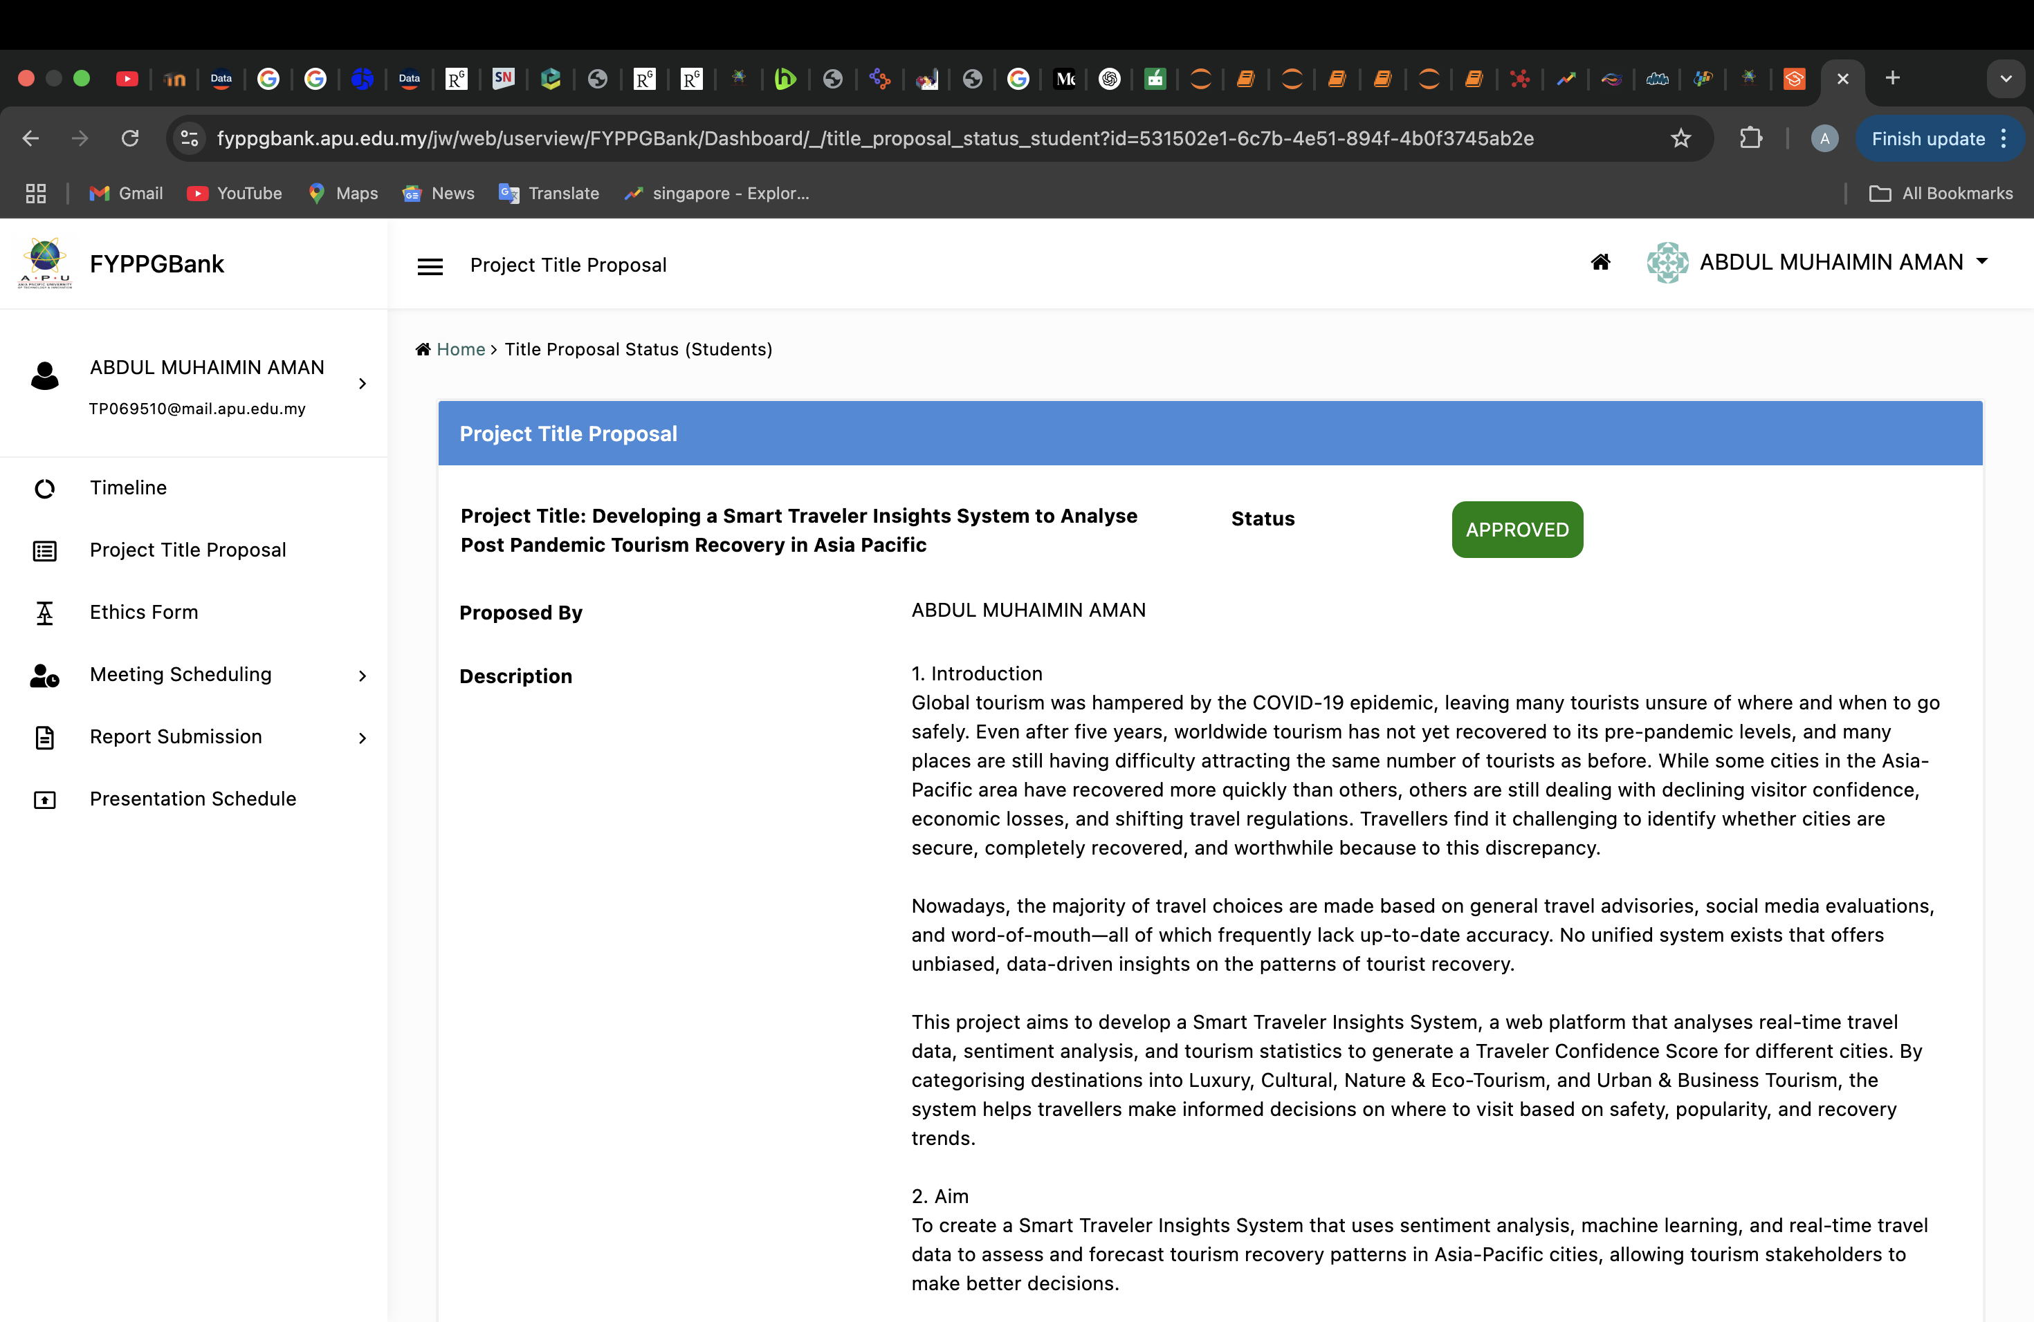

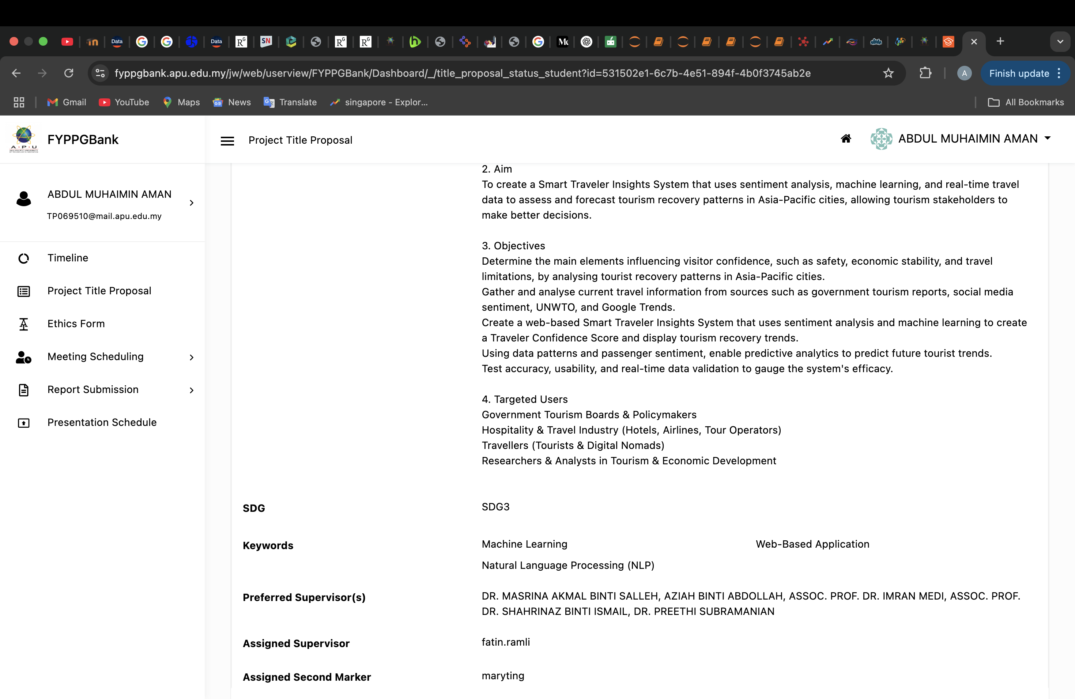

## 2. Ethics Form

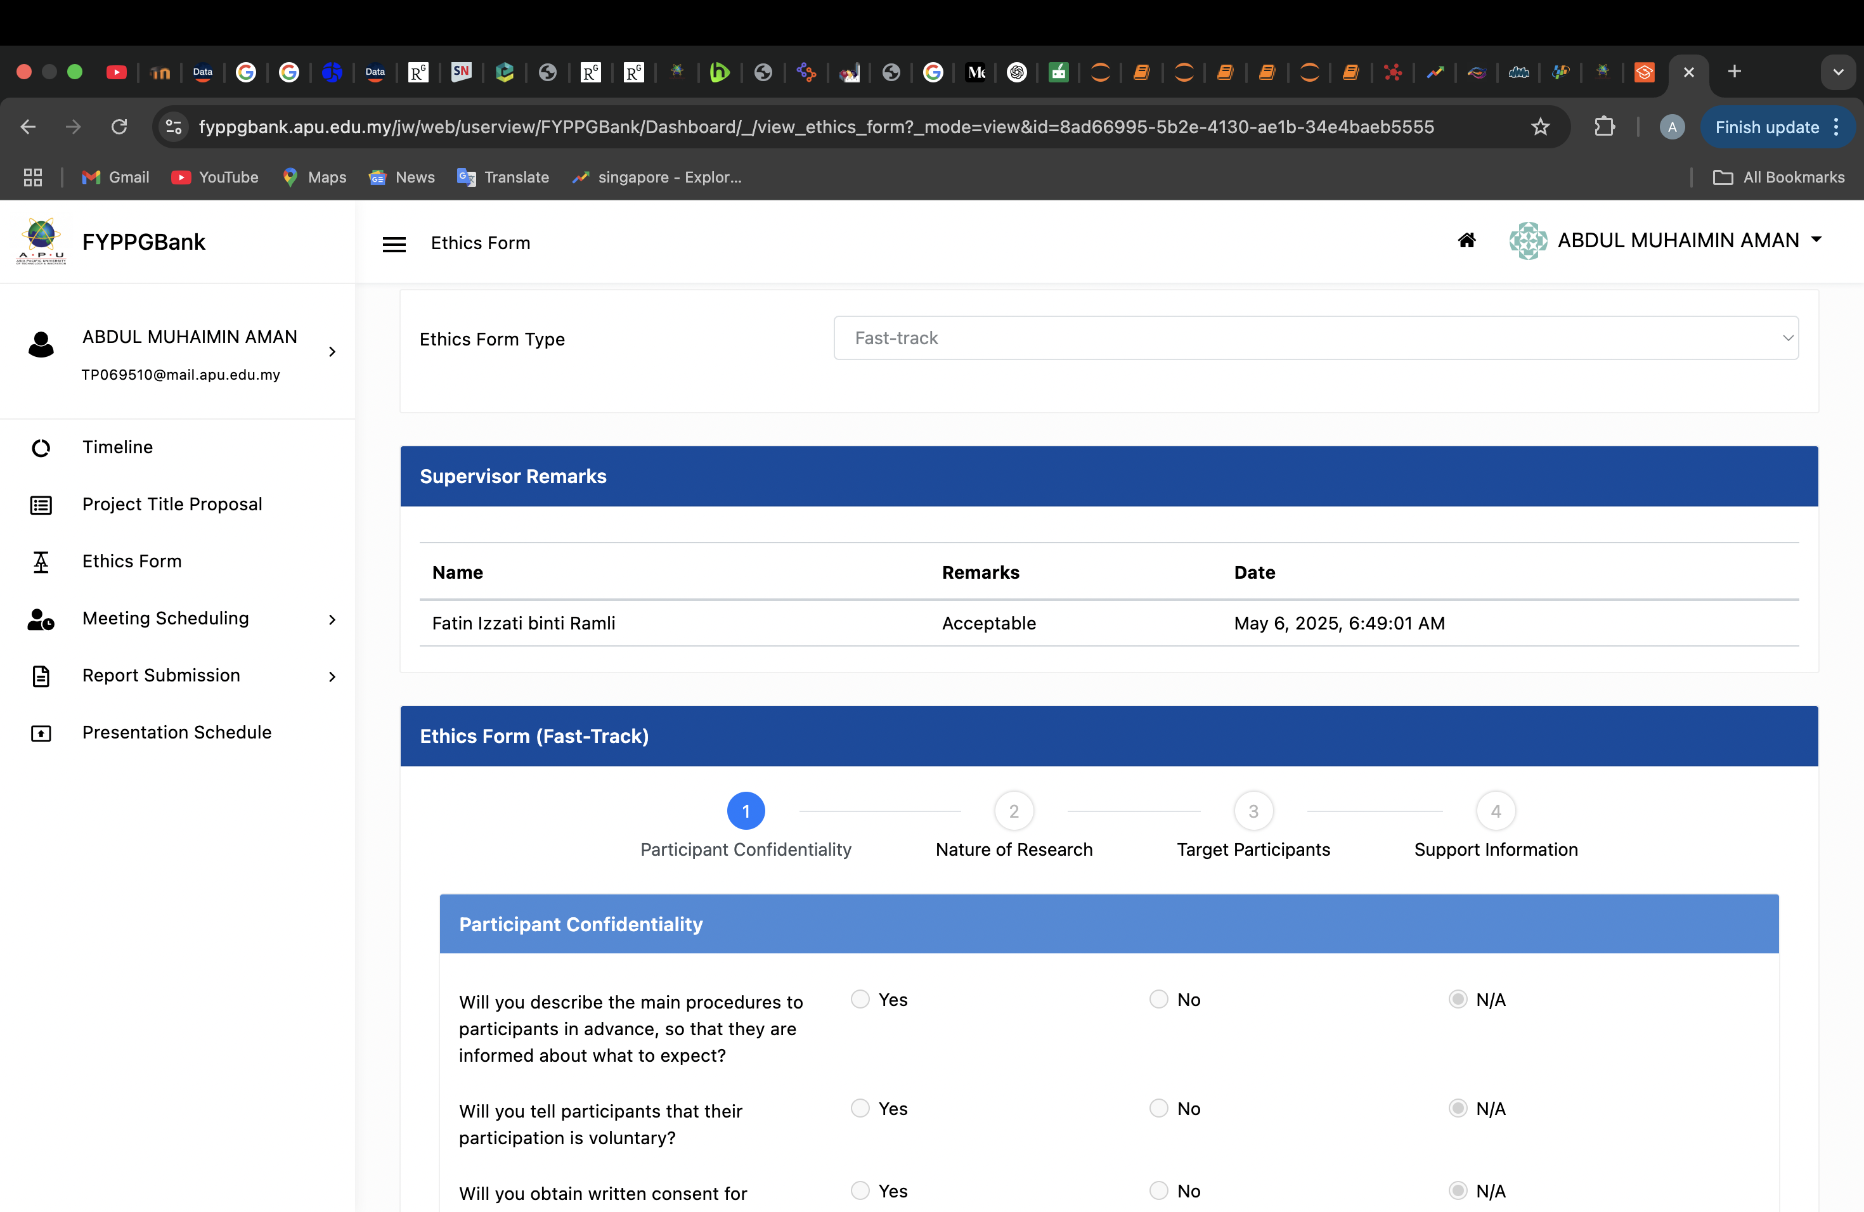

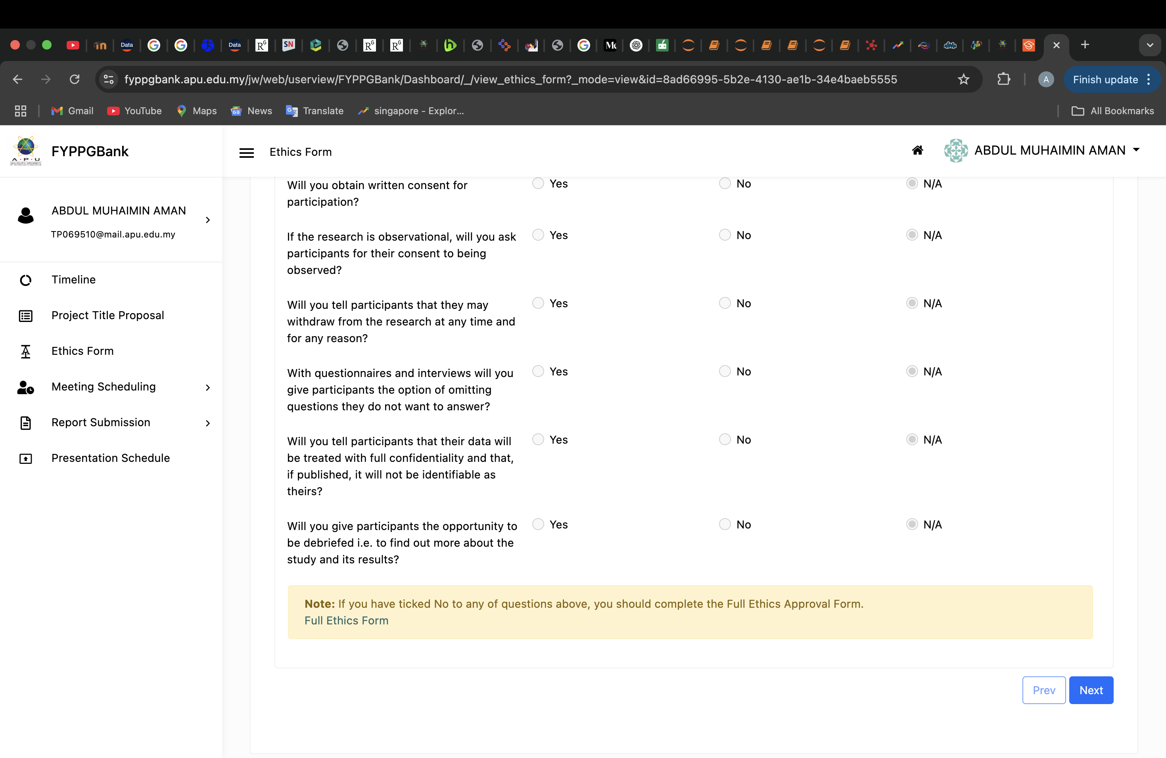

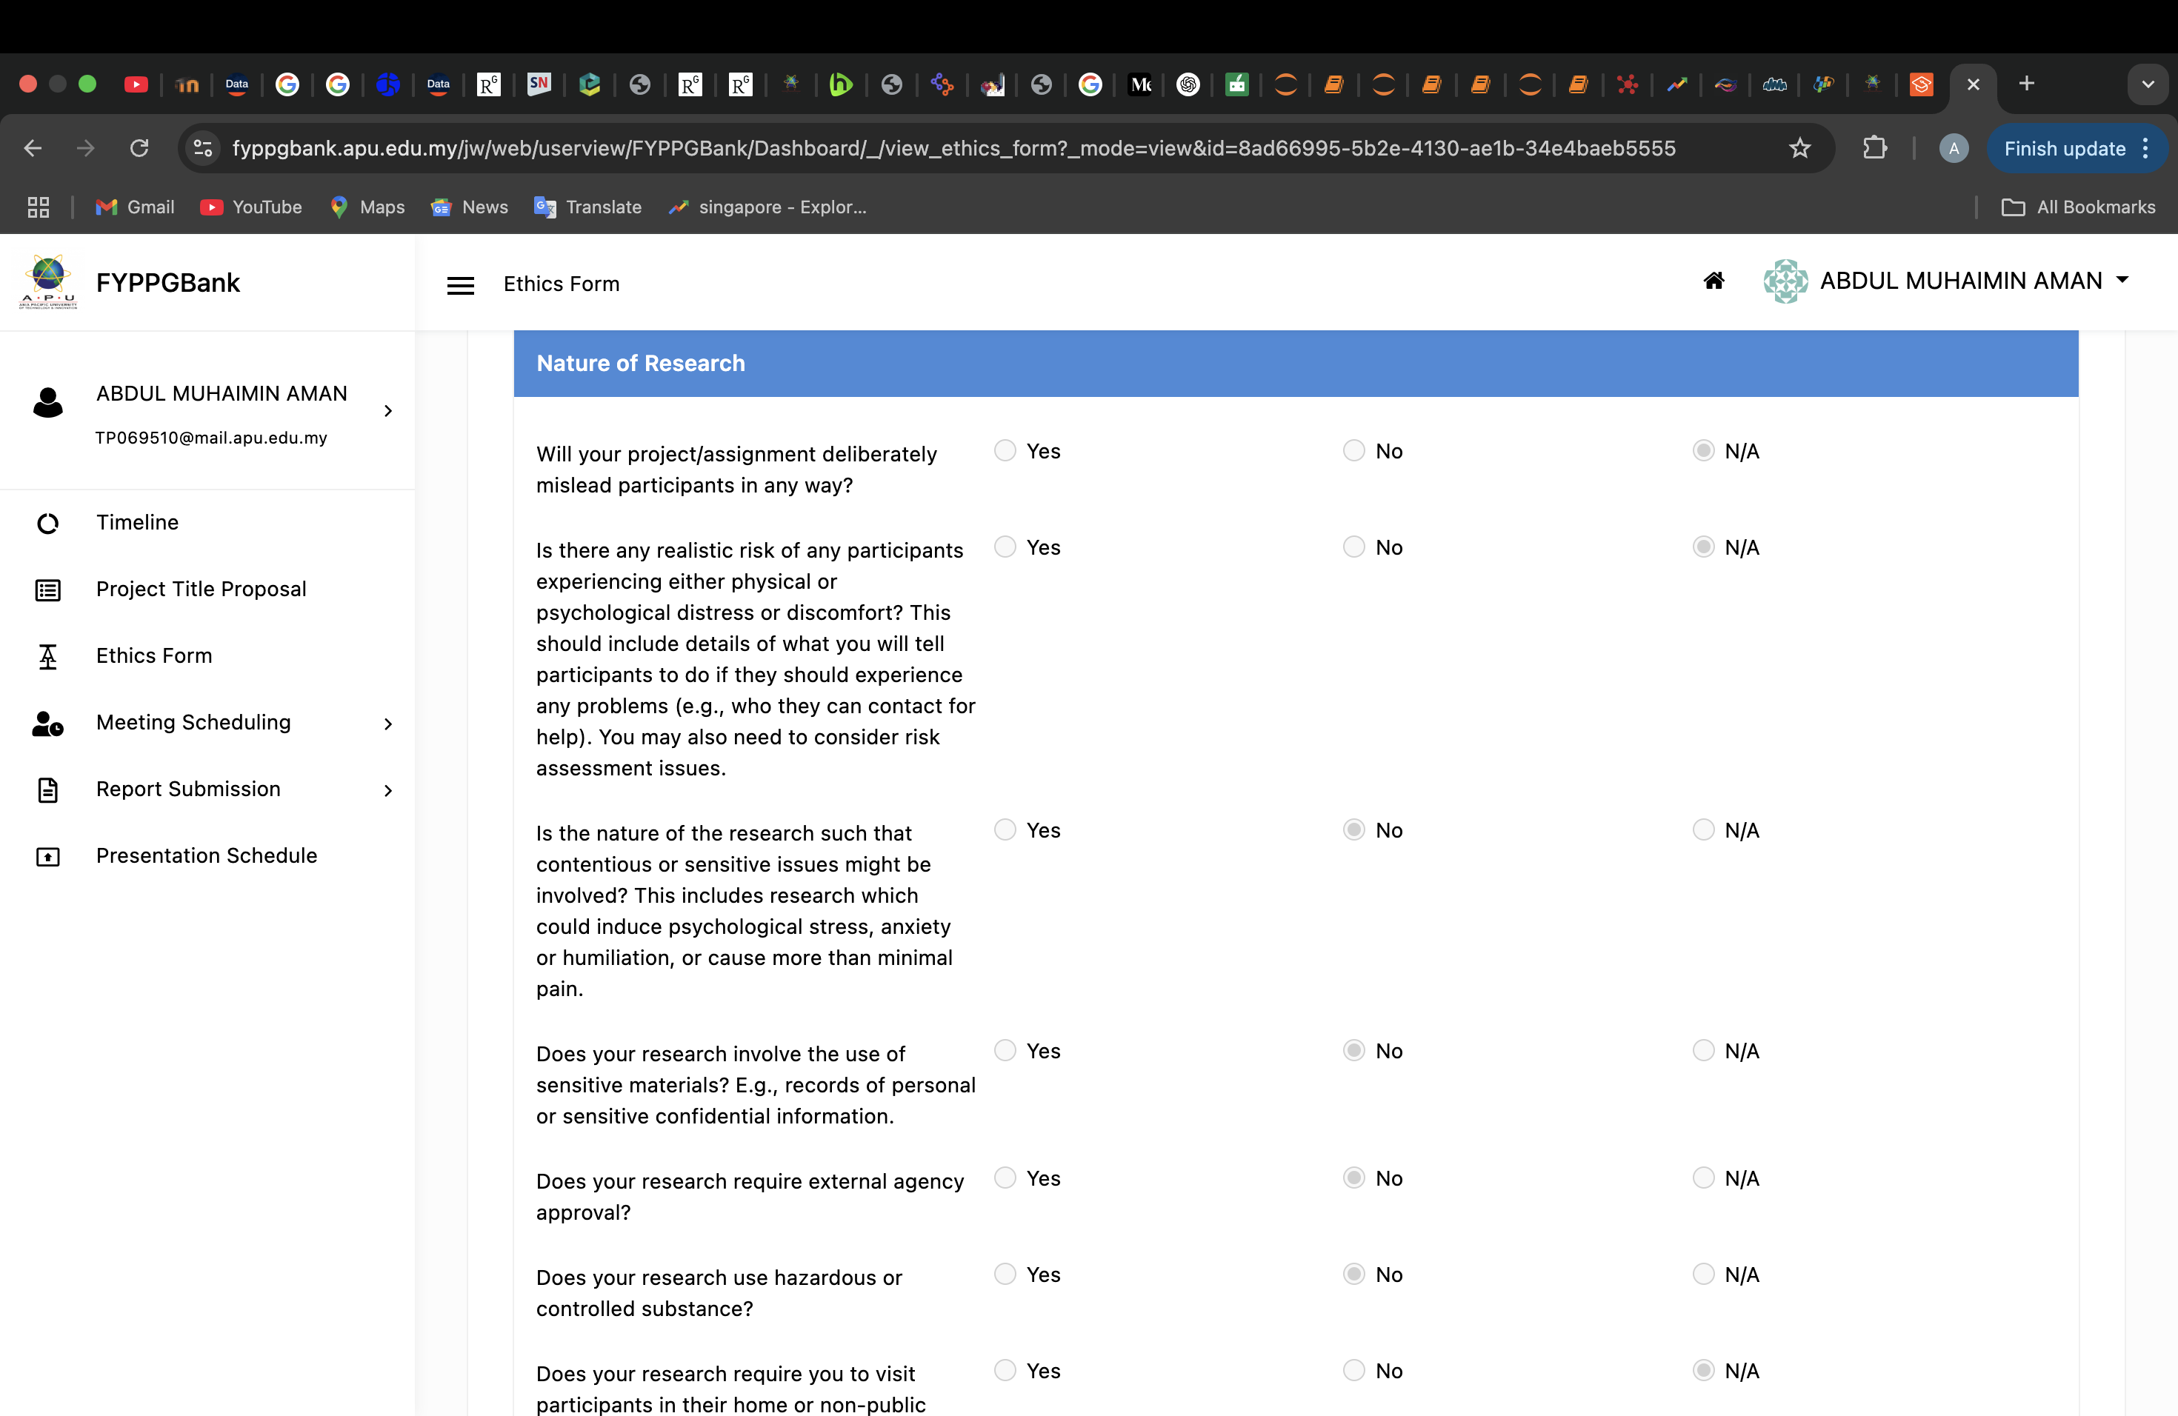

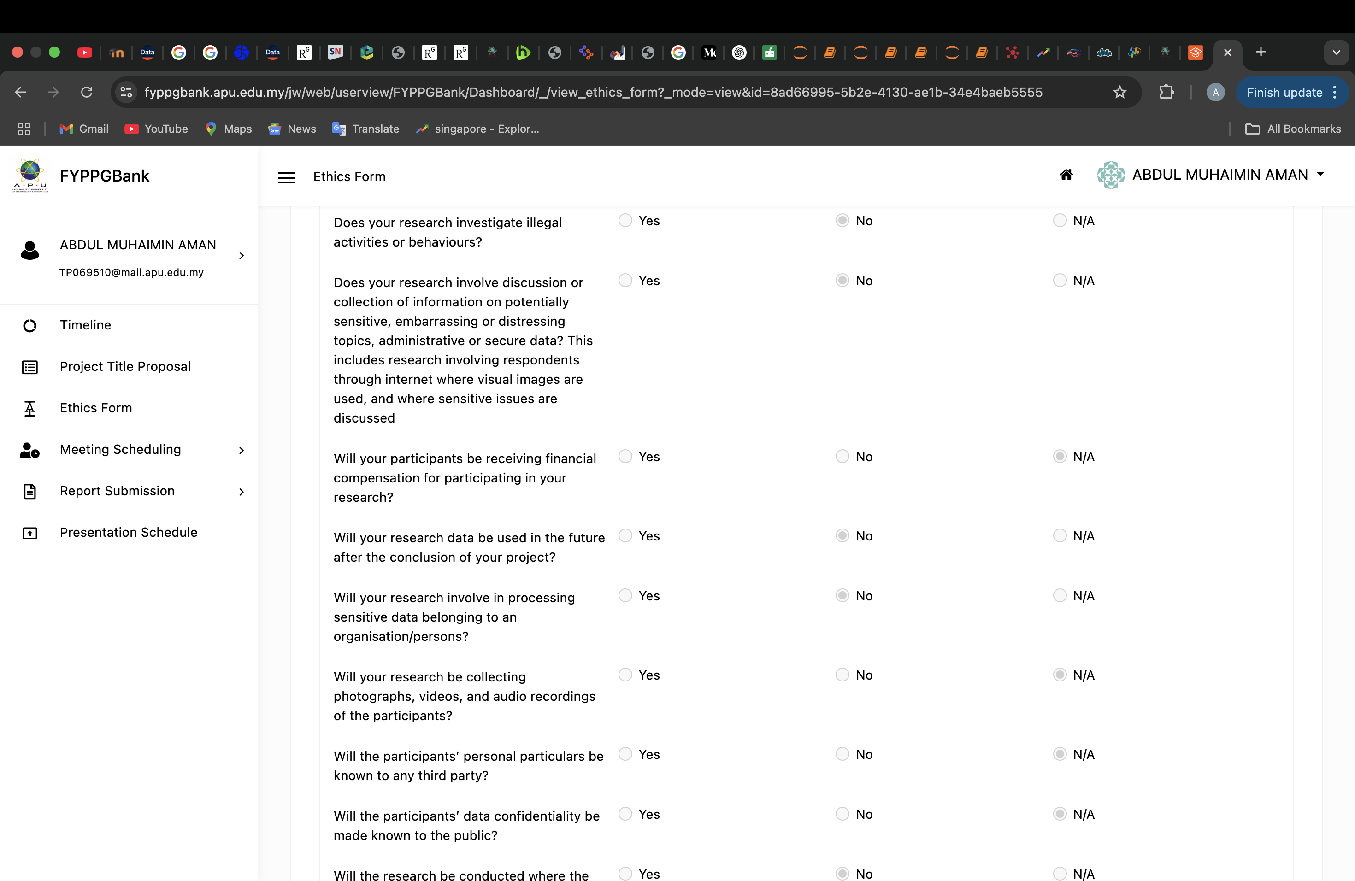

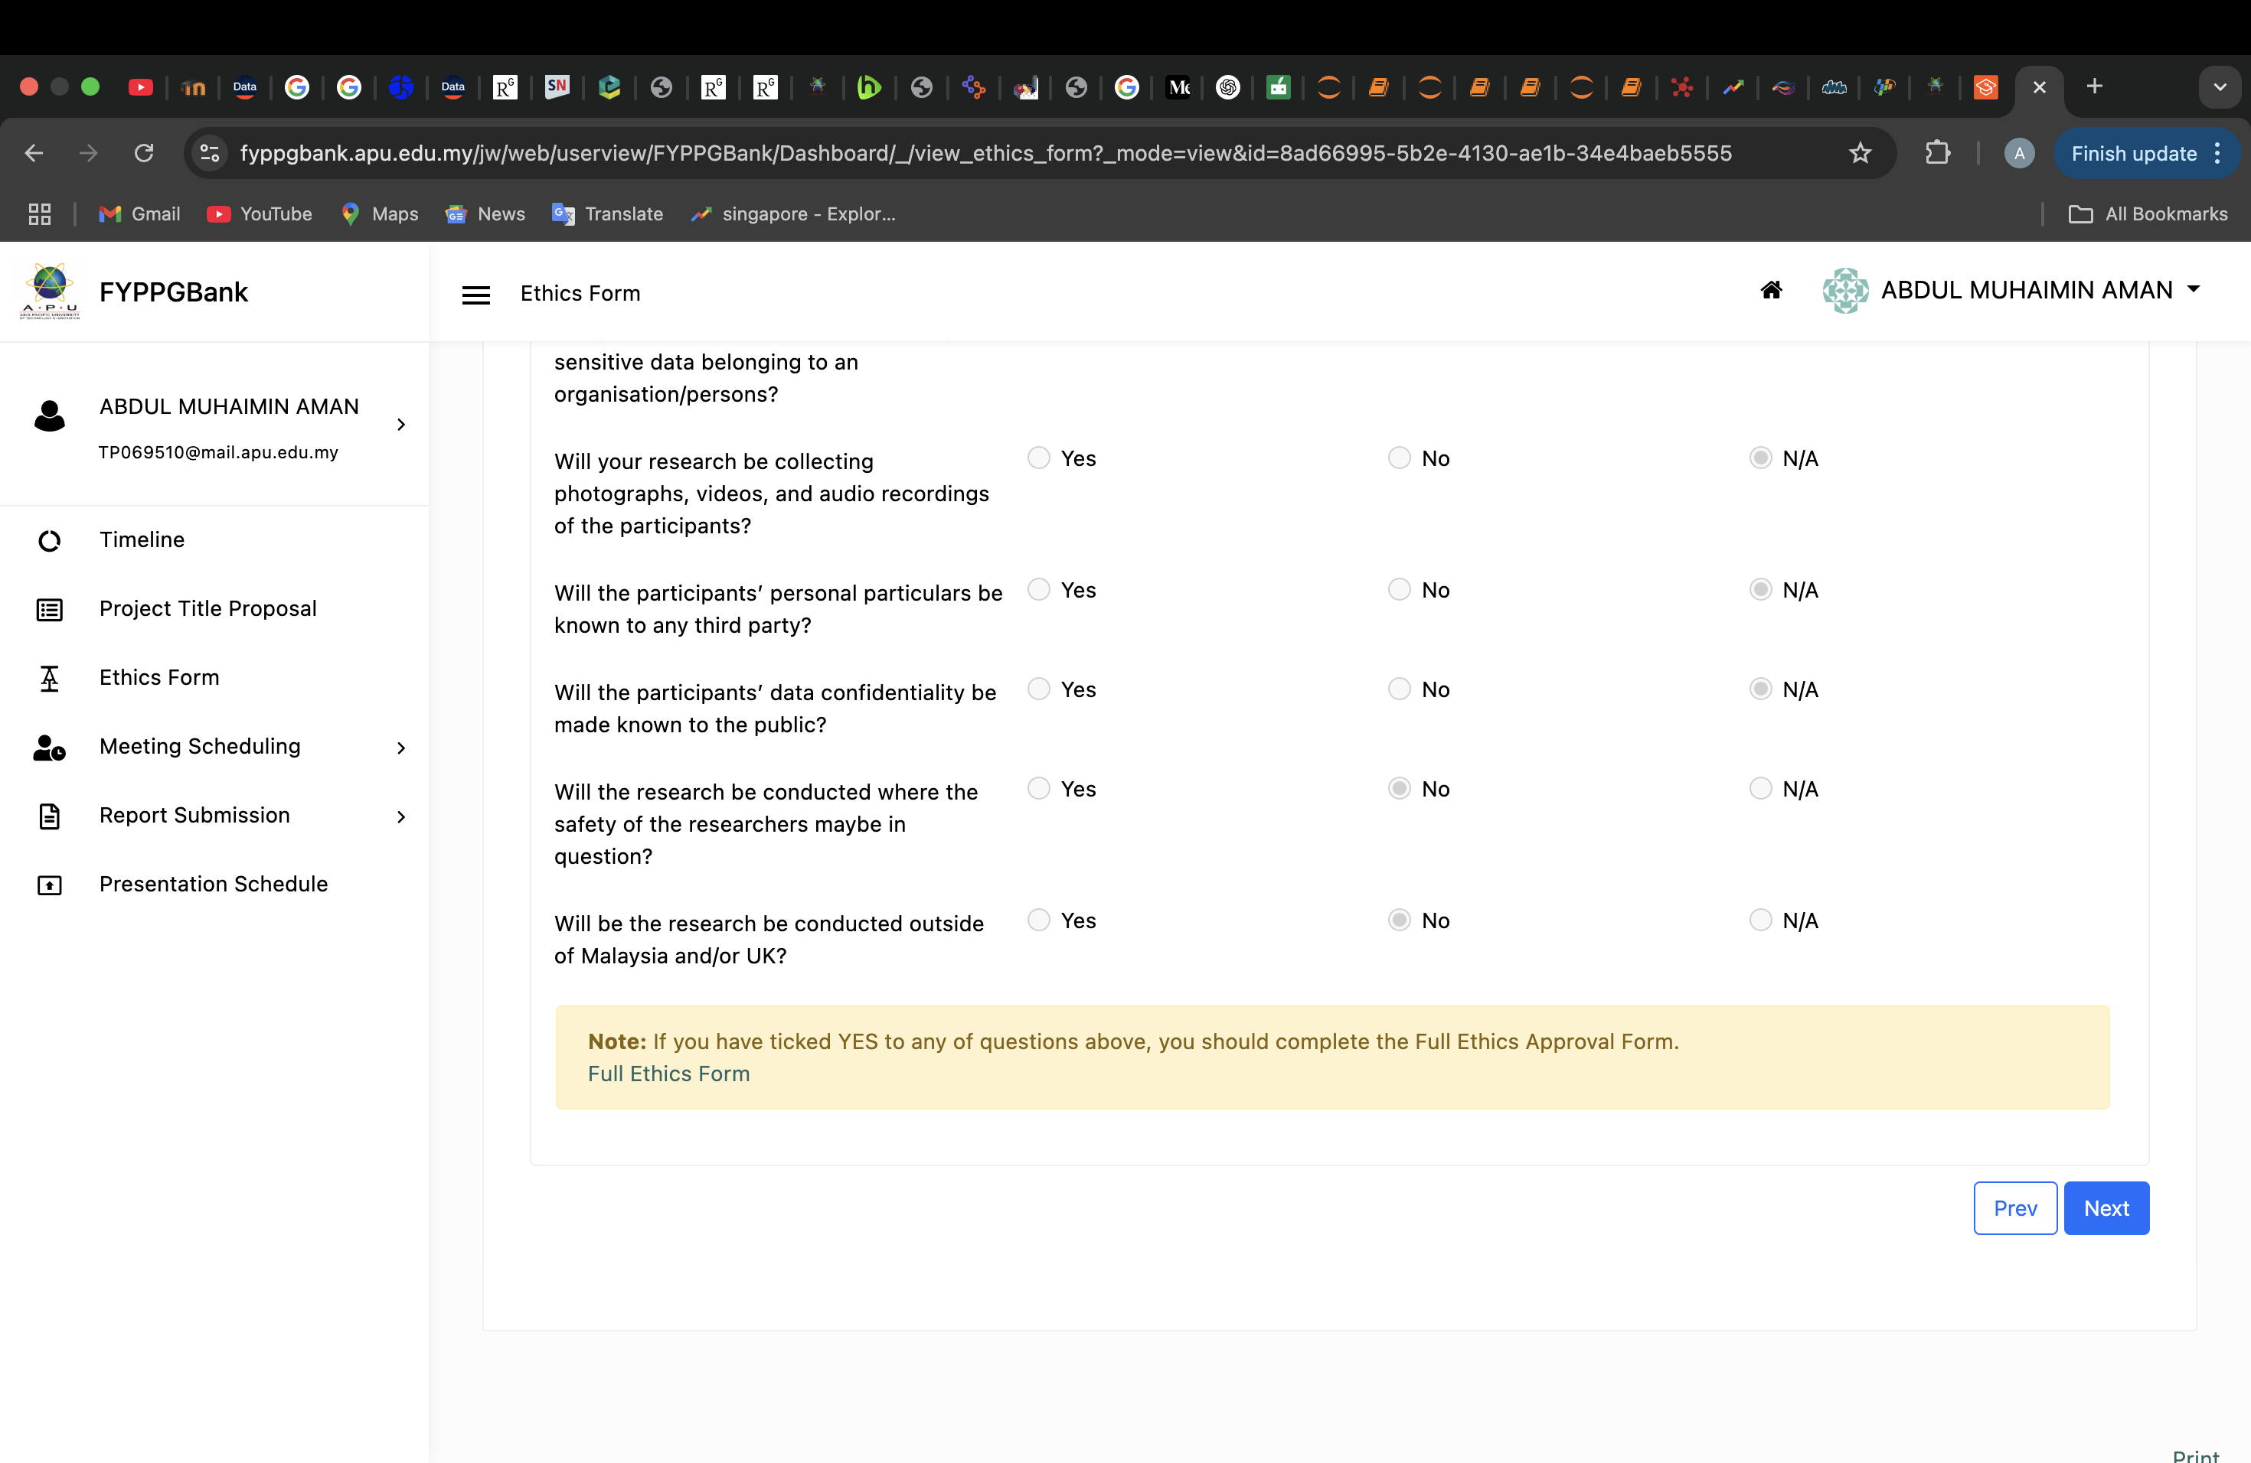

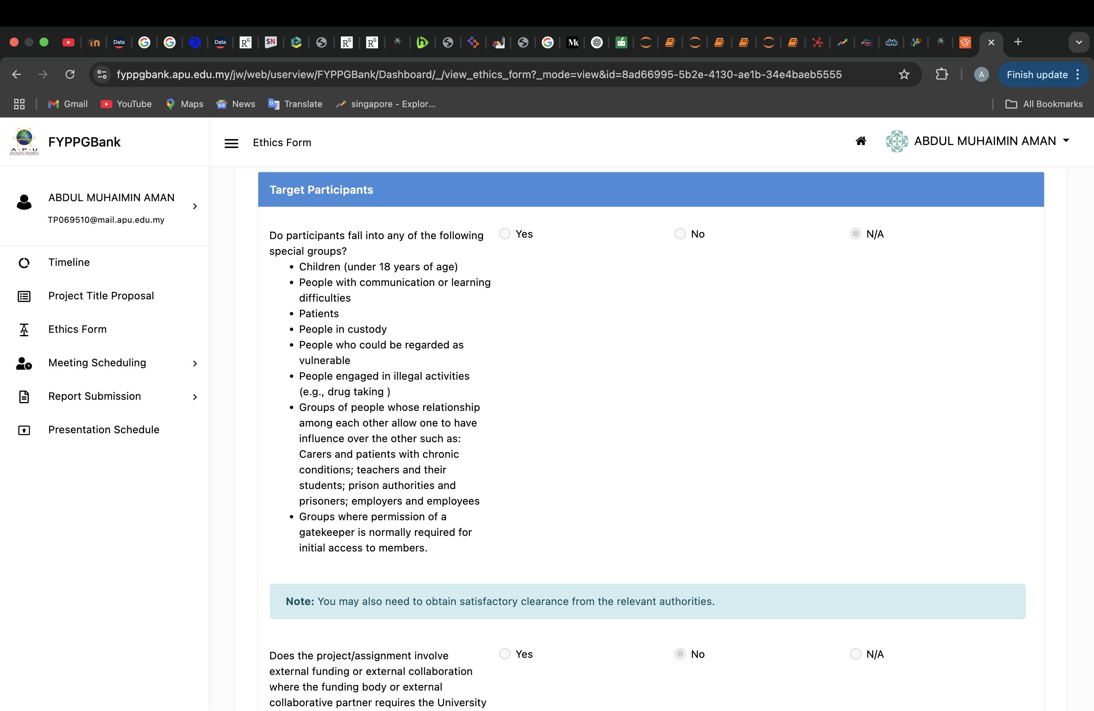

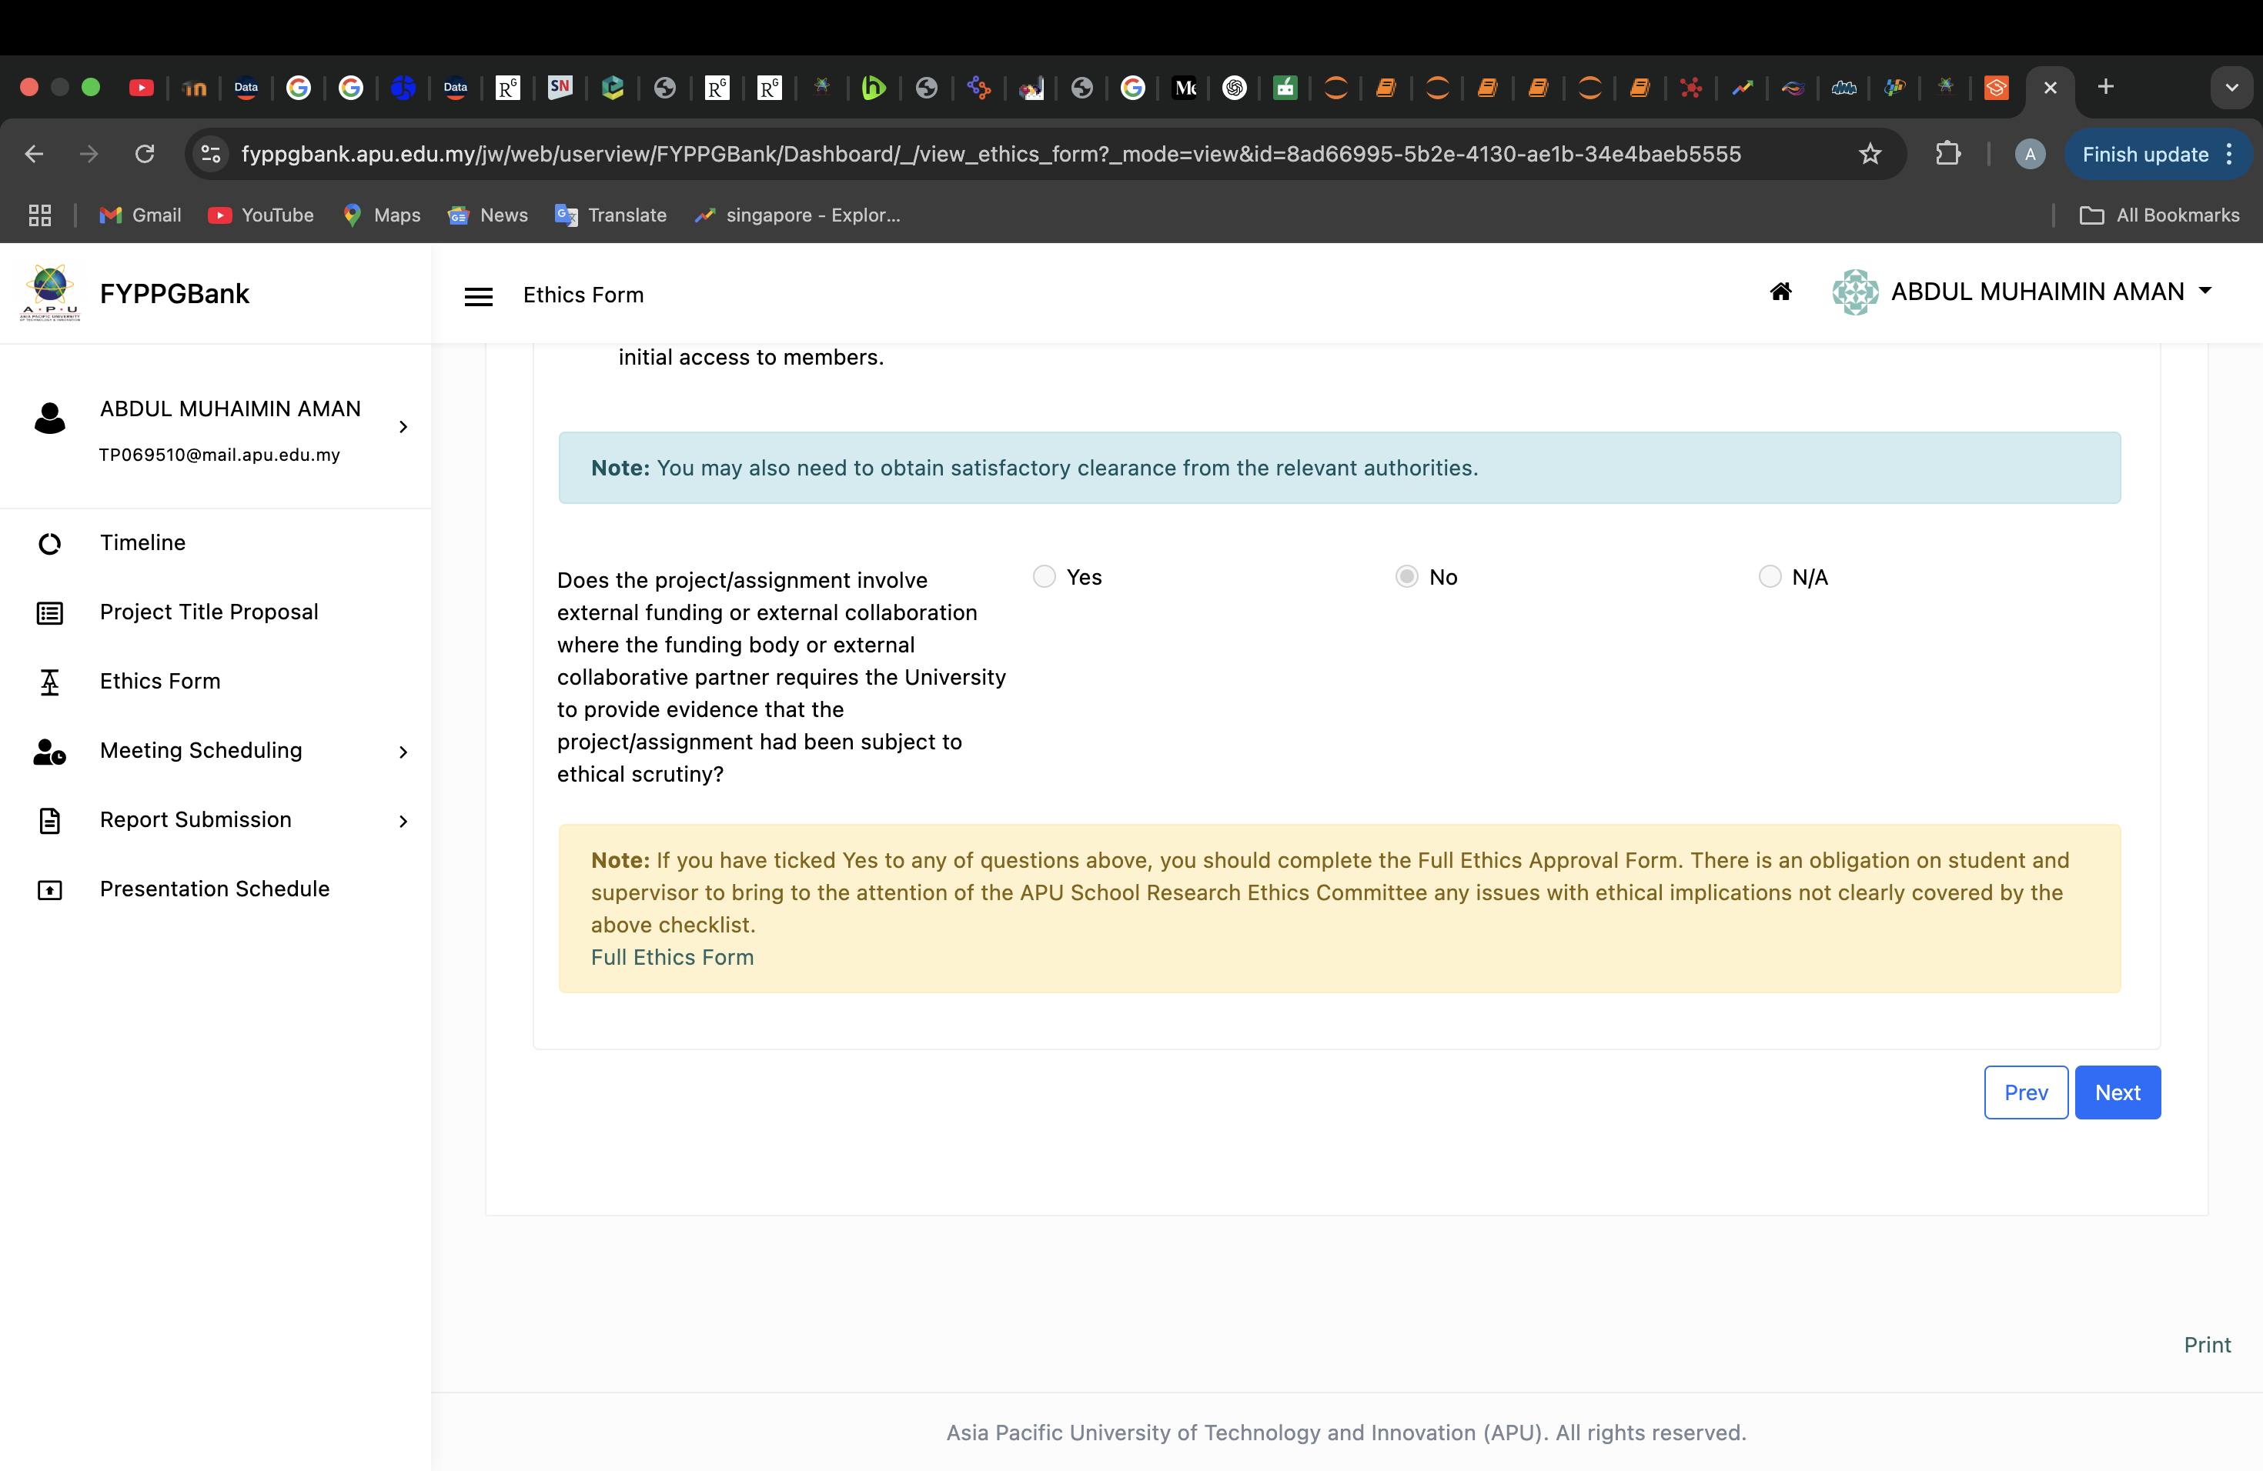

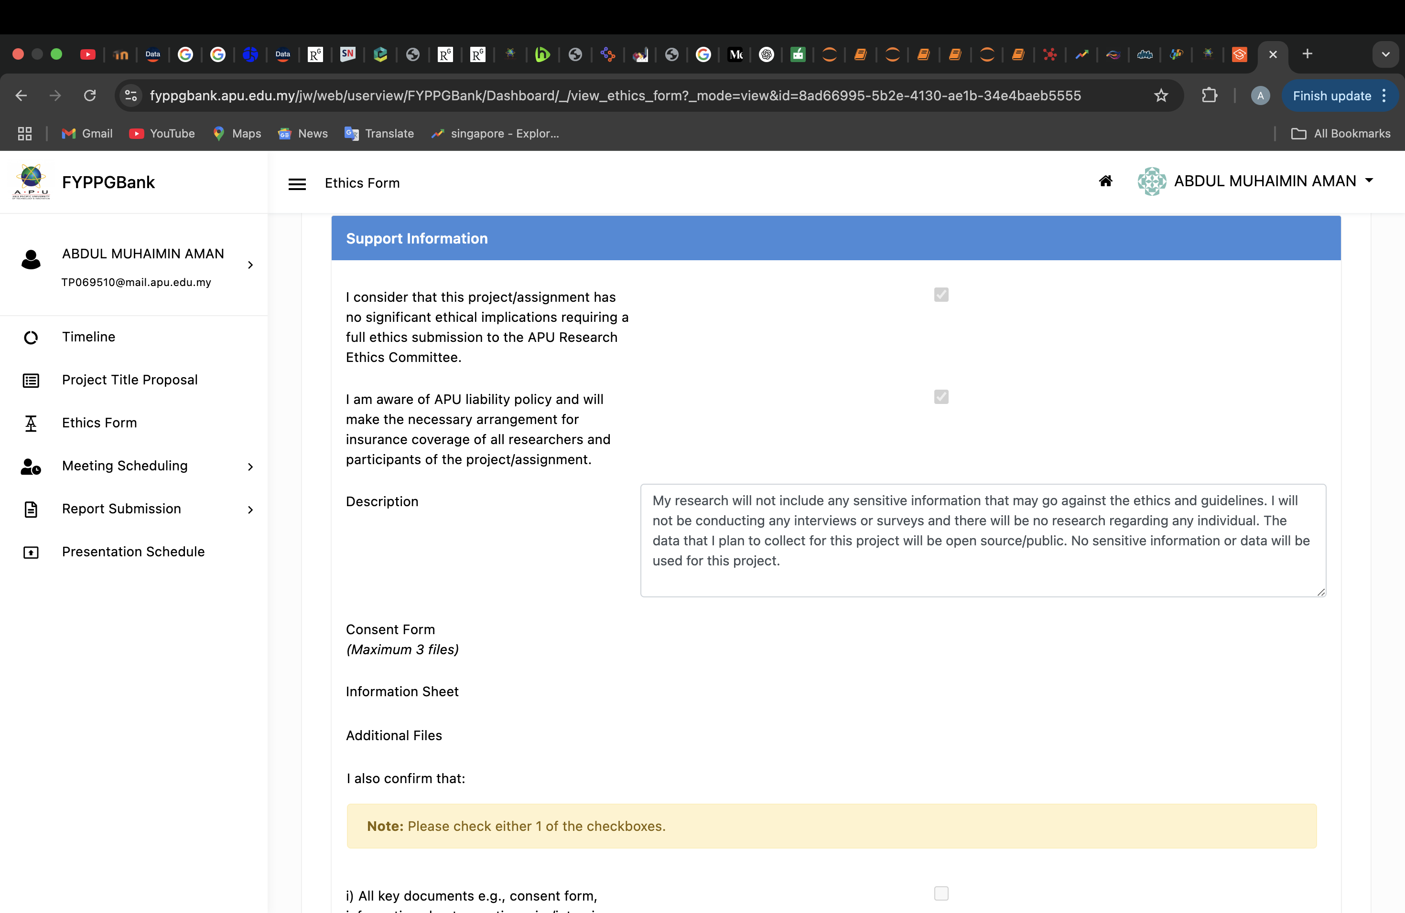

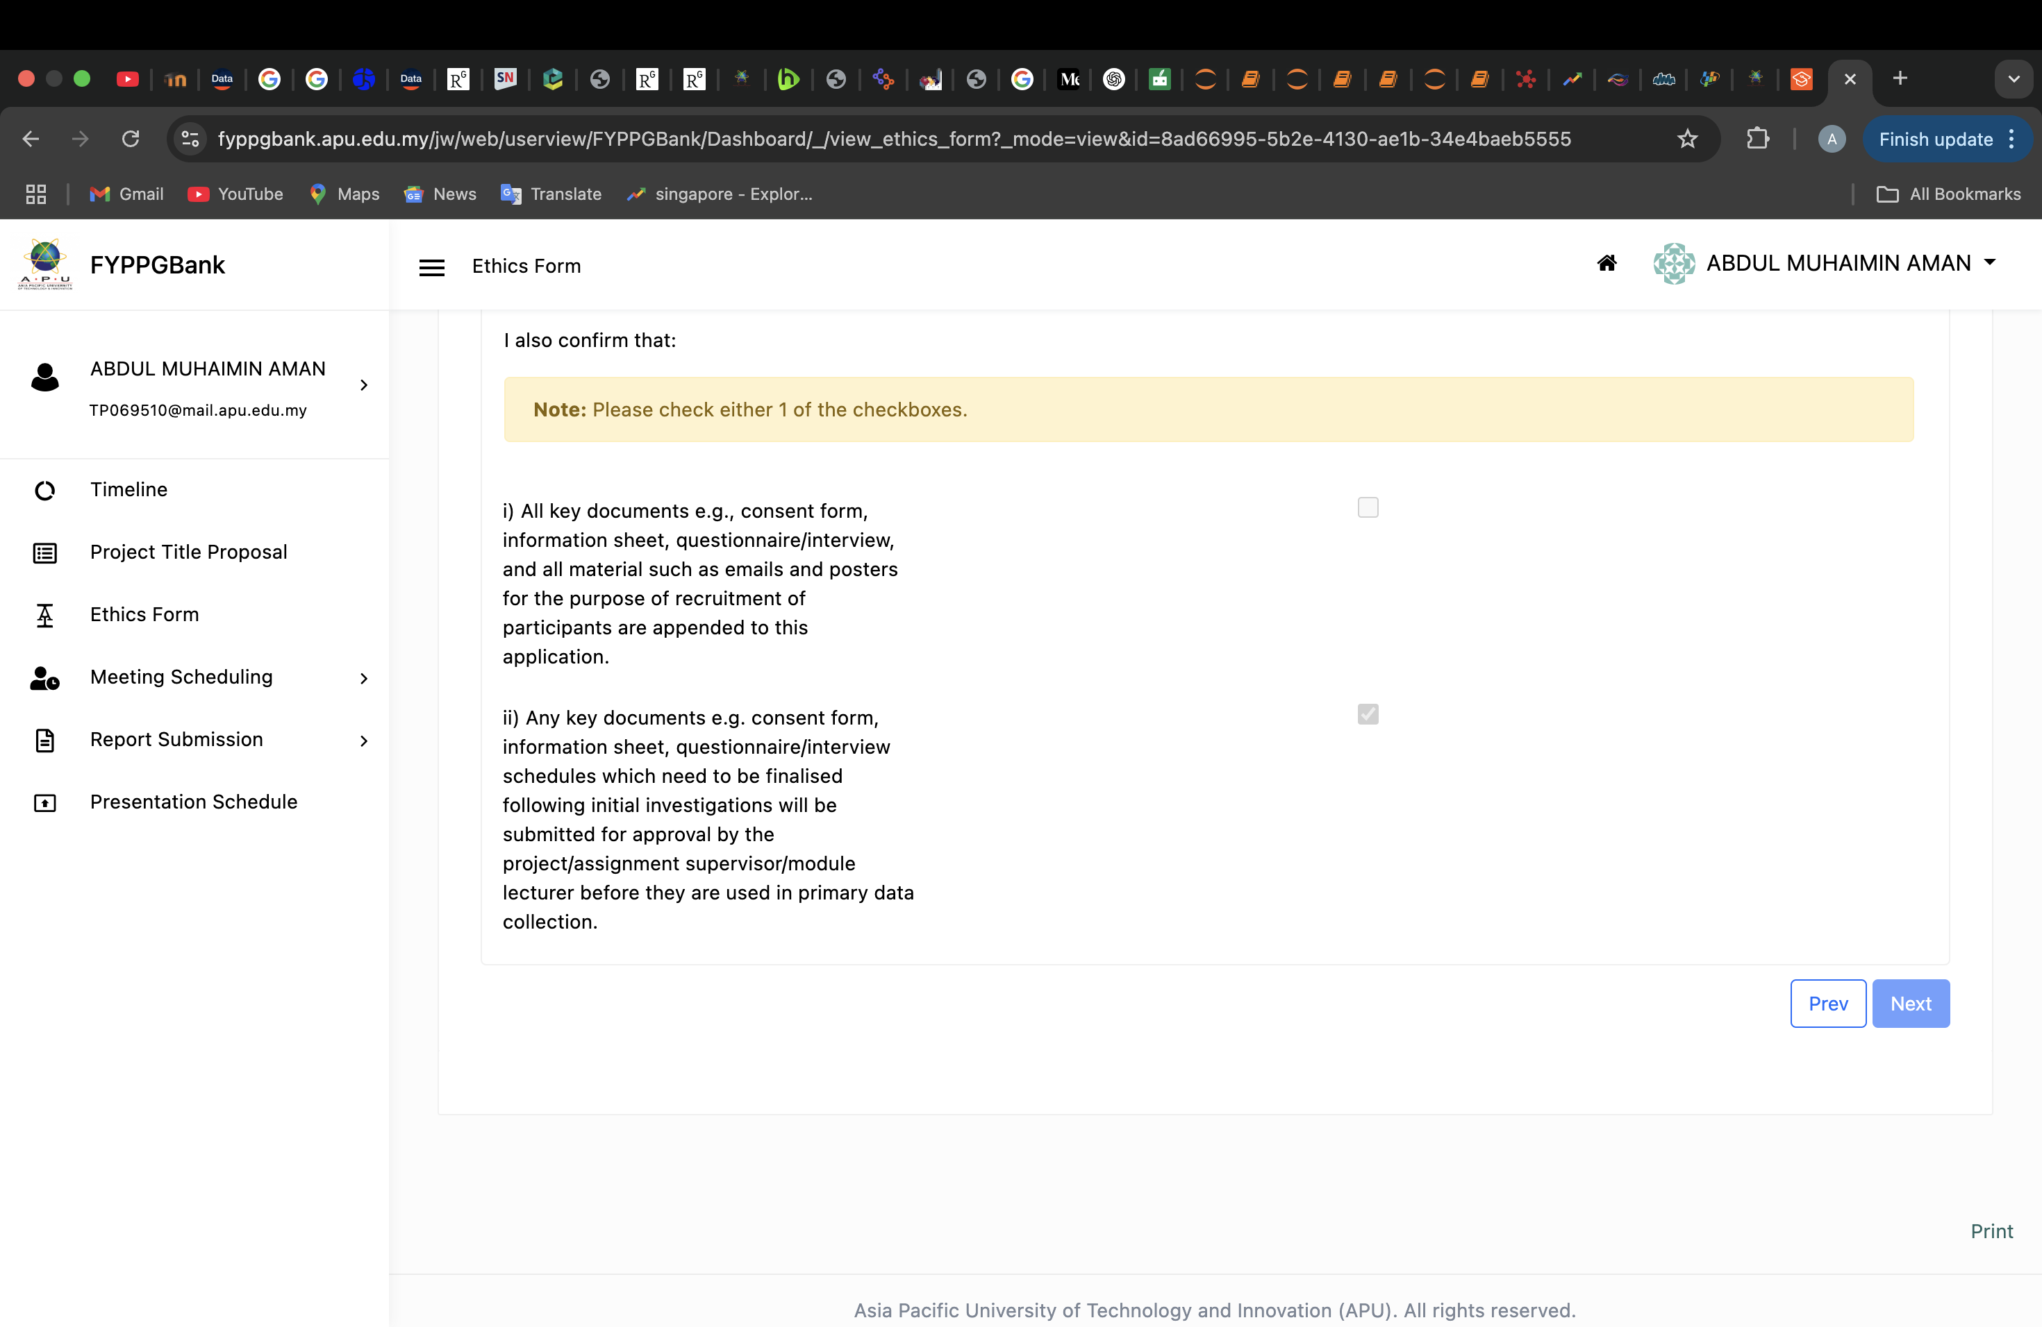

## 3. Log Sheets

### Log sheet 1

**Project Log Sheet – Supervisory Session**

**(APU: Serial Number)**

**Notes on use of the project log sheet:**

1. This log sheet is designed for meetings of more than 15 minutes duration, of which there must be at minimum SIX (6) during the course of the project (SIX mandatory supervisory sessions).
2. The student should prepare for the supervisory sessions by deciding which question(s) he or she needs to ask the supervisor and what progress has been made (if any) since the last session, and noting these in the relevant sections of the form, effectively forming an agenda for the session.
3. A log sheet is to be brought by the STUDENT to each supervisory session.
4. The actions by the student (and, perhaps the supervisor), which should be carried out before the next session should be noted briefly in the relevant section of the form.
5. The student should leave a copy (after the session) of the Project Log Sheet with the supervisor and to the administrator at the academic counter. A copy is retained by the student to be filed in the project file.
6. It is recommended that students bring along log sheets of previous meetings together with the project file during each supervisory session.
7. The log sheet is an important deliverable for the project and an important record of a student’s organisation and learning experience. The student **must** hand in the log sheets as an appendix of the final year documentation, with sheets dated and numbered consecutively.

|  |
| --- |
| **Student’s name: ABDUL MUHAIMIN AMAN**  **Date: 22.04.2025 Meeting No: 1** |

|  |
| --- |
| **Project title: Developing a Smart Traveller Insights System to Analyse Post Pandemic Tourism Recovery in Asia Pacific**  **Intake: APD3F2502CS(DA)** |

|  |
| --- |
| **Supervisor’s name:**  **Fatin Izzati binti Ramli Supervisor’s signature: Fatin** |

|  |
| --- |
| **Items for discussion (noted by student before mandatory supervisory meeting):**   1. **Project Proposal** 2. **Algorithms to use** 3. **Software for pre-processing** |

|  |
| --- |
| **Record of discussion (noted by student during mandatory supervisory meeting):**   1. **Addressed the algorithms to use for the project.** 2. **Addressed the pre-processing techniques** 3. **Supervisor agreed on the topic and the implementation.** |
| **Action List (to be attempted or completed by student by the next mandatory supervisory meeting):**   1. **Start gathering data for the project.** 2. **Finalize on the algorithms and pre-processing techniques** |

*Note: A student should make an appointment to meet his or her supervisor (via the consultation system) at least ONE (1) week prior to a mandatory supervisor session – please see document on project timelines. In the event a supervisor could not be booked for consultation, the project manager should be informed ONE (1) week prior*

### Log sheet 2

****

**Project Log Sheet – Supervisory Session**

**(APU: Serial Number)**

**Notes on use of the project log sheet:**

1. This log sheet is designed for meetings of more than 15 minutes duration, of which there must be at minimum SIX (6) during the course of the project (SIX mandatory supervisory sessions).
2. The student should prepare for the supervisory sessions by deciding which question(s) he or she needs to ask the supervisor and what progress has been made (if any) since the last session, and noting these in the relevant sections of the form, effectively forming an agenda for the session.
3. A log sheet is to be brought by the STUDENT to each supervisory session.
4. The actions by the student (and, perhaps the supervisor), which should be carried out before the next session should be noted briefly in the relevant section of the form.
5. The student should leave a copy (after the session) of the Project Log Sheet with the supervisor and to the administrator at the academic counter. A copy is retained by the student to be filed in the project file.
6. It is recommended that students bring along log sheets of previous meetings together with the project file during each supervisory session.
7. The log sheet is an important deliverable for the project and an important record of a student’s organisation and learning experience. The student **must** hand in the log sheets as an appendix of the final year documentation, with sheets dated and numbered consecutively.

|  |
| --- |
| **Student’s name: ABDUL MUHAIMIN AMAN**  **Date: 07.05.2025 Meeting No: 2** |

|  |
| --- |
| **Project title: Developing a Smart Traveller Insights System to Analyse Post Pandemic Tourism Recovery in Asia Pacific**  **Intake: APD3F2502CS(DA)** |

|  |
| --- |
| **Supervisor’s name:**  **Fatin Izzati binti Ramli Supervisor’s signature: Fatin** |

|  |
| --- |
| **Items for discussion (noted by student before mandatory supervisory meeting):**   1. **Constraints of the project such as data gathering** 2. **Updating Supervisor on the report.** 3. **Report Formatting.** |

|  |
| --- |
| **Record of discussion (noted by student during mandatory supervisory meeting):**   1. **Addressed how gathering data of multiple cities is difficult.** 2. **Addressed the order of sub-topics in the report.** |
| **Action List (to be attempted or completed by student by the next mandatory supervisory meeting):**   1. **Finish up on data visualisation.** 2. **Submit report 1.** |

*Note: A student should make an appointment to meet his or her supervisor (via the consultation system) at least ONE (1) week prior to a mandatory supervisor session – please see document on project timelines. In the event a supervisor could not be booked for consultation, the project manager should be informed ONE (1) week prior*

## 4. Gantt chart

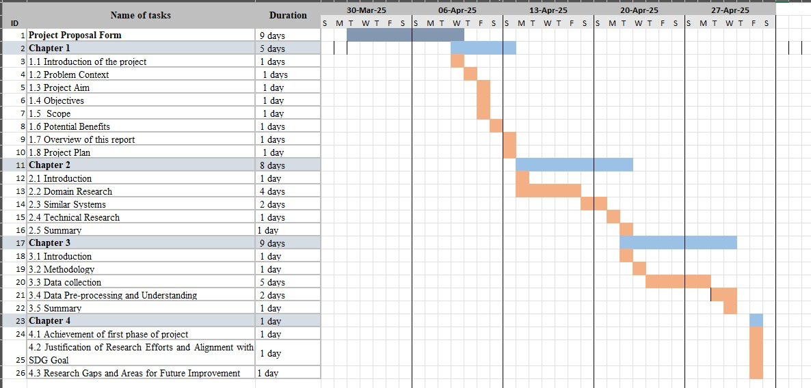

## 5. Turnitin

